CLOUD COMPUTING (19CS337)

**Regulation – R19**

**Lab manual for the Academic Year (2022-23) I semester**

**DEPARTMENT OF COMPUTER SCIENCE & ENGINEERING**



**Vadlamudi, 522 213, AP, India**

**PREFACE**

# About the course / Lab

This course is aimed at offering the fundamental concepts of Virtualization & Amazon Web Services (AWS) to the students. It starts with the basics of desktop virtualization. The objective of this course is to enable the students to develop the applications using the platforms like VMware Workstation and AWS.

* Perform desktop virtualization using VMware.
* Understand the availability of various instances to develop applications in AWS.
* Use AWS platform to deploy EC2 instance.
* Handle the failures of an instance by masking with an Elastic IP address.
* Implement a network layer Amazon Virtual Private Cloud (VPC) to launch AWS resources.
* Apply Elastic Block Store (EBS) for use with EC2 instance.

**INDEX**

|  |  |  |
| --- | --- | --- |
| **S.no** | **Description** | **Page.**  **No** |
| **I** | **Syllabus** | **i** |
| **II** | **List of Experiments** | **v** |
| **III** | **Experiments** | **1** |
| 1 | VM Ware Software and Ubuntu OS Installation. | 1 |
| 2 | To connect to Amazon Linux instance from Linux client operating  system | 10 |
| 3 | To connect to Amazon Linux instance from Windows client  operating system | 10 |
| 4 | To connect to Amazon Windows instance from Linux client  operating system | 18 |
| 5 | To connect Windows instance from Windows client operating system | 18 |
| 6 | To configure Web Server on Amazon Linux instance with Elastic IP | 25 |
| 7 | To Assign Elastic IP address | 26 |
| 8 | To Configure Amazon Simple Storage Service (Amazon s3) | 29 |
| 9 | To Create your own VPC | 42 |
| 10 | To Create public subnet | 45 |
| 11 | To Create private subnet | 45 |
| 12 | Create an Internet gateway and attach to your VPC, | 48 |
| 13 | Create Pubic Routing Table, associate subnet and add routing rules | 51 |
| 14 | Create Private Routing Table, associate subnet and add routing rules | 58 |
| 15 | To launch Windows instance in Public. | 63 |
| 16 | To launch Windows instance in Private subnet under your VPC | 70 |
| 17 | To connect to Public Subnet instance | 78 |
| 18 | To connect to Private Subnet instance | 89 |
| 19 | To Connect Linux instance in private subnet | 96 |
| 20 | To Connect Linux instance in public subnet | 99 |
| **IV** | **Viva Voce Questions** | **106** |

**Lab Evaluation Guidelines**

# Guidelines for Lab teacher:

* + 1. **Before commencement of lab class work:**
       1. The detailed information consisting of experiments, batch formations, experiment schedules, etc., will be displayed / informed to the students one week before the commencement of the semester so that the student comes prepared for the session.
       2. Before commencement of laboratory classes, the teachers and instructor handling the courses should practice the experiments.
       3. Copies of the lab manual (soft copy) will be made available to the students along with the schedule. The lab manual will consist of the list of equipment, detailed procedure to conduct the experiment, format for record writing, algorithm or procedure, circuit diagrams, list of equipment/tools needed, sample calculations, sample graphs, outcomes for each experiment and possible set of short questions to help student’s gain critical understanding. Three hardcopies are to be made available during the lab sessions one is master copy and the other two copies are for student’s ready reference during lab sessions.
    2. **During Laboratory Sessions:**
       1. Conduct a demo session of all the experiments in that cycle to students. Explain them about other guidelines to be followed in the lab.
       2. A logbook is to be maintained by the instructor in which student will sign every time when he visits the lab to do the experiment.
       3. Verify the student record before allowing him to perform experiment. Previous experiment completion and preparedness for performing the experiment scheduled on that day has to be checked.
       4. Evaluate the performance as per the table given below. The set of parameters may slightly differ from one laboratory to the other and will be announced before the commencement of the lab session. These parameters are to be assessed for each laboratory session. The lab teacher has to use red pen to give evaluation results on record.

## Continuous Evaluation of Laboratory

|  |  |  |
| --- | --- | --- |
| S.No | Component | Marks |
| 1 | Preparedness | 2M |
| 2 | Coding | 4M |
| 3 | Testing | 2M |
| 4 | Viva | 2M |
| Total | | 10M |

* + - 1. These marks are to be marked in record, component wise for each experiment and total marks are to be entered into section wise lab sheet.

This assessment is to be carried out for each practical session and the average mark of all the sessions is to be considered and finally scaled down to 30 marks. An internal laboratory examination will be conducted for another 20 marks.

**Absent students / not performed students:**

Students can do the experiments after class hrs.

**Internal Laboratory Examination:**

The internal laboratory examination shall be conducted around the middle of the semester. The examination is to be conducted, by a team of two examiners, one who conducts the laboratory sessions and the other appointed by the Deputy HoD. The scheme of evaluation is given below.

|  |  |  |  |
| --- | --- | --- | --- |
| **Component** | **Marks** | | |
| **Internal Examiner (Lab Teacher)** | **External Laboratory Examiner (Appointed by**  **Deputy HoD)** | **Total** |
| Objective & Procedure write up  including outcomes | 5 | 5 | 10 |
| Coding | 10 | 10 | 20 |
| Testing | 5 | 5 | 10 |
| Viva voce | 0 | 10 | 10 |
| **Total Marks** | **20** | **30** | **50** |

The teacher shall make a comparative statement of these lab marks with the student’s previous aggregate percentage of marks. When the difference is more than 20%, the remarks of the teacher are to be endorsed with full justification and displayed at notice boards. A committee appointed by the Dean Evaluation will scrutinize all such comparisons and take necessary action.

* + 1. **End – semester Laboratory Evaluation:**

End semester examination for each practical course is conducted jointly by both internal and external examiners. The examiners are appointed by Dean, Evaluation from the panel of examiners suggested by the respective Heads of the Department. To maintain the objectivity and seriousness of the students towards the lab curriculum and lab examinations, a panel of large number of examiners, four times to the actual requirement shall be suggested by the HoD, at least one month in advance and submit the details to the Dean Evaluation. The Dean Evaluation will select the examiners on a random basis. After examination, at least 10% of the scripts are to be audited by a three-member committee appointed by the Dean- Evaluation. For every class, the mean of the lab marks and theory marks are to be compared and if there is a deviation of more than 20% the reasons are to be analyzed and documented. The scheme of evaluation may vary depending on the nature of laboratory, which shall be shared with the student by the laboratory in-charge and also stamped on the answer scripts. The general scheme of evaluation is given in

Table below.

## End Semester Evaluation Pattern of Labs

|  |  |  |  |
| --- | --- | --- | --- |
| **Component** | **Marks** | | |
| **Internal Examiner** | **External**  **Laboratory Examiner** | **Total** |
| Objective & Procedure write up including  outcomes | 5 | 5 | 10 |
| Coding | 5 | 5 | 10 |
| Testing | 10 | 10 | 20 |
| Viva voce | 0 | 10 | 10 |
| **Total Marks** | **20** | **30** | **50** |

* 1. **Guidelines to lab instructor / programmers:**

1. **Before commencement of semester:**
   1. Along with lab teacher do all the experiments offered for students in that laboratory.
   2. Familiarize yourself about purpose of the experiment, outcomes, result analysis, probable sources of errors in readings etc...
   3. Collect the following information
      1. List of experiments
      2. Instructions related to that lab
      3. Lab manual – 3 hard copies and one softcopy
      4. Sample lab record – 3 hard copies
      5. Logbook / File
      6. Format of stamp to be printed on record sheets
   4. Make the stamp and stamp pad ready for experiments. Before commencement of lab session check the stamp and stamp pad ready for the use by lab teachers.
2. **One or two days before the lab session:**
   1. Check the functioning of systems, instruments and take action if found defective.
   2. Maintain cleanness in the laboratory
3. **During lab session:**
   1. Allow students having appropriate dress code and ID cards into lab.
   2. Ask the student to make entry into the logbook. Verify with reference to the batch wise planning of experiments. Deviations if any inform to faculty.
   3. Make rounds in the laboratory, help the students to perform the experiment and clarify their doubts.
   4. While helping the students, please remember that the students should be able to do the experiment on their own.
   5. After class work, clean the system and make the lab ready for next session.
4. **During examination:**
   1. Obtain the student wise experiment schedules from the lab teacher and make the lab ready for examination.
   2. Collect necessary stationary from the examination section.
   3. Follow the instructions given by lab teacher during examinations.
   4. After evaluation, return the examination records to examination section.
5. **Records to be maintained by lab instructor:**
   1. Log sheet for each lab.

# CLOUD COMPUTING (19CS337)

1. **SYLLABUS**

## PREREQUISITE COURSES:

Operating systems and Computer Networks.

## COURSE DESCRIPTION AND OBJECTIVES:

This course deals with computing model, which enables information, software, and shared resources to be provisioned over the network as services in an on-demand manner. The objective of this course is to enable the student to understand parallel and distributed computing, virtualization, architecture of cloud, aneka, task programming.

## COURSE OUTCOMES:

Upon completion of course, the student will be able to achieve the following outcomes:

|  |  |  |
| --- | --- | --- |
| **COs** | **Course Outcomes** | **POs** |
| 1 | Analyze the trade-offs among deploying of applications in  the cloud and the local infrastructure. | 2 |
| 2 | Evaluate the concepts of various virtualization technologies. | 4 |
| 3 | Deploy applications over commercial cloud computing  infrastructures. | 5 |
| 4 | Identify security and privacy issues in cloud computing. | 6, 8 |

## SKILLS:

* Gain Knowledge of different types of Cloud Service Providers
* Explore basic issues of Cloud Applications
* Compare & Evaluate the optimum costs in the data transmissions.

**UNIT– I L- 9**

**INTRODUCTION:** Definition, Historical developments, Computing platforms and technologies.

**PRINCIPLES OF PARALLEL AND DISTRIBUTED COMPUTING:** Parallel versus distributed computing, Elements of parallel computing, Elements of distributed computing, Technologies for distributed computing.

**UNIT – II L- 9**

**VIRTUALIZATION:** Introduction, Characteristics, Virtualization techniques, Virtualization and cloud computing, Pros. and cons. of virtualization, Technology examples.

**CLOUD COMPUTING ARCHITECTURE:** Introduction, Cloud reference model, Types of clouds, Economics of clouds, Open challenges.

**UNIT – III L- 9**

**ANEKA:** Cloud application platform, Framework overview, Anatomy of the Aneka container, Building Aneka clouds, Cloud programming and management.

**HIGH THROUGHPUT COMPUTING- TASK PROGRAMMING:** Task computing, Task - based application models, Aneka task - based programming.

**UNIT – IV L- 9**

**CLOUD PLATFORMS IN INDUSTRY:** Amazon web Services, Google app engine, Microsoft Azure.

**CLOUD APPLICATIONS:** Scientific applications in healthcare, biology, geo-science; Business applications in– CRM and ERP, productivity, social networking, media applications, multiplayer online gaming.

**UNIT - V L- 9**

**ADVANCED TOPICS IN CLOUD COMPUTING:** Energy efficiency in clouds, Market based management of clouds, Federated clouds / Inter Cloud, Third party cloud services.

# LIST OF EXPERIMENTS:

Exercise 1. VM Ware Software and Ubuntu OS Installation.

Exercise 2. To Launch Amazon Linux EC2 Instance

1. To connect to Amazon Linux instance from Linux client operating system
2. To connect to Amazon Linux instance from Windows client operating system Exercise 3. To Launch Windows EC2 instance in AWS
3. To connect to Amazon Windows instance from Linux client operating system
4. To connect Windows instance from Windows client operating system Exercise 4. To configure Web Server on Amazon Linux instance with Elastic IP Exercise 5. To Assign Elastic IP address

Exercise 6. To Configure Amazon Simple Storage Service (Amazon s3) Exercise 7. To Configure Amazon Virtual Private Cloud (VPC)

* 1. To Create your own VPC
  2. To Create public subnet
  3. To Create private subnet
  4. Create an Internet gateway and attach to your VPC
  5. Create Pubic Routing Table, associate subnet and add routing rules
  6. Create Private Routing Table, associate subnet and add routing rules
  7. To launch Windows instance in Public subnet
  8. To launch Windows instance in private Subnet under your VPC
  9. To Connect to Public subnet instance
  10. To Connect to Private subnet instance
  11. To Connect Linux instance in private subnet
  12. To Connect Linux instance in public subnet

# TEXT BOOK:

1. Raj Kumar Buyya, C Vecchiola and S TSelvi, “Mastering Cloud Computing”, 1st edition, Tata McGraw Hill Education (India), 2013

## REFERENCE BOOKS:

1. Raj Kumar Buyya, Broberg J and GoscinskiA, “Cloud Computing - Principles and Paradigms”, 1st edition, Wiley, 2011.
2. Rittinghouse J W, and Ransome J F, “Cloud Computing - Implementation, Management, and Security”, 1st edition, CRC Press, 2009.

# Branch: Computer Science & Engineering Year & Semester: IV Year I Semester

**Lab Name: CLOUD COMPUTING (19CS337)**

1. **LIST OF EXPERIMENTS (WEEK WISE)**

|  |  |  |  |  |
| --- | --- | --- | --- | --- |
| **WEEK** | **EXP.No** | **Experiments** | **CO**  **Mapping** | **PO**  **Mapping** |
| Week 1 | NA | Commencement of class work on 6/12/19 | NA | NA |
| Week-2 | NA | Introduction to Concepts | 1 | 2 |
| Week-3 | 1 | VM Ware Software and Ubuntu OS Installation. | 2 | 4 |
| Week-4 | 2.1 | To connect to Amazon Linux instance from Linux client  operating system | 3 | 5 |
| Week-5 | 2.2 | To connect to Amazon Linux instance from Windows client  operating system | 3 | 5 |
| Week-6 | 3.1 | To connect to Amazon Windows instance from Linux client  operating system | 3 | 5 |
| Week-7 | 3.2 | To connect Windows instance from Windows client operating  system | 3 | 5 |
| Week-8 | 4 | To configure Web Server on Amazon Linux instance with  Elastic IP | 3 | 5 |
| Week-9 | 5 | To Assign Elastic IP address | 3 | 5 |
| Week-10 | 6 | To Configure Amazon Simple Storage Service (Amazon s3) | 3 | 5 |
| Week-11 | 7.1 | To Create your own VPC | 3 | 5 |
| Week-12 | 7.2 | To Create public subnet | 3 | 5 |
| Week-12 | 7.3 | To Create private subnet | 3 | 5 |
| Week-13 | 7.4 | Create an Internet gateway and attach to your VPC, | 3 | 5 |
| Week-14 | 7.5 | Create Pubic Routing Table, associate subnet and add routing  rules | 3 | 5 |
| Week-15 | 7.6 | Create Private Routing Table, associate subnet and add  routing rules | 3 | 5 |
| Week-16 | 7.7 | To launch Windows instance in public subnet | 3 | 5 |
| Week-16 | 7.8 | To launch Windows instance in Private subnet under your  VPC | 3 | 5 |
| Week-17 | 7.9 | To connect to Public Subnet instance | 3 | 5 |
| Week-17 | 7.10 | To connect to Private Subnet instance | 3 | 5 |
| Week-18 | 7.11 | To Connect Linux instance in private subnet | 3 | 5 |
| Week-18 | 7.12 | To Connect Linux instance in public subnet | 3 | 5 |

1. **EXPERIMENTS**

**Exercise 1. VM Ware Software and Ubuntu OS Installation. AIM**: Installation of VMware Workstation 14 player and running Ubuntu OS. **PROCEDURE:**

**About**: When it comes to desktop’s virtualization world, VMware workstation 14 player is the most enhanced virtualization software amongst all. Key point to use VMware workstation is that it is the flawless choice for users to keep their initial windows intact. On the other hand, operators can also set up Networking labs, software development programs, and testing environments. Specifically, VMware Workstation 14 is a free version for subjective consumption since it gives an idea about virtual machinery. *Features:*

* Simplifying and streamlining the virtualization of computer systems
* Compatibility with Windows 10
* User-friendly interface with powerful 3D graphics
* Support DirectX 10 and OpenGL 3.3 for running 3D software; With this feature, you can run all the software that you need to run DirectX 10 in a virtual machine.
* Possibility to use Intel-based tablets using Workstation Player’s virtual tablet sensors
* Display of high resolutions including 4K UHD (3840 x 2160) and QHD + (3200×1800)
* Support for the latest HD audio, USB 3.0, Bluetooth to connect the printer, headset, and webcam to the virtual machine
* Run virtual machines limited and expired

## Requirements:

Operating Systems: Windows XP, Vista, 7, 8 as well as 10 (64- bit) Processor: 1.3 GHz multi-core

RAM: 2 GB

Hard Disk Space: 1.2. GB Free Screen Resolution: 1024 * 768

## Download links:

**VMware Workstation 14 player:** https://my.vmware.com/en/web/vmware/free#desktop_end_user_computing/vmware_workstation_player/ 14_0|PLAYER-1418|product_downloads

## Ubuntu ISO:

<https://ubuntu.com/download/desktop>

## Installation Steps:

1. Open the destination folder where you have stored the Workstation 14 Player, setup file.

For example, on the download folder. Click on the setup.exe file to start the installation wizard.

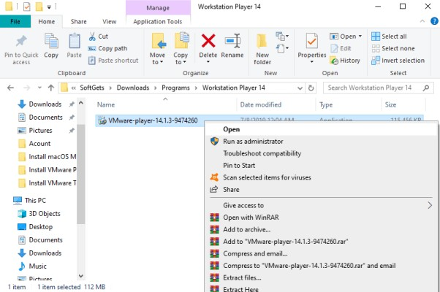

1. Next, you will be guided to the installation wizard page with a summary of information about VMware 14 Player. Whether to continue the installation or Cancel to exit the setup wizard.

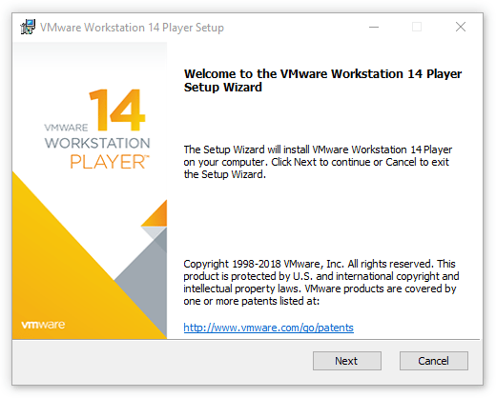

1. Kindly read the end user license agreement carefully. Before commuting to accept the terms.

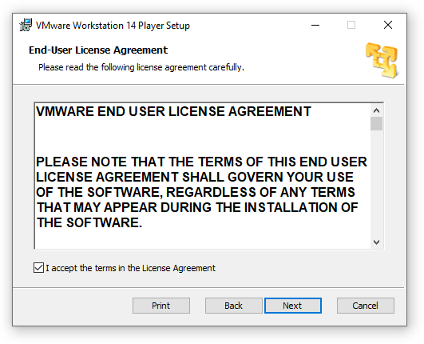

1. You can change the default installation destination folder. To a different drive and folder.

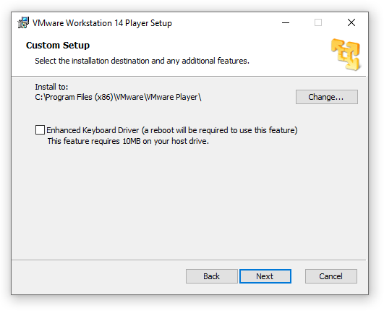

1. Every important part, to be up to date when using any software. You must confirm to check for product update on every startup.

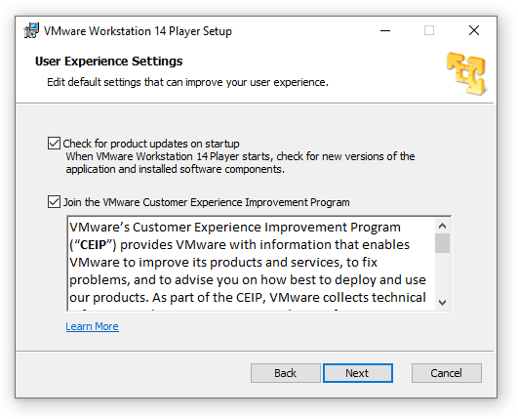

1. Shortcuts will help to access any software quickly. So make sure to create the shortcuts on your desktop even your start menu.

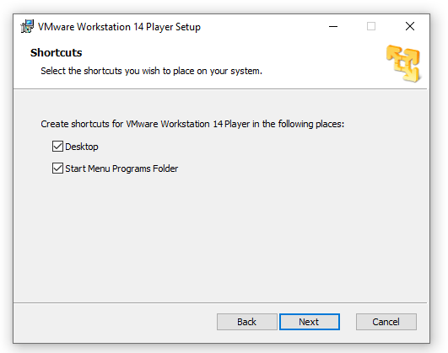

1. Finally, you are a click away to begin the installation after passing the basic steps.

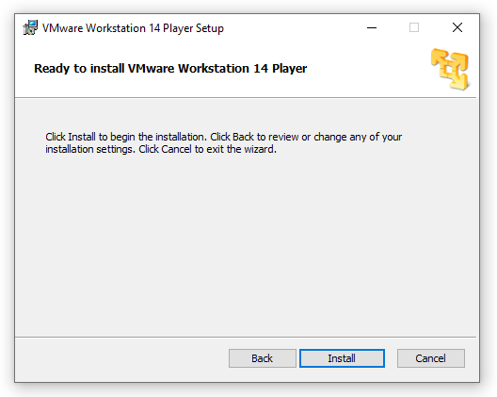

1. Completed VMware Workstation 14 Player installation, click on **Finish**.

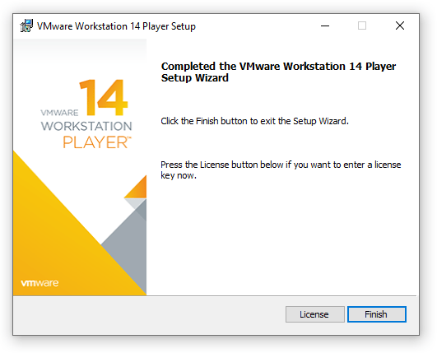

1. After opening VMware Workstation 14 Player. You will see a page asking for the license key. If you have one, but it’s the free version you can select to use as non-commercial. And the product will get you the next page, thanks for using VMware Workstation 14 Player. Click on finish to get into VMware Workstation Player home page.

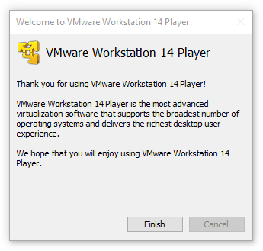

1. You have successfully installed VMware Workstation 14 Player, in your computer. If you are deciding to create a new virtual machine and stall any operating system on VMware on Windows.

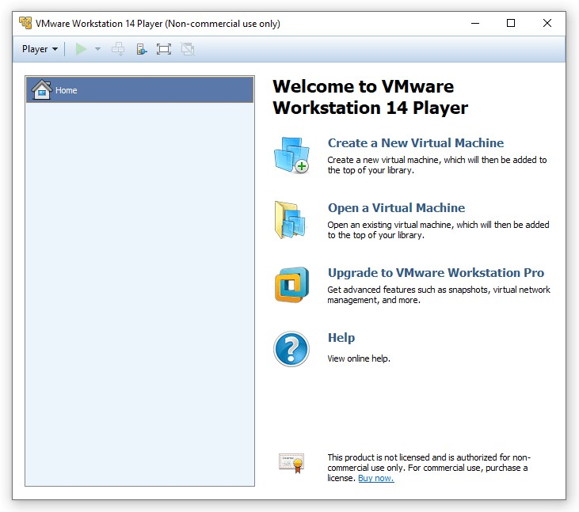

1. How To Create a New Virtual Machine?

Before going to install any operating system on VMware, you have to create a new virtual machine first. Next, you can continue to the installation of any operating system as a guest inside VMware.

To do so, you need to open the VMware Player Application. On the Home Page click on “Create A New Virtual Machine. You will be guided to the page where you have to select how you want to install an operating system.

If you already have an installation media, Such as Windows 10 ISO or Ubuntu ISO, you can select the ISO file and continue.

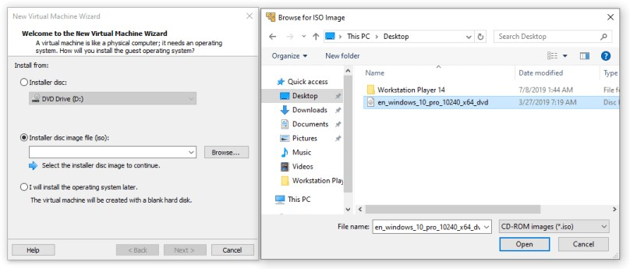Next page, you see the installation information like providing Product Key, Windows 10 Version, Name, and

Password. If you don’t have any product key skip that option and go next.

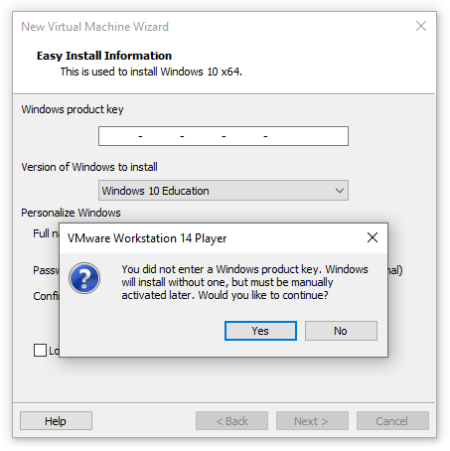

1. Type a name which you would like to use for this virtual machine. And even you can change the location where you want to store.

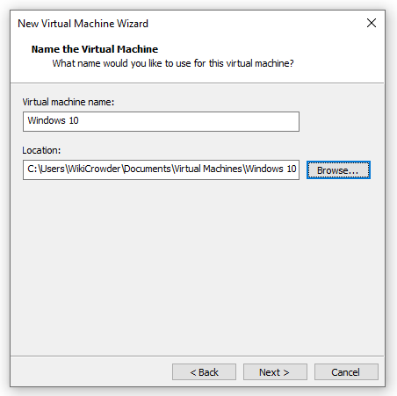

1. Specify the disk capacity of your virtual machine and store the virtual machine file as a single file.

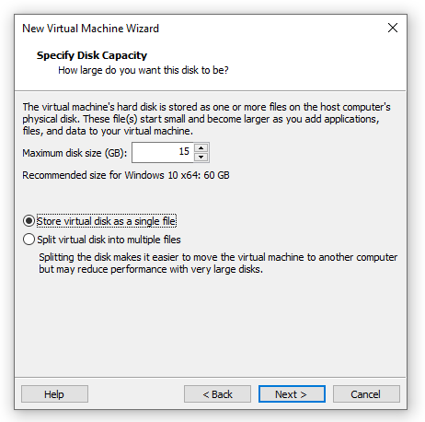

1. Finally, installation is done .Click on finish to create the Windows 10 virtual machine and continue to the installation of windows 10.

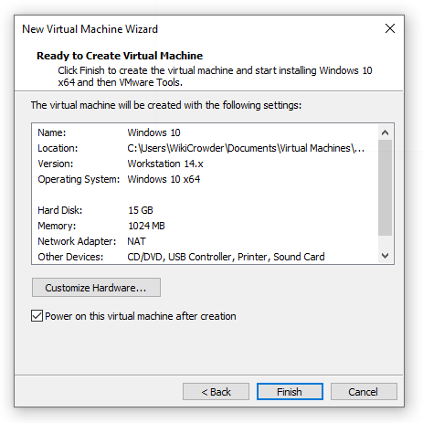

**Result:** Successfully created a new virtual machine.

## Exercise 2. Launching Amazon Linux EC2 Instance

**AIM**: To connect to Amazon Linux instance from Linux and Windows client operating system

## PROCEDURE:

**Amazon EC2:** Amazon Elastic Compute Cloud (Amazon EC2) is a web service that provides secure, resizable compute capacity in the cloud. It is designed to make web-scale computing easier for developers. It is a simple web service interface allows you to obtain and configure capacity with minimal friction.

It provides you with complete control of your computing resources and lets you run on Amazon’s proven computing environment.

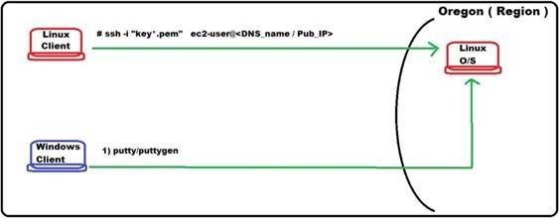,

both up and down, as your computing requirements change.

**Setting Up with Amazon EC2:** Sign Up for AWS : When you sign up for Amazon Web Services (AWS), your AWS account is automatically signed up for all services in AWS, including Amazon EC2.

In the navigation pane first of all you need to choose your region and then click on EC2 in the Compute services.

## ➔Launching Amazon Linux EC2 Instance Step 1: Choose an Amazon Machine Image (AMI)

An AMI is a template that contains the software configuration (operating system, application server, and applications) required to launch your instance. You can select an AMI provided by AWS, our user community, or the AWS Marketplace; or you can select one of your own AMIs.

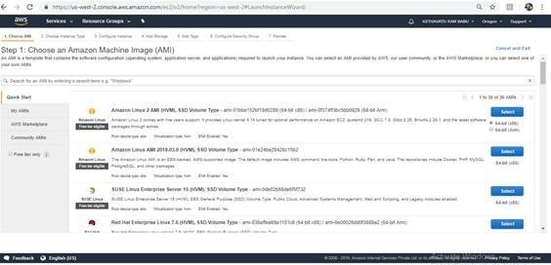

Select-> Ubuntu Server 18.04 LTS (HVM), SSD Volume Type - ami- 0bbe6b35405ecebdb (64-bit x86) / ami-0db180c518750ee4f (64-bit Arm).

## Step 2: Choose an Instance Type Amazon

EC2 provides a wide selection of instance types optimized to fit different use cases. Instances are virtual servers that can run applications. They have varying combinations of CPU, memory, storage, and networking capacity, and give you the flexibility to choose the appropriate mix of resources for your applications.

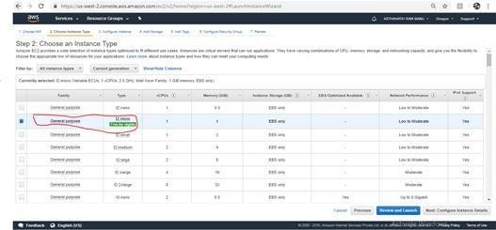

Select à Next: Configure Instance Details

## Step 3: Configure Instance Details

Configure the instance to suit your requirements. You can launch multiple instances from the same AMI, request Spot instances to take advantage of the lower pricing, assign an access management role to the instance, and more.

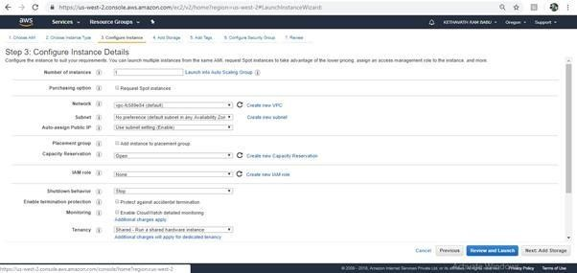

Select à Based on your requirement select instance type and subnet .

## Step 4: Add Storage

Your instance will be launched with the following storage device settings. You can attach additional EBS volumes and instance store volumes to your instance, or edit the settings of the root volume. You can also attach additional EBS volumes after launching an instance, but not instance store volumes

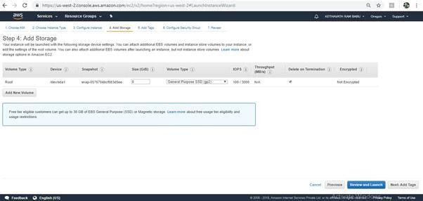

## Step 5: Add Tags

A tag consists of a case-sensitive key-value pair. For example, you could define a tag with key = Name and value = Webserver.

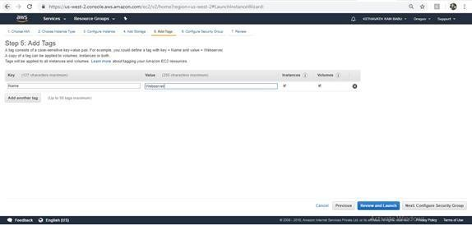

## Step 6: Configure Security Group

A security group is a set of firewall rules that control the traffic for your instance. On this page, you can add rules to allow specific traffic to reach your instance. For example, if you want to set up a web server and allow Internet traffic to reach your instance, add rules that allow unrestricted access to the HTTP and HTTPS ports. You can create a new security group or select from an existing one .

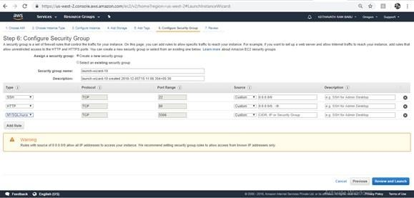

**Click on -> Review and launch Step 7:** Review Instance Launch

Please review your instance launch details. You can go back to edit changes for each section. Click Launch to assign a key pair to your instance and complete the launch process.

## Create a Key Pair:

Before launching your instance AWS uses public-key cryptography to secure the login information for your instance. A Linux instance has no password; you use a key pair to log in to your instance securely. You specify the name of the key pair when you launch your instance, then provide the private key when you login using SSH. If you haven't created a key pair already, you can create one using the Amazon

EC2 console. From the navigation bar, select a region for the key pair. You can select any region that's available to you, regardless of your location. However, key pairs are specific to a region; for example, if you plan to launch an instance in the US East (Ohio) Region, you must create a key pair for the instance in the US East (Ohio) Region.

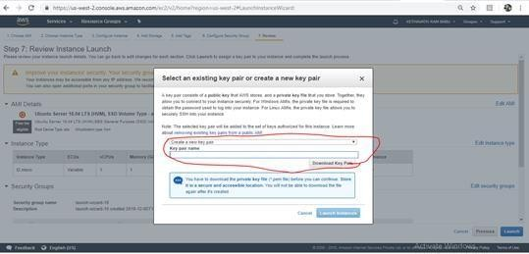

To connect to your instance using your key pair To connect to your Ubuntu instance from a computer running Mac or Linux, you'll specify the .pem file to your SSH client with the -i option and the path to your private key.

## To connect to Amazon Linux instance from linux client operating system Command:

**$ ssh -i key.pem** [**ubuntu@ec2-35-164-184-80.us-west-2.compute.amazonaws.com**](mailto:ubuntu@ec2-35-164-184-80.us-west-2.compute.amazonaws.com)

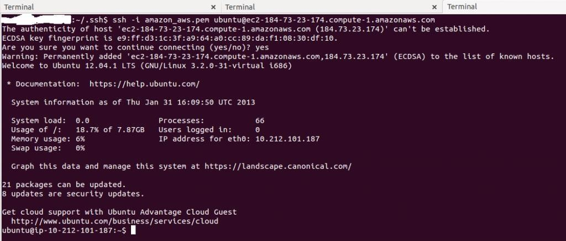Select your instance and make sure your key (pem file) matches your key pair name

## To connect to Amazon Linux instance from Windows client operating system

To connect to your Ubuntu instance from a computer running Windows, you can use either MindTerm or PuTTY. If you plan to use PuTTY, you'll need to install it and use the following procedure to convert the .pem file to a .ppk file(for generation of PPK file Install Puttygen)

Download PuTTY:

[https://www.chiark.greenend.org.uk/~sgtatham/putty/latest.html.](https://www.chiark.greenend.org.uk/~sgtatham/putty/latest.html)

To prepare to connect to a Ubuntu instance from Windows using PuTTY

,**CONVERT YOUR PEM FILE TO PPK FORMAT**

1. Open puttygen and load the pem file into the puttygen

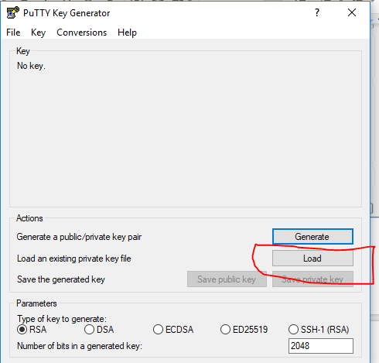

1. Save the private key by assigning a name to that file

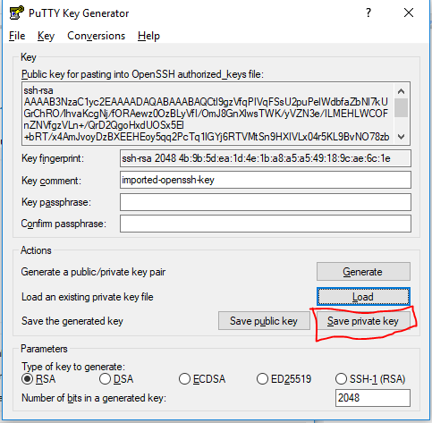

> Open Putty

i. Enter Host Name ii.Select your PPK file.

1. Open your terminal Session

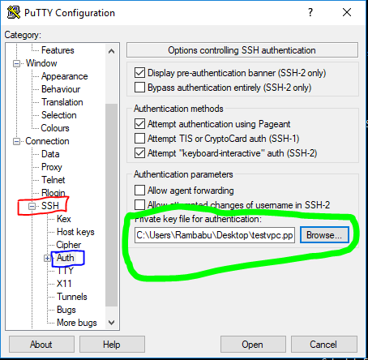

Installing a LAMP Web Server on Amazon

To install and start the LAMP web server on Amazon Ubuntu .

* 1. Connect to your instance in putty

## User name: ubuntu or ec2-user

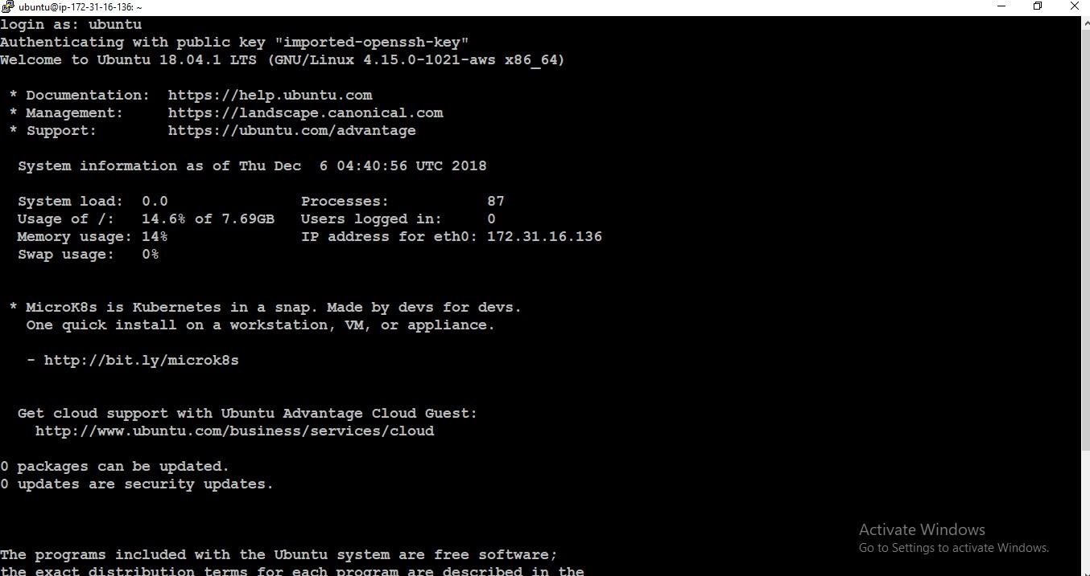

* 1. To ensure that all of your software packages are up to date, perform a quick software update on your instance. **$ sudo apt-get update**

1. Now that your instance is current, you can install the Apache web server, MySQL, and PHP software packages. **$ sudo apt-get install php7 mysql-server php7- mysqlnd**
2. Restart the Apache web server. **$ sudo /etc/init.d/apache2 restart**
3. Also start all the web servers by executing its commands
4. If your server is installed and running, and your file permissions are set correctly, your ec2- user account should be able to create a PHP file in the /var/www/html directory that is available from the internet e.g: 54.187.117.10
5. 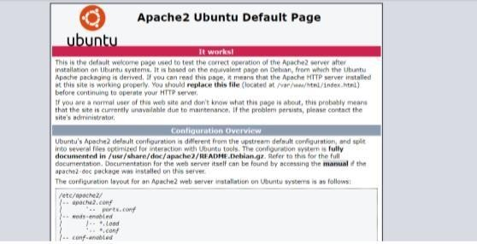In the web browser, type the URL of the file that you just created. This URL is the public DNS or ip address of your instance followed by a forward slash and the file name.

## Exercise 3: To Launch Windows EC2 instance in AWS

**AIM**: To connect to Amazon Windows instance from Linux client operating system

## PROCEDURE:

Amazon EC2 instances created from most Windows Amazon Machine Images (AMIs) enable you to connect using Remote Desktop. Remote Desktop uses the Remote Desktop Protocol (RDP) and enables you to connect to and use your instance in the same way you use a computer sitting in front of you. It is available on most editions of Windows and available for Mac OS.

-> To Launch Windows EC2 instance

**Step 1:** An AMI is a template that contains the software configuration (operating system, application server, and applications) required to launch your instance. You can select an AMI provided by AWS, our user community, or the AWS Marketplace; or you can select one of your own AMIs.

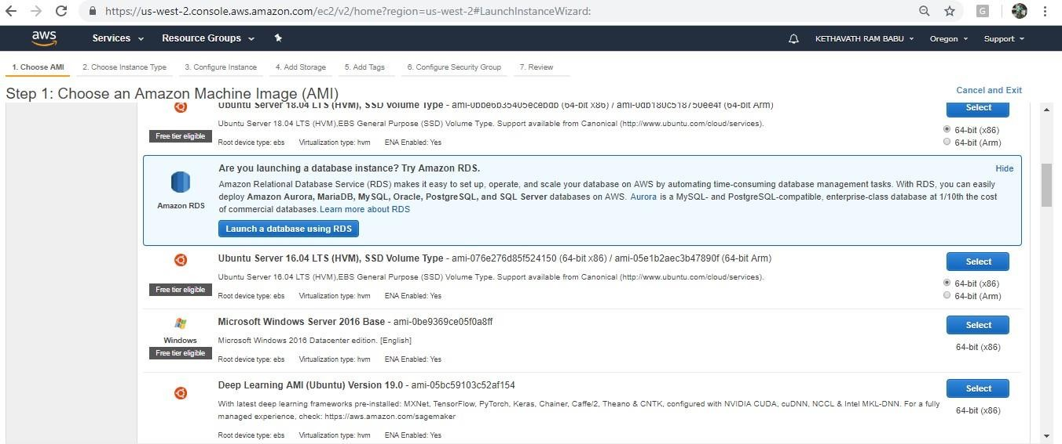

**Select -> Microsoft Windows Server 2016 Base - ami-0be9369ce05f0a8ff**

Step 2: Choose an Instance Type

Amazon EC2 provides a wide selection of instance types optimized to fit different use cases. Instances are virtual servers that can run applications. They have varying combinations of CPU, memory, storage, and networking capacity, and give you the flexibility to choose the appropriate mix of resources for your applications.

Step 3: Configure Instance Details

Configure the instance to suit your requirements. You can launch multiple instances from the same AMI, request Spot instances to take advantage of the lower pricing, assign an access management role to the instance.

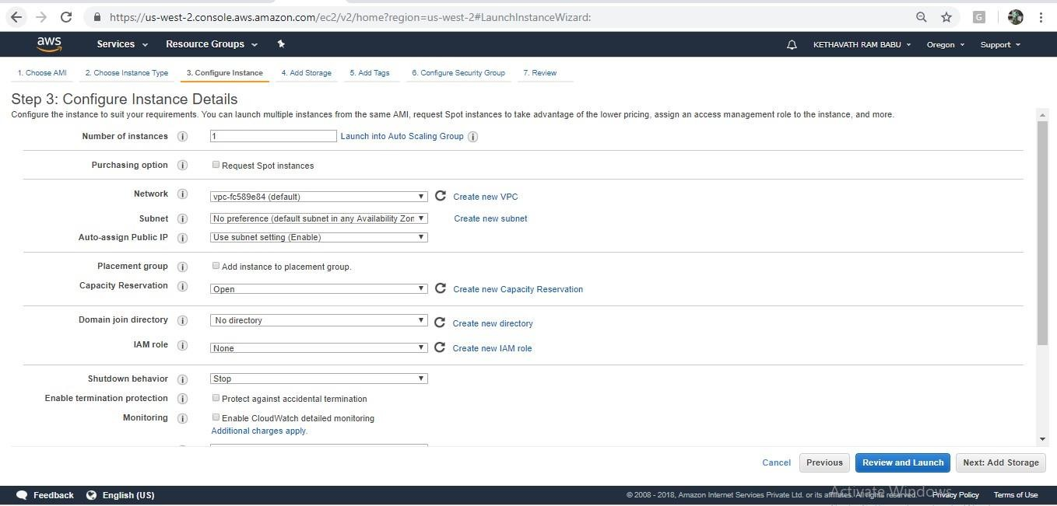

Step 4: Add Storage

Your instance will be launched with the following storage device settings. You can attach additional EBS volumes and instance store volumes to your instance, or edit the settings of the root volume. You can also attach additional EBS volumes afterlaunching an instance, but not instance store volumes.(Free tier eligible customers can get up to 30 GB of EBS General Purpose (SSD) or Magnetic storage.)

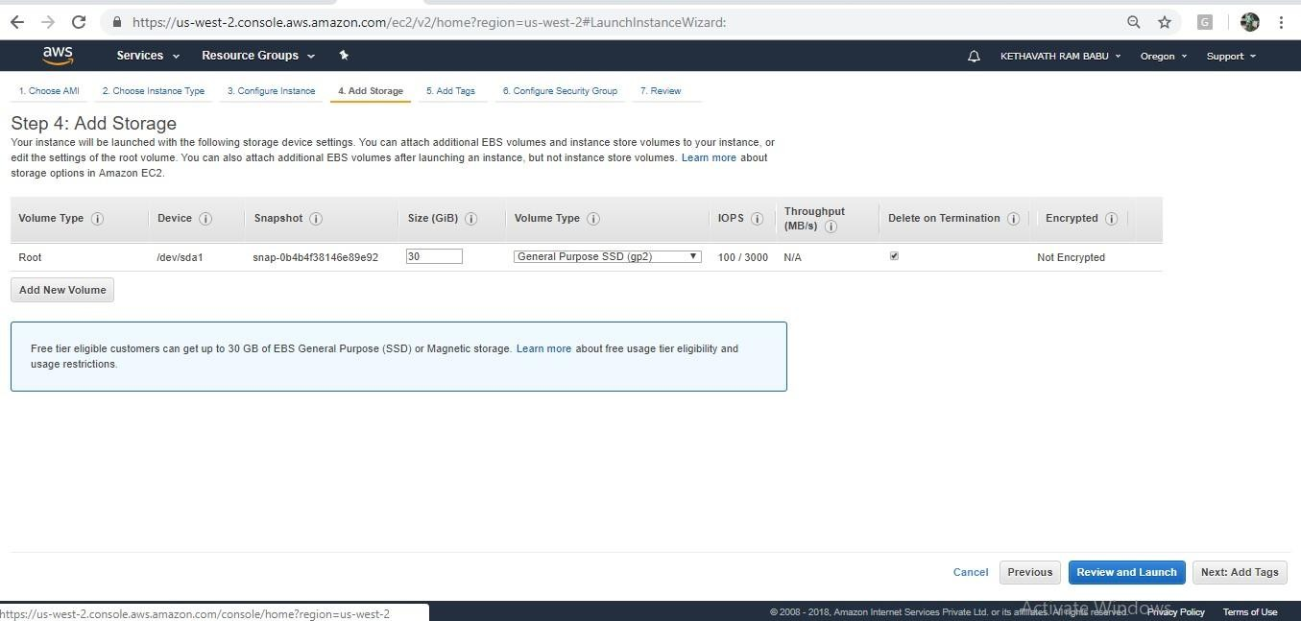Step 5: Add Tags A tag consists of a case-sensitive key-value pair. For example, you could define a tag with key = Name

and value = Webserver.A copy of a tag can be applied to volumes, instances or both.Tags will be applied to all instances and volumes.

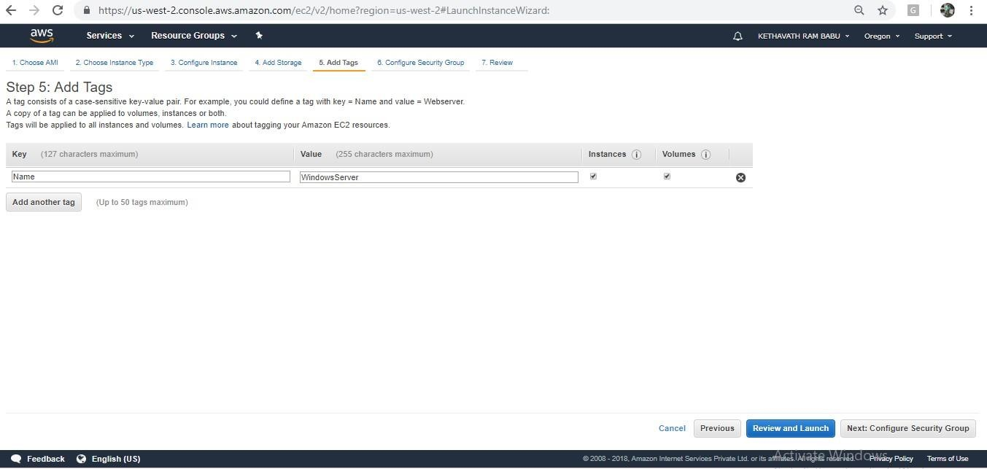

Step 6: Configure Security Group

A security group is a set of firewall rules that control the traffic for your instance. On this page, you can add rules to allow specific traffic to reach your instance. For example, if you want to set up a web server and allow Internet traffic to reach your instance, add rules that allow unrestricted access to the HTTP and HTTPS ports. You can create a new security group or select from an existing one below. If want to launch a windows remote desktop, allow the port RDP with port range- 3389.

Step7:Review Instance Launch

Please review your instance launch details. You can go back to edit changes for each section. Click **Launch**

to assign a key pair to your instance and complete the launch process.

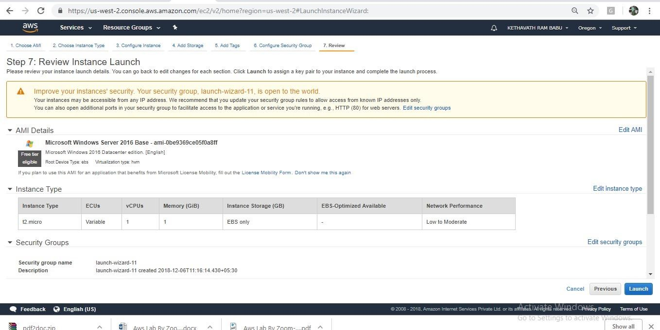

## To connect to Amazon Windows instance from linux client operating system

Login to client operating system

-> Open linux terminal

## Note: rdesktop or xfreerdp { RHEL-6,7 } package should be installed

**$ rdesktop -u Administrator <Pub_DNS_name/Public_IP>**

Or

## $ xfreerdp -u Administrator <Pub_DNS_name/Public_IP>

In **{ RHEL-6,7 } ->**

**-u -> user name**

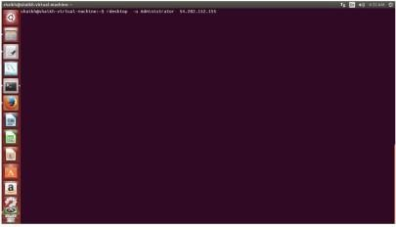

**Click on Administrator and Provide the password and click on verify**

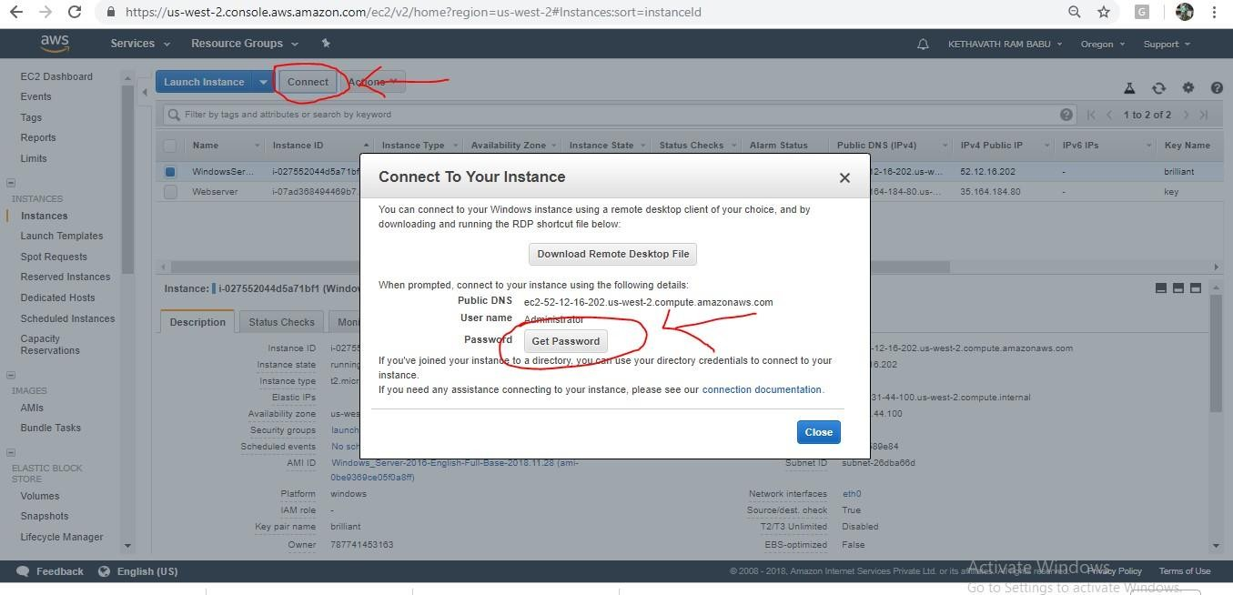

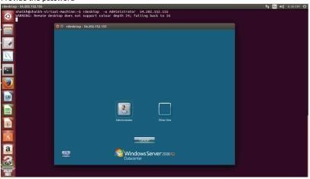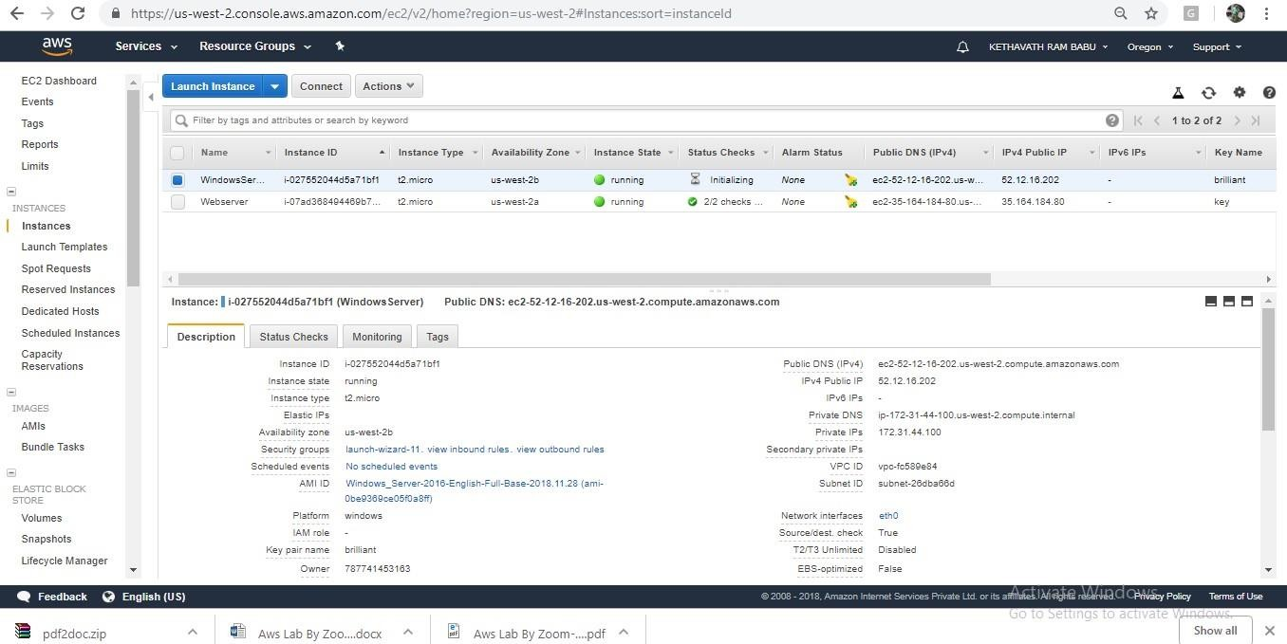

**Once logged in Windows, Desktop is available.{ If you are going to use the instance,terminate the instance }**

* 1. **To connect Windows instance from Windows client operating system**

->In the navigation pane, under Instances, choose Instances.

Browse to and choose your Windows Server instance in the list.

-> Choose **Connect** and click on **Get Password**

**->** Choose **Browse**. Browse to and choose the Amazon EC2 instance **key pair** file associated with the Windows Server Amazon EC2 instance, and then choose Open

.->Choose **Decrypt Password**. Make a note of the password that is displayed. Later You need it.

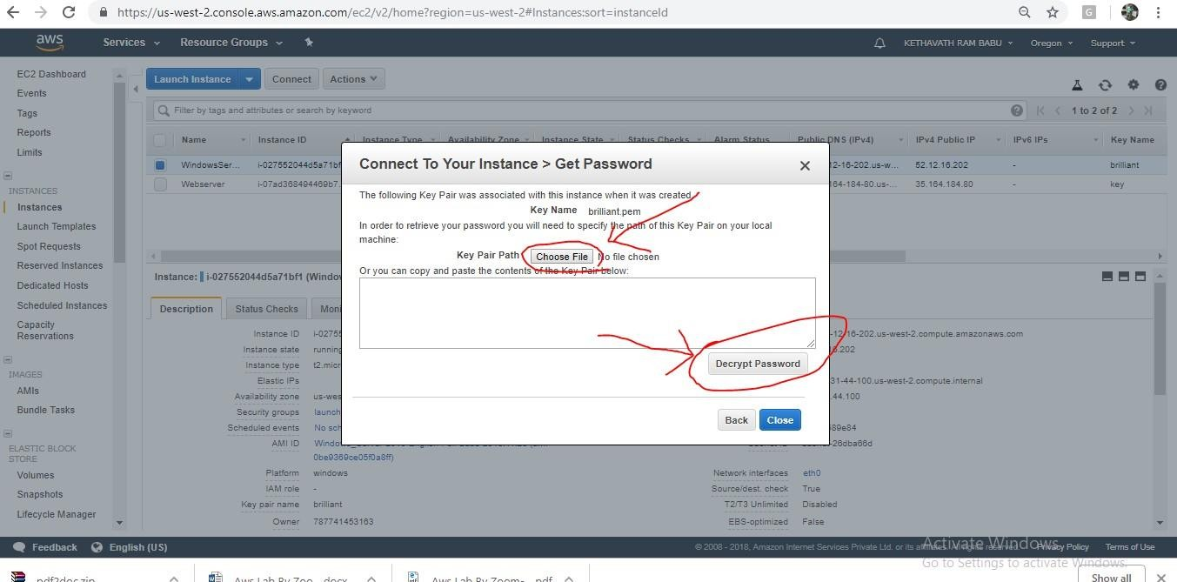

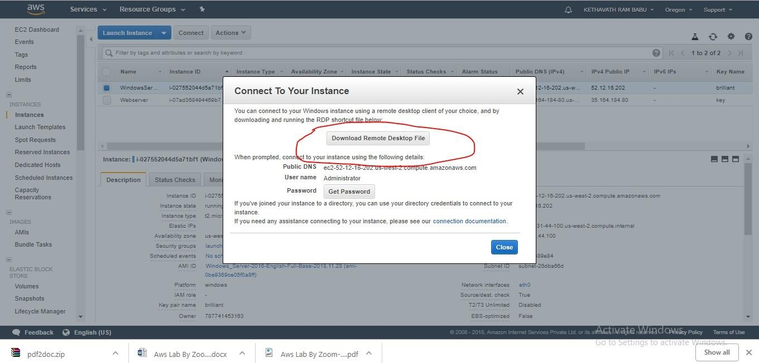

-> Choose **Download Remote Desktop File**, and then open the file.

-> f you are prompted to connect even though the publisher of the remote connection can't be identified, proceed.

->Type the password you noted in step 7, and then proceed. (If your RDP connection client application prompts you for a user name, type **Administrator**.)

->If you are prompted to connect even though the identity of the remote computer cannot be verified, proceed.

->After you are connected, the desktop of the Amazon EC2 instance running Windows Server is

displayed.

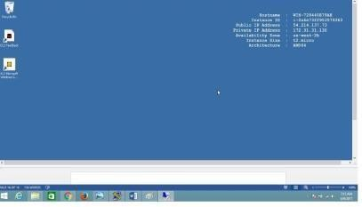

**Exercise 4: To configure Web Server on Amazon Linux instance with Elastic IP. AIM:** To configure Web Server on Amazon Linux instance with Elastic IP. **PROCEDURE:**

Amazon EC2 Instance IP Addressing

Amazon EC2 and Amazon VPC support both the IPv4 and IPv6 addressing protocols. By default, Amazon EC2 and Amazon VPC use the IPv4 addressing protocol; you can't disable this behavior. When you create a VPC, you must specify an IPv4 CIDR block (a range of private IPv4 addresses). You can optionally assign an IPv6 CIDR block to your VPC and subnets, and assign IPv6 addresses from that block to instances in your subnet. IPv6 addresses are reachable over the Internet. Private IPv4 Addresses and Internal DNS Hostnames

A private IPv4 address is an IP address that's not reachable over the Internet. You can use private IPv4 addresses for communication between instances in the same VPC.

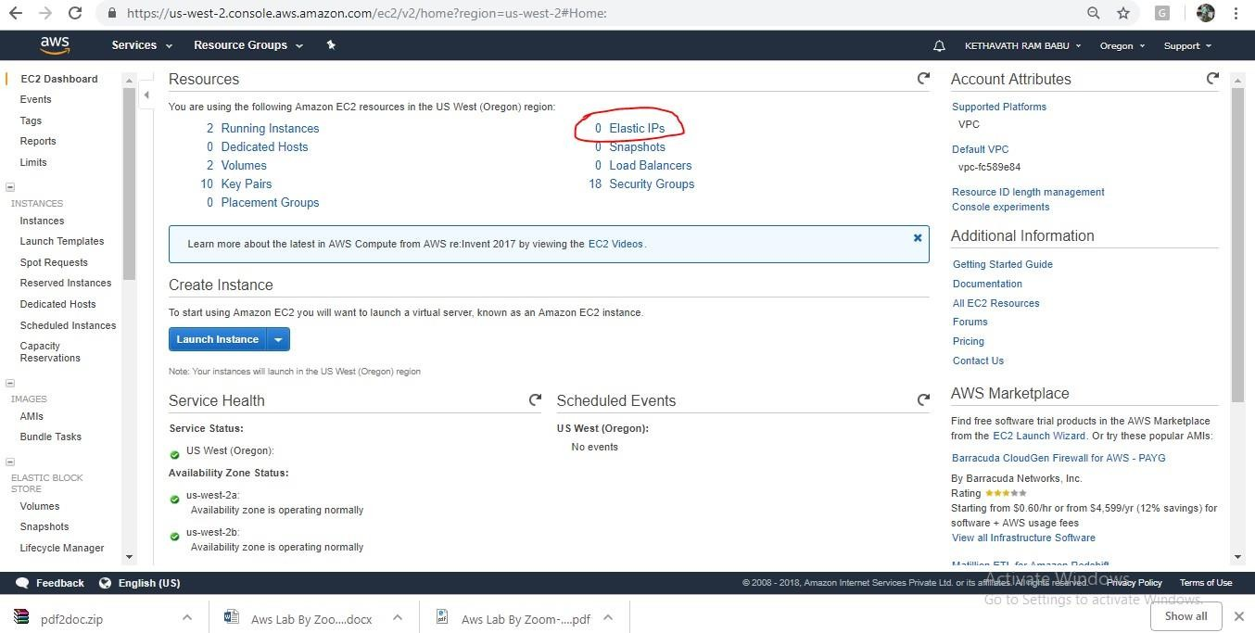

Public IPv4 Addresses and External DNS Hostnames

A public IP address is an IPv4 address that's reachable from the Internet. You can use public addresses for communication between your instances and the Internet.

**Exercise 5: To Assign Elastic IP address AIM:** To Assign Elastic IP address **PROCEDURE:**

Elastic IP Add

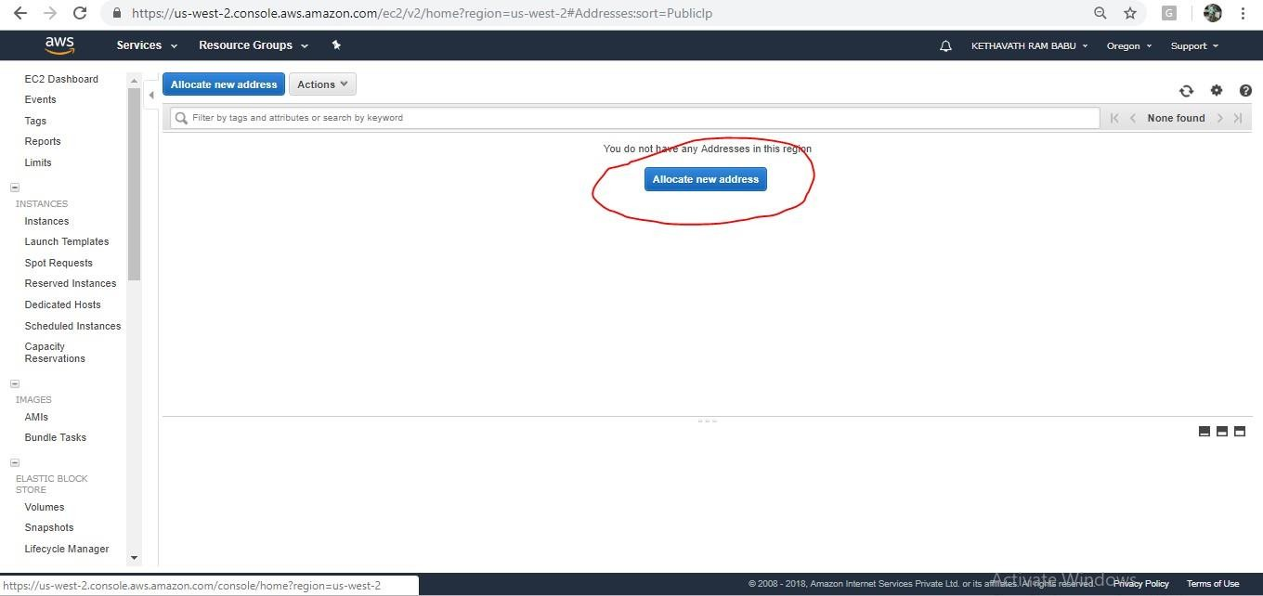resses

(IPv4)

An Elastic IP address is a public IPv4 address that you can allocate to your account. You can associate it to and from instances as you require, and it's allocated to your account until you choose to release it.

To allocate an Elastic IP and associate it with an Amazon Web Services (AWS) instance, do the following:

1. i. Open the AWS Management Console, click the EC2 link, and display the page associated with

your region.Click the **Elastic IPs** link in the **EC2 Dashboard**.



1. Click **Allocate New Address** and choose **VPC** or **EC2** from the drop-down list, depending whether you're going to associate this IP with an instance in Amazon EC2-Virtual Private Cloud (VPC) or Amazon EC2-Classic, respectively. Click **Yes, Allocate** to confirm your choice.

v. Choose your desired instance to associate Elastic IP.

Click on associate, now your instance has been associated with instance.

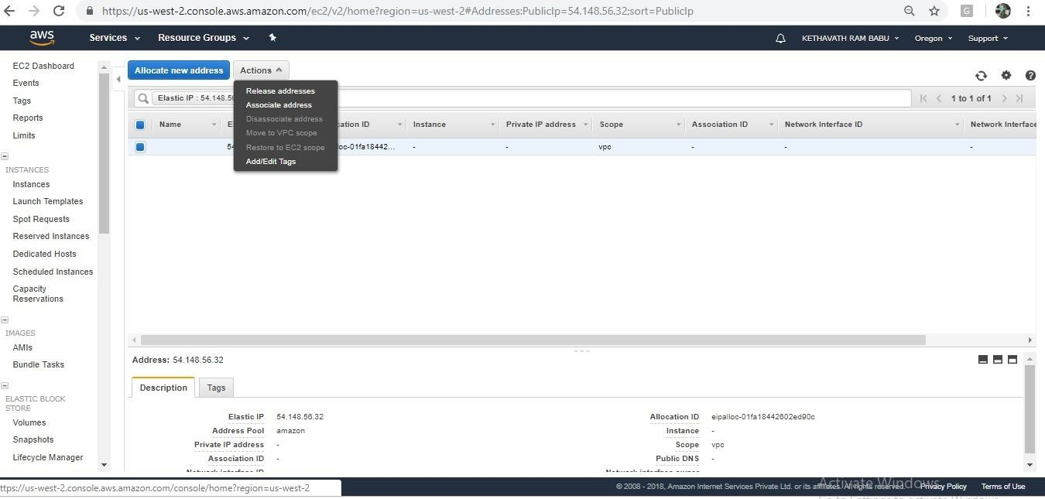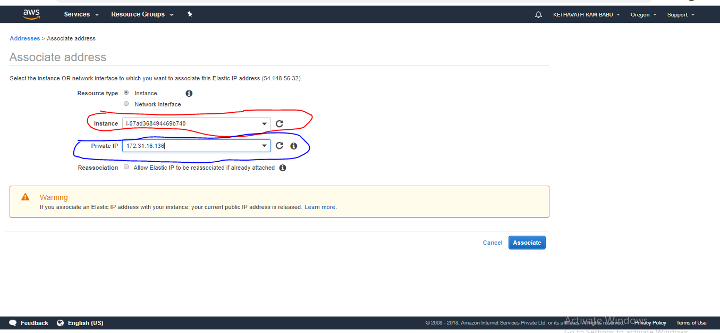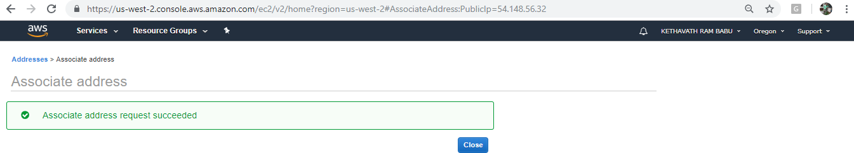

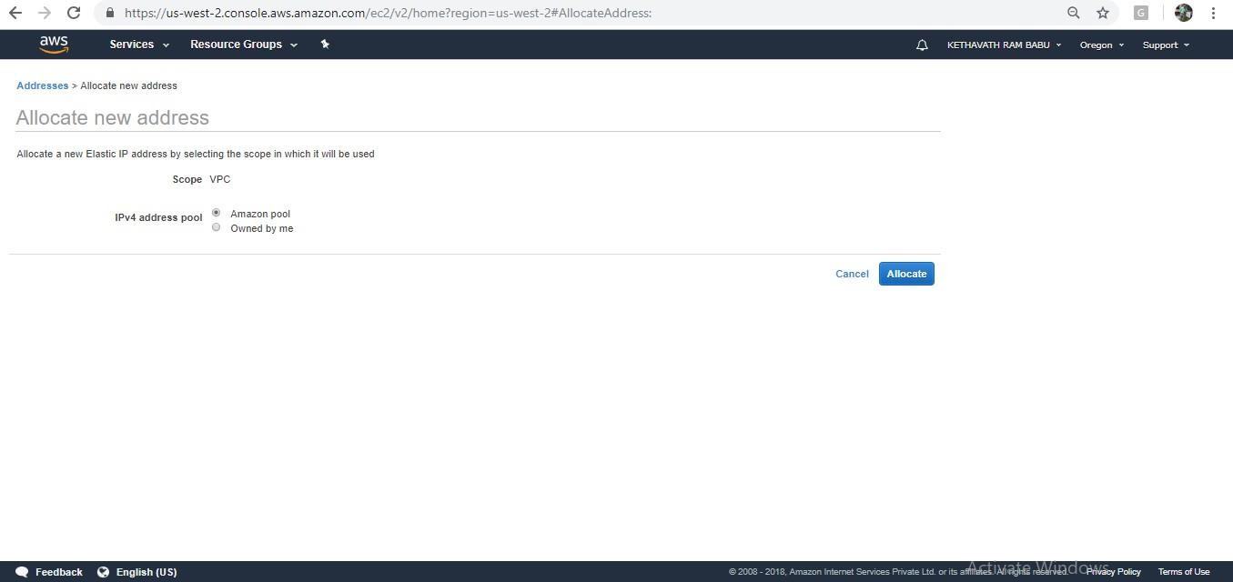

1. Right-click the newly created Elastic IP and choose **Associate Address**.
2. Choose your desired EC2 instance from the drop-down list of running instances and click

**Associate**.

To release Elastic IP

Open the console EC2 Dashboard

Select **Elastic IP** and click on **Action** button Select Disassociate Address

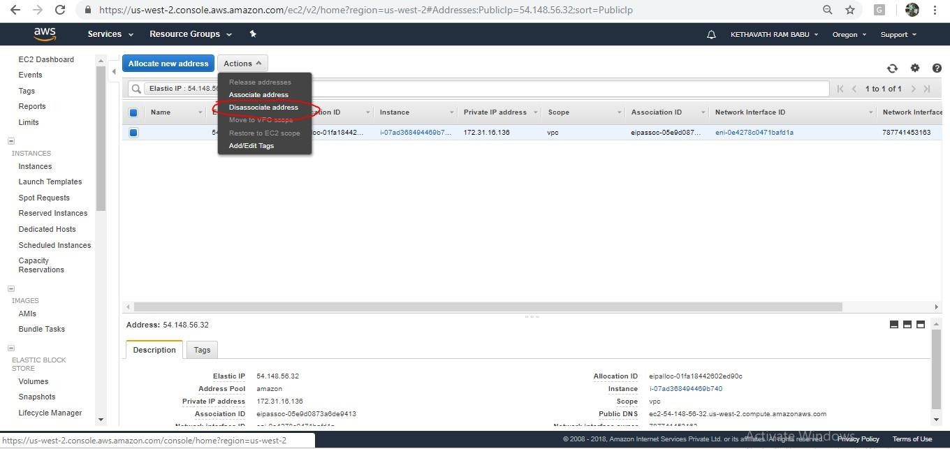

Click on Disassociate address

Click On Action Button and then click on Release Address

## Exercise 6: To Configure Amazon Simple Storage Service (Amazon s3)

**AIM:** To Configure Amazon Simple Storage Service (Amazon s3)

## PROCEDURE:

**Amazon Simple Storage Service** is storage for the Internet. It is designed to make web-scale computing easier for developers. Amazon S3 has a simple web services interface that you can use to store and retrieve any amount of data, at any time, from anywhere on the web. It gives any developer access to the same highly scalable, reliable, fast, inexpensive data storage infrastructure that Amazon uses to run its own global network of websites. The service aims to maximize benefits of scale and to pass those benefits on to developers.

**Amazon s3 Bucket**. A bucket is a logical unit of storage in Amazon Web Services (AWS) object storage service, Simple Storage Solution S3. Buckets are used to store objects, which consist of data and metadata that describes the data.

When you subscribe to the data feed, you must specify an Amazon S3 bucket to store the data feed files. Before you choose an Amazon S3 bucket for the data feed, consider the following: You must use a bucket from the US East. You must have FULL_CONTROL permission to the bucket.

If you're the bucket owner, you have this permission by default. Otherwise, the bucket owner must grant your AWS account this permission.

When you create your data feed subscription, Amazon S3 updates the ACL of specified bucket to allow the AWS data feed account read and write permissions

Removing the permissions for the data feed account does not disable the data feed. If you remove those permissions but don't disable the data feed, we restore those permissions the next time that the data feed account needs to write to the bucket.

Each data feed file has its own ACL. The bucket owner has FULL_CONTROL permission to the data files. The data feed account has read and write permissions. If you delete your data feed subscription, Amazon EC2 doesn't remove the read and write permissions for the data feed account on either the bucket or the data files. You must remove these permissions yourself.

To create an S3 bucket

* 1. Sign in to the AWS Management Console and open the Amazon S3 console

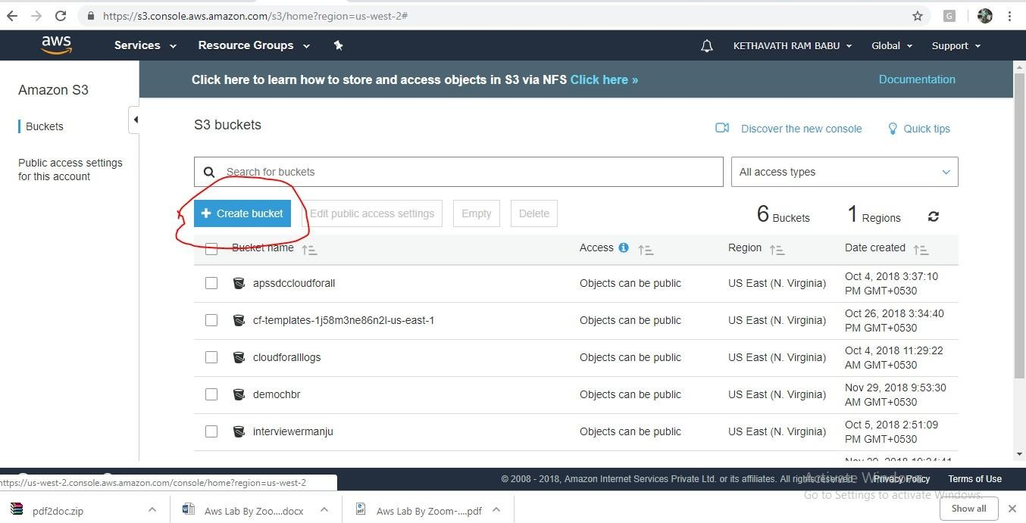

* 1. Choose Create bucket.

The bucket name you choose must be globally unique across all existing bucket names in Amazon S3 (that is, across all AWS customers).

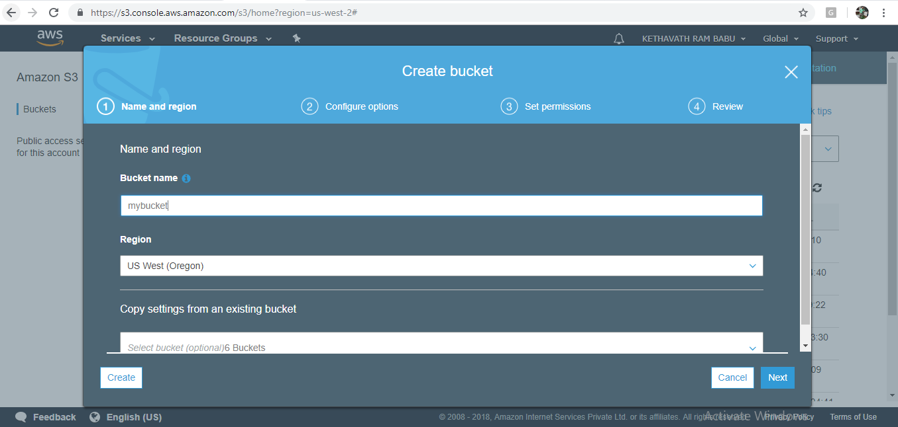

In **Region**, choose **Region** and Click on **Create**.

When Amazon S3 successfully creates your bucket, the console displays your empty bucket in the **Buckets** pane

## Step 2: Upload a File to Your Amazon S3 Bucket

Now that you've created a bucket, you're ready to add an object to it. An object can be any kind of file: a document, a photo, a video, a music file, or other file type.

* + 1. In the Amazon S3 console, choose the bucket where you want to upload an object, choose **Upload**, and then choose **Add Files**.

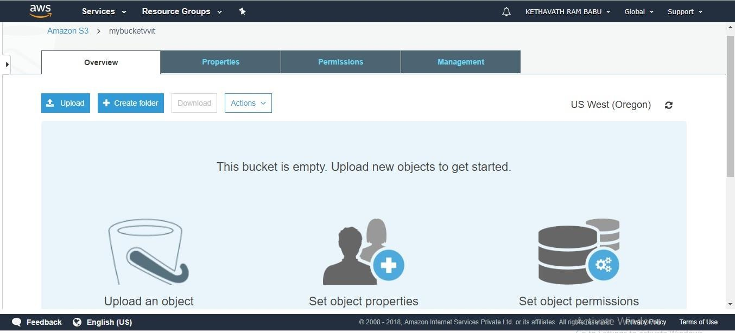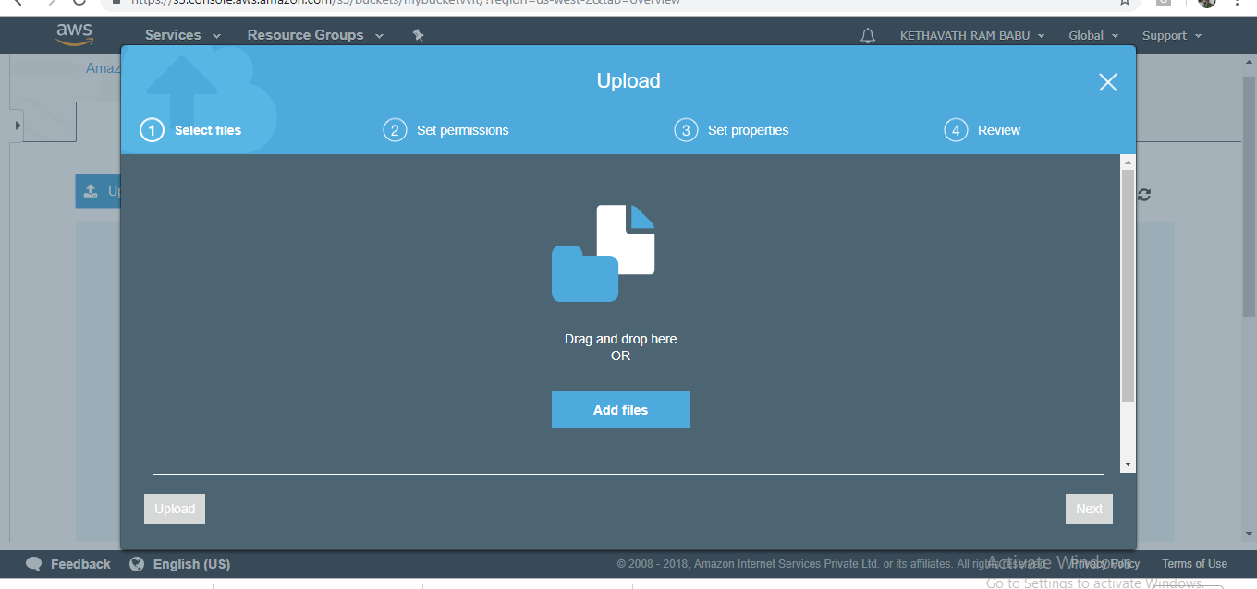

In the **Upload** dialog box, do one of the following:

* + - 1. Drag and drop more files and folders to the console window that displays the **Upload** dialog box. To add more files, you can also choose **Add more files**. This option works *only* for files, not folders.
      2. To immediately upload the listed files and folders without granting or removing permissions for specific users or setting public permissions for all of the files that you're uploading, choose **Upload**.
      3. To set permissions or properties for the files that you are uploading, choose

**Next**.

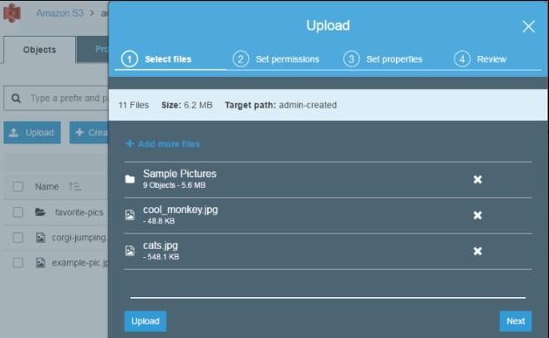

-> On the **Set Permissions** page, under **Manage users** you can change the permissions for the AWS account owner. The *owner* refers to the AWS account root user, and not an AWS Identity and Access Management (IAM) user.

->Under **Manage public permissions** you can grant read access to your objects to the general public (everyone in the world), for all of the files that you're uploading. Granting public read access is applicable to a small subset of use cases such as when buckets are used for websites. We recommend that you do not change the default setting of **Do not grant public read access to this object(s)**. You can always make changes to object permissions after you upload the object.

-> When you're done configuring permissions, choose **Next**.

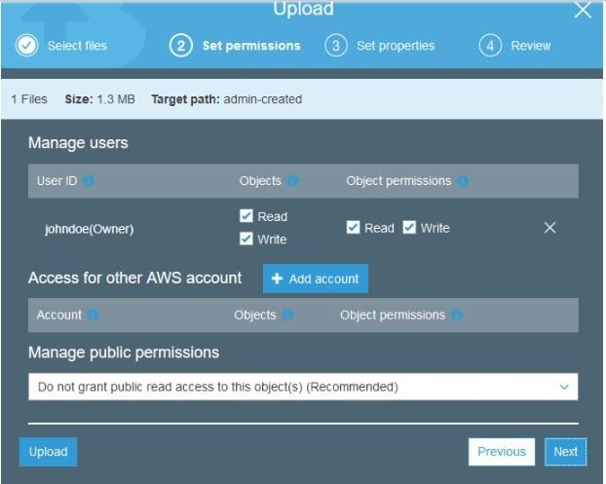

On the **Set Properties** page, choose the storage class and encryption method to use for the files that you are uploading. You can also add or modify metadata.

Choose a storage class for the files you're uploading.

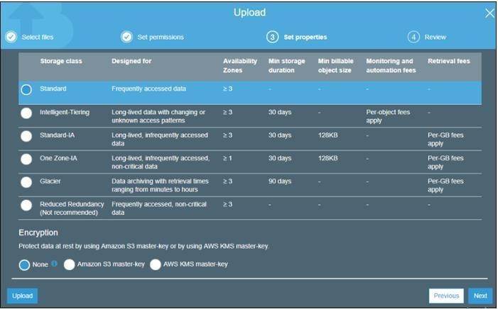

Choose the type of encryption for the files that you're uploading. If you don't want to encrypt them, choose **None**.

1. To encrypt the uploaded files using keys that are managed by Amazon S3, choose **Amazon S3 master-key**.
2. To encrypt the uploaded files using the AWS Key Management Service (AWS KMS), choose **AWS KMS master-key**. Then choose a master key from the list of AWS KMS master keys.

**Note**

To encrypt objects in a bucket, you can use only keys that are available in the same AWS Region as the bucket.

You can give an external account the ability to use an object that is protected by an AWS KMS key. To do this, select **Custom KMS ARN** from the list and enter the Amazon Resource Name (ARN) for the external account. Administrators of an external account that have usage permissions to an object protected by your AWS KMS key can further restrict access by creating a resource-level IAM policy.

Metadata for Amazon S3 objects is represented by a name-value (key-value) pair. There are two kinds of metadata: system-defined metadata and user-defined metadata.

If you want to add Amazon S3 system-defined metadata to all of the objects you are uploading, for **Header**, select a header. You can select common HTTP headers, such as **Content-Type** and **Content-Disposition**. Type a value for the header, and then choose **Save**.

Any metadata starting with prefix x-amz-meta- is treated as user-defined metadata. User- defined metadata is stored with the object, and is returned when you download the object.

To add user-defined metadata to all of the objects that you are uploading, type x- amz- meta- plus a custom metadata name in the **Header** field. Type a value for the header, and then choose **Save**. Both the keys and their values must conform to US- ASCII standards. User-defined metadata can be as large as 2 KB.

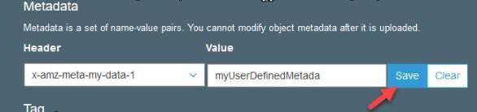

Object tagging gives you a way to categorize storage. Each tag is a key-value pair. Key and tag values are case sensitive. You can have up to 10 tags per object.

To add tags to all of the objects that you are uploading, type a tag name in the **Key** field. Type a value for the tag, and then choose **Save**. A tag key can be up to 128 Unicode characters in length and tag values can be up to 255 Unicode characters in length.

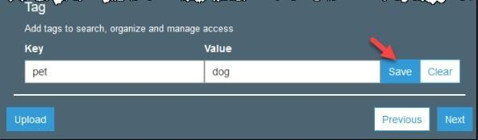

* Choose **Next**.
* On the **Upload** review page, verify that your settings are correct, and then choose

**Upload**. To make changes, choose **Previous**.

To see the progress of the upload, choose **In progress** at the bottom of the browser window.

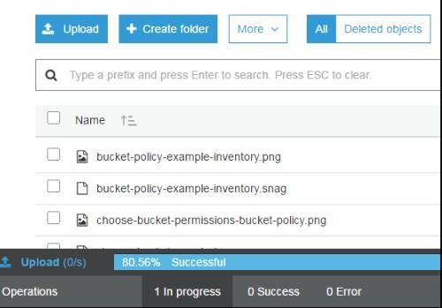

To see a history of your uploads and other operations, choose **Success**.

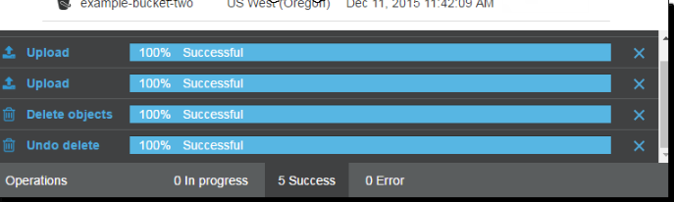

## Hosting a Static Website on Amazon S3

You can host a static website on Amazon Simple Storage Service (Amazon S3). On a static website, individual web pages include static content. They might also contain client-side scripts. By contrast, a dynamic website relies on server-side processing, including server-side scripts such as PHP, JSP, or ASP.NET. Amazon S3 does not support server-side scripting.

➔ To host a static website, you configure an Amazon S3 bucket for website hosting, and then upload your website content to the bucket. This bucket must have public read access. It is intentional that everyone in the world will have read access to this bucket. The website is then available at the AWS Region- specific website endpoint of the bucket,

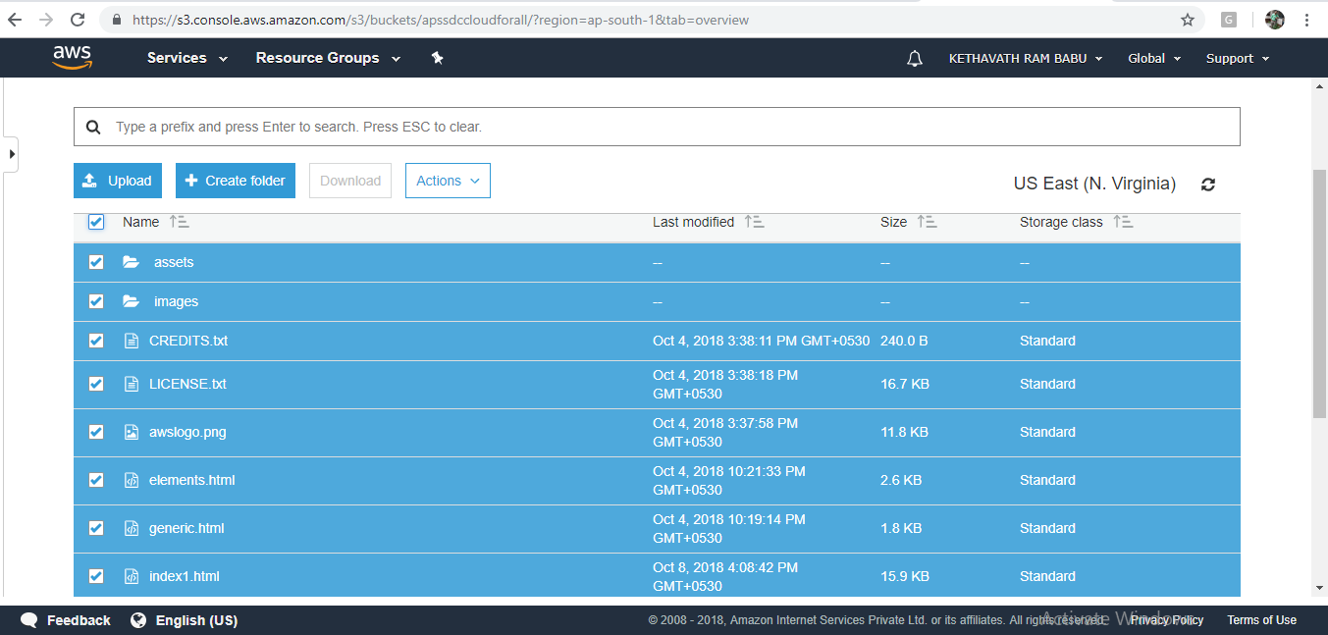

➔ After successful completion of code uploaded to S3, then select all object in bucket make it as public as shown below slide,

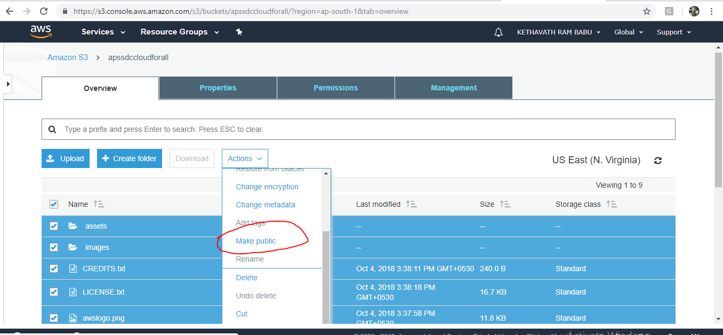➔

-->Open the bucket **Properties** pane, choose **Static Website Hosting**, and do the following:

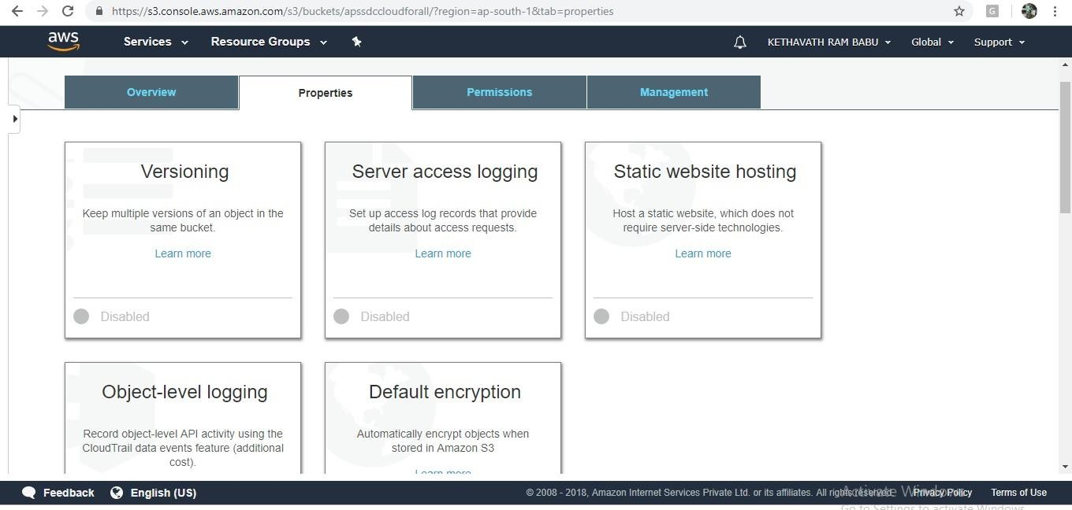

➔ Choose **Use this bucket to host a website**.

➔ In the **Index Document** box, type the name of your index document. The name is typically index.html.

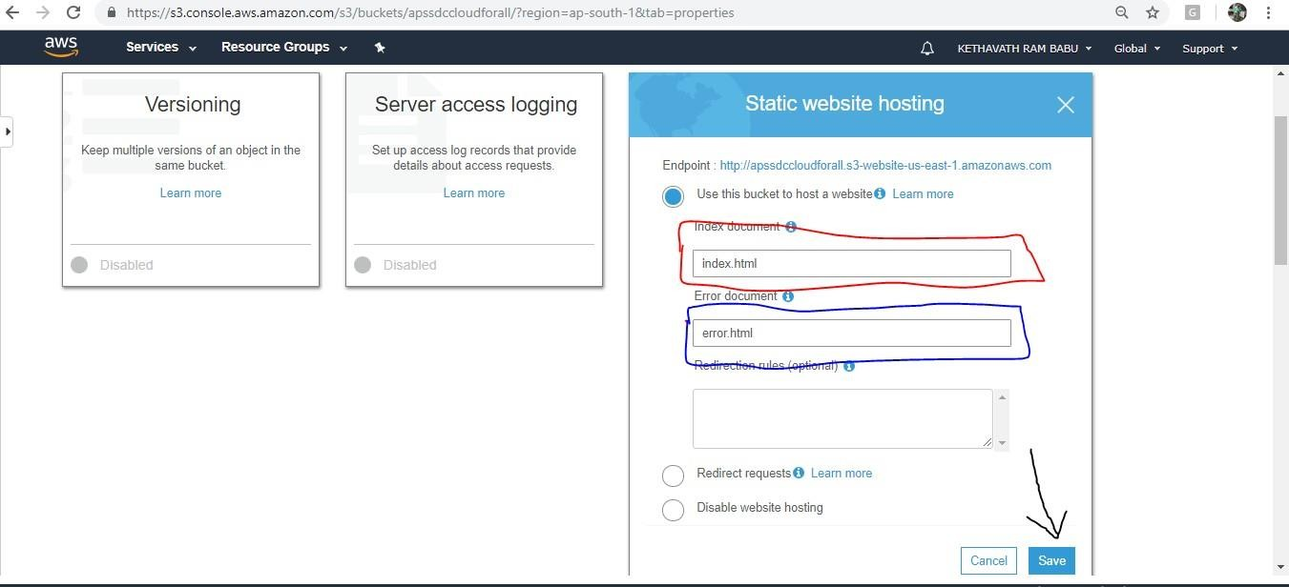

➔ Choose **Save** to save the website configuration.

➔ Write down the **Endpoint**.

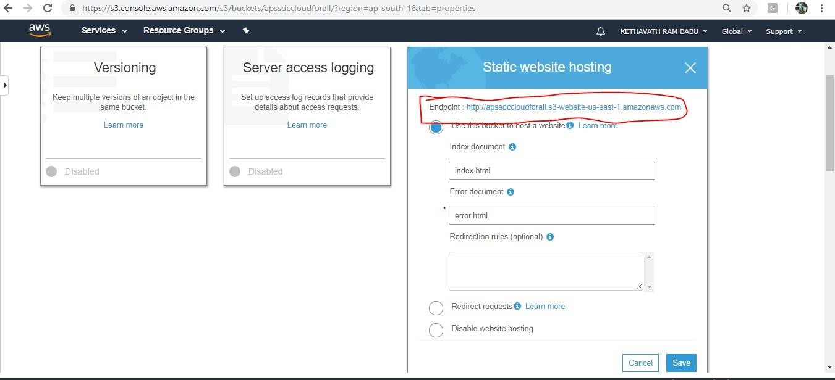

## Step 2: Adding a Bucket Policy That Makes Your Bucket Content Publicly Available

* 1. In the **Properties** pane for the bucket, choose **Permissions**.

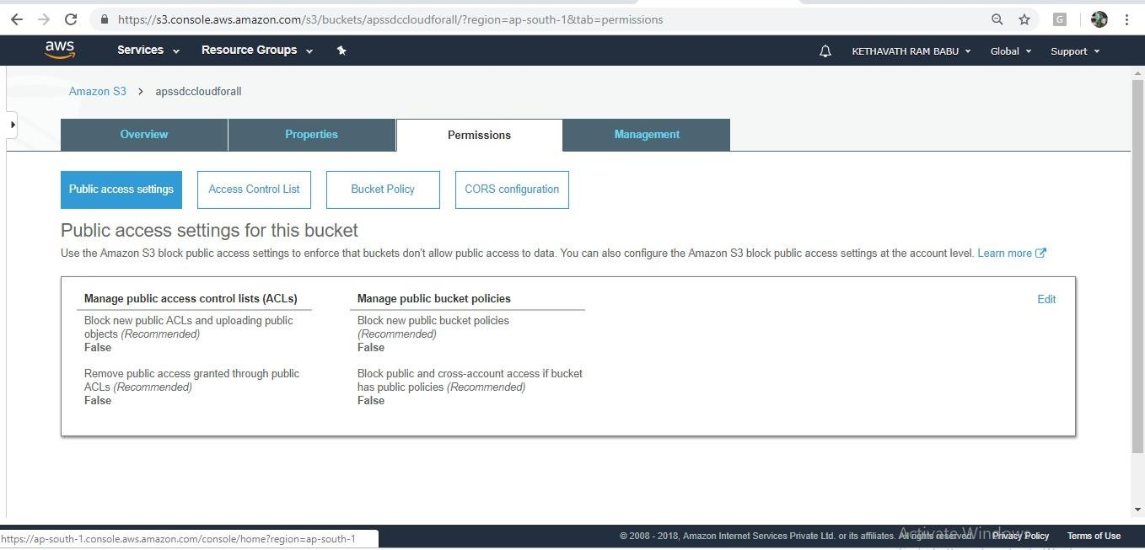

* 1. Choose **Add Bucket Policy**.

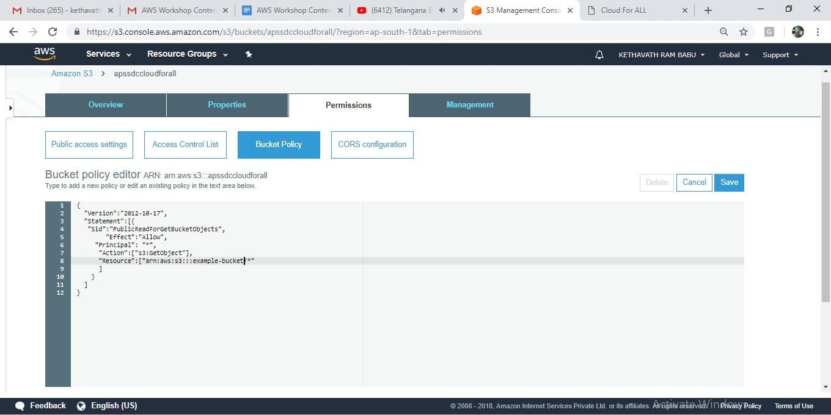

* 1. To host a website, your bucket must have public read access. It is intentional that everyone in the world will have read access to this bucket. Copy the following bucket policy, and then paste it in the Bucket Policy Editor.

4. { "Version":"2012-10-17",

"Statement":[{

"Sid":"PublicReadForGetBucketObjects",

|  |  |  |  |
| --- | --- | --- | --- |
| "Effect":"Allow", |  | | |
| "Principal": "*", | | | |
| "Action":["s3:GetObject"], | |  | |
| "Resource":["arn:aws:s3:::*example-bucket*/*" | | |  |

] } ] }

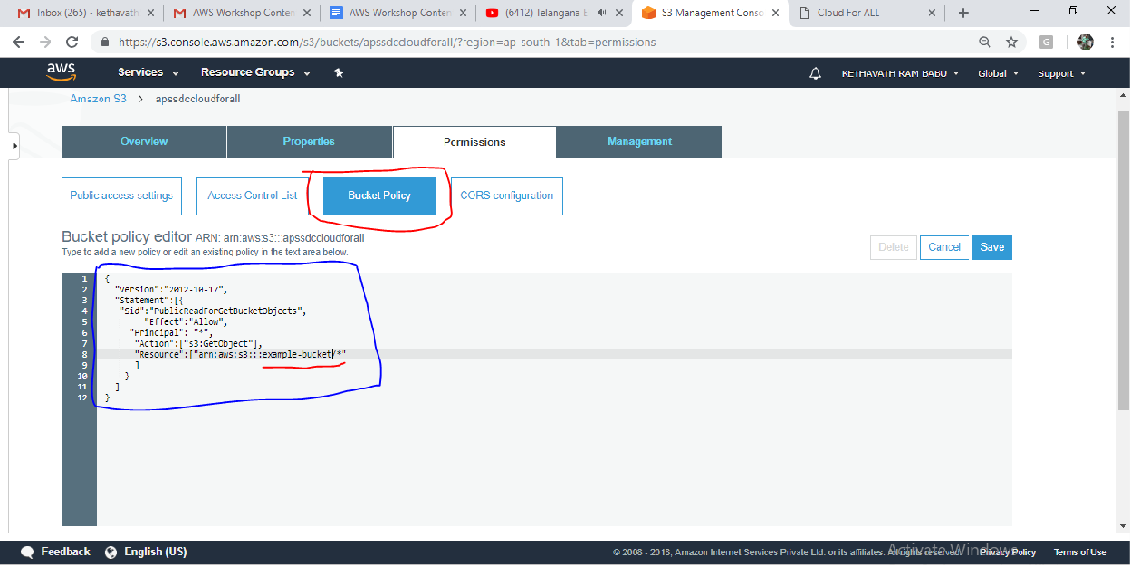

1. In the policy, replace *example-bucket* with the name of your bucket.
2. Choose **Save**.

## Testing Your Website

Type the following URL in the browser, replacing *example-bucket* with the name of your bucket and *website-region* with the name of the AWS Region where you deployed your bucket.

➔ This is the Amazon S3-provided website endpoint for your bucket. You use this endpoint to test your website is running or not by pasting the Endpoint into your browser.

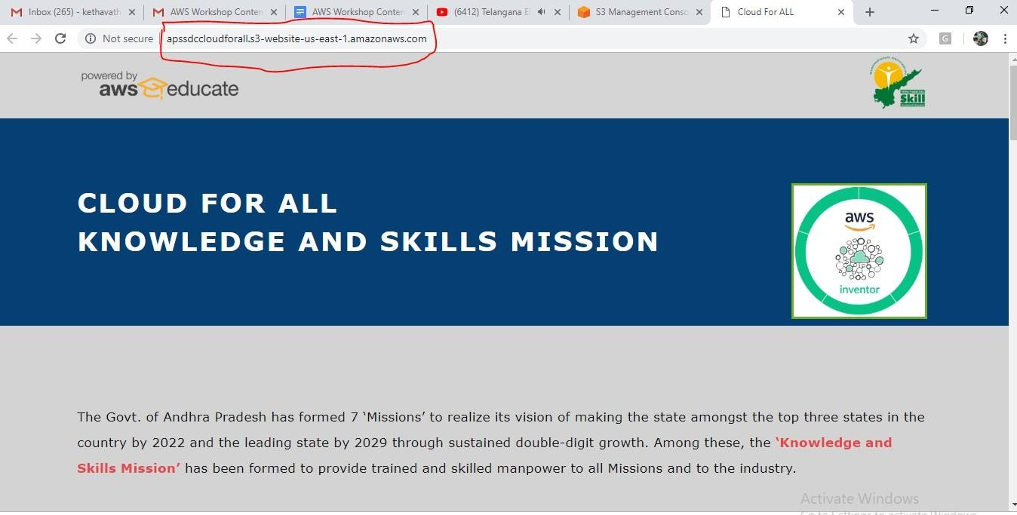

If your browser displays your index.html page, the website was successfully deployed.

**Note :** HTTPS access to the website is not supported.

You now have a website hosted on Amazon S3. This website is available at the Amazon S3 website endpoint. However, you might have a domain, such as example.com, that you want to use to serve the content from the website you created. You might also want to use Amazon S3 root domain support to serve requests for both [http://www.example.com](http://www.example.com/) and [http://example.com.](http://example.com/)

## Exercise 7. To Configure Amazon Virtual Private Cloud (VPC)

## URL: <https://aws.amazon.com/vpc/faqs/>

## AIM:

* 1. **:** To Create your own VPC

## PROCEDURE:

Amazon Virtual Private Cloud (Amazon VPC) lets you provision a logically isolated section of the Amazon Web Services (AWS) cloud where you can launch AWS resources in a virtual network that you define. You have complete control over your virtual networking environment, including selection of your own IP address range, creation of subnets, and configuration of route tables and network gateways. You can use both IPv4 and IPv6 in your VPC for secure and easy access to resources and applications. You can easily customize the network configuration for your Amazon Virtual Private Cloud.

## For example:

you can create a public-facing subnet for your web servers that has access to the Internet, and place your backend systems such as databases or application servers in a private-facing subnet with no Internet access. You can leverage multiple layers of security, including security groups and network access control lists, to help control access to Amazon EC2 instances in each subnet. Features and Benefits

Multiple Connectivity Options Secure Simple

Use All the Scalability and Reliability of AWS

Cases

Host a simple, public-facing website Host multi-tier web applications

Host scalable web applications in the AWS cloud that are connected to your Datacenter Extend your corporate network into the cloud Disaster

Recovery

Amazon VPC enables you to launch AWS resources into a virtual network that you've defined. If you have a default VPC, you can skip this section and move to the next task, Create a Security Group. Open AWS console Click on Services

Select Networking and Content Delivery Click on VPC

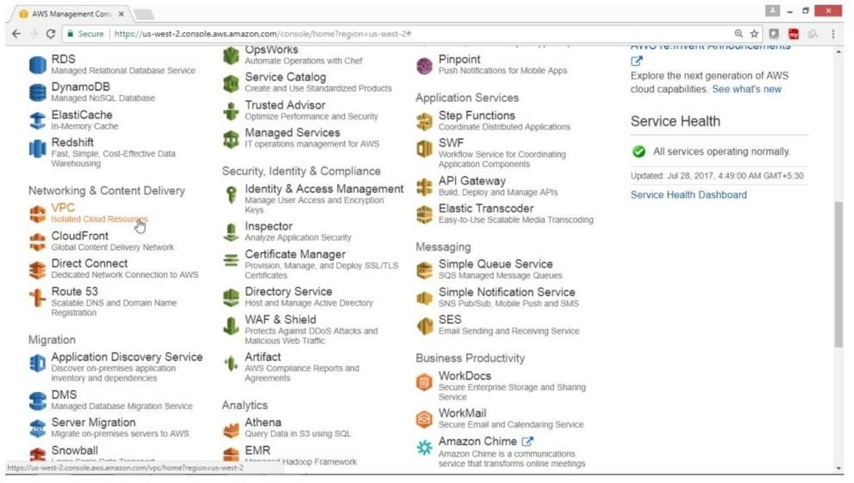

On VPC Dashboard panel Click on Your VPC

Click on Create VPC button

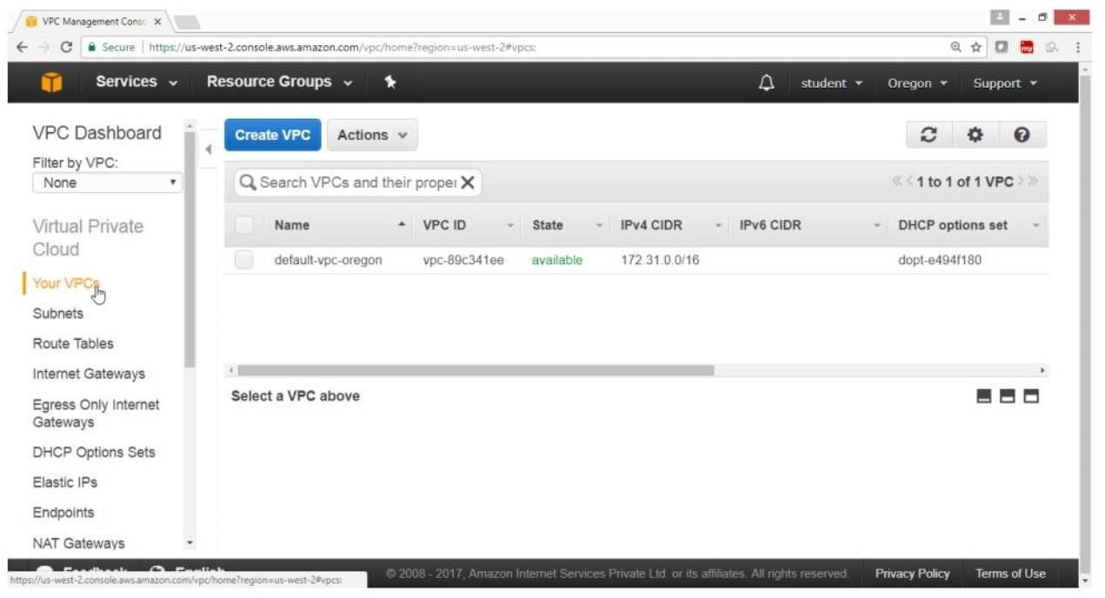

On “Create VPC”, page

For Name tag -> HYD VPC

For IPv4 CIDR block -- 192.168.0.0/16

Leave on “Yes Create” button

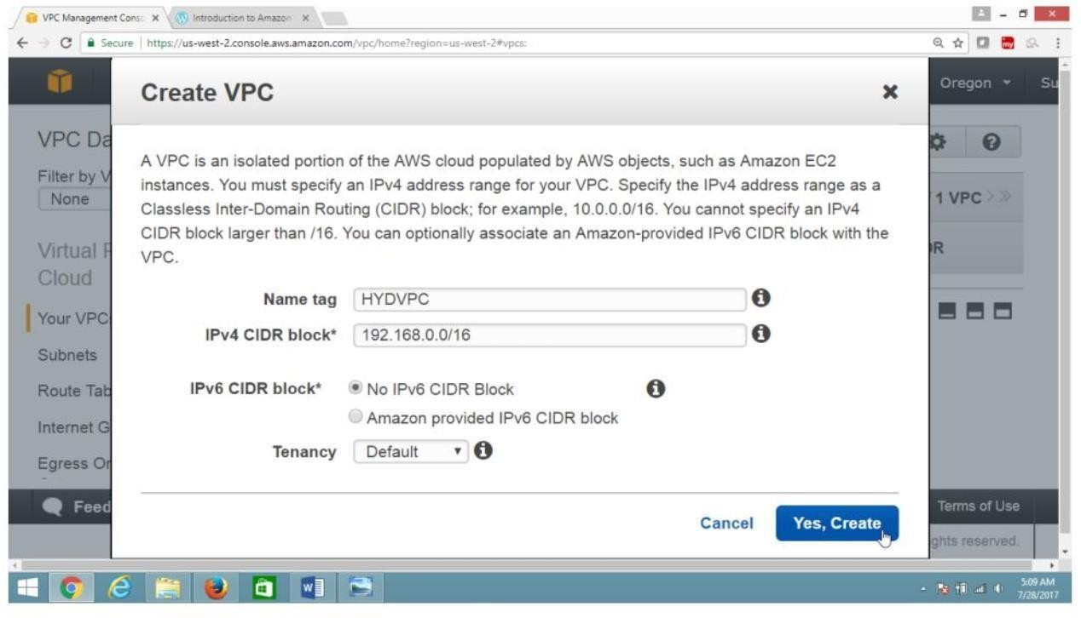

Verify

HYD VPC is created

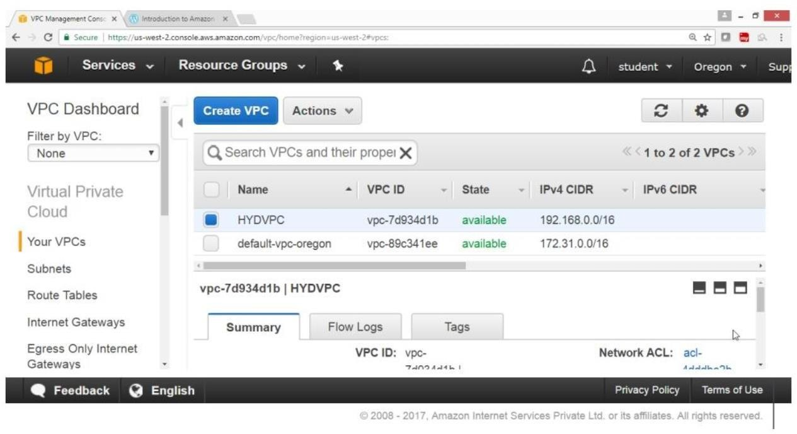

## AIM:

* 1. **&7.3**: To Create public & private subnet

**PROCEDURE:** Click on Subnet Click on Create Subnet button

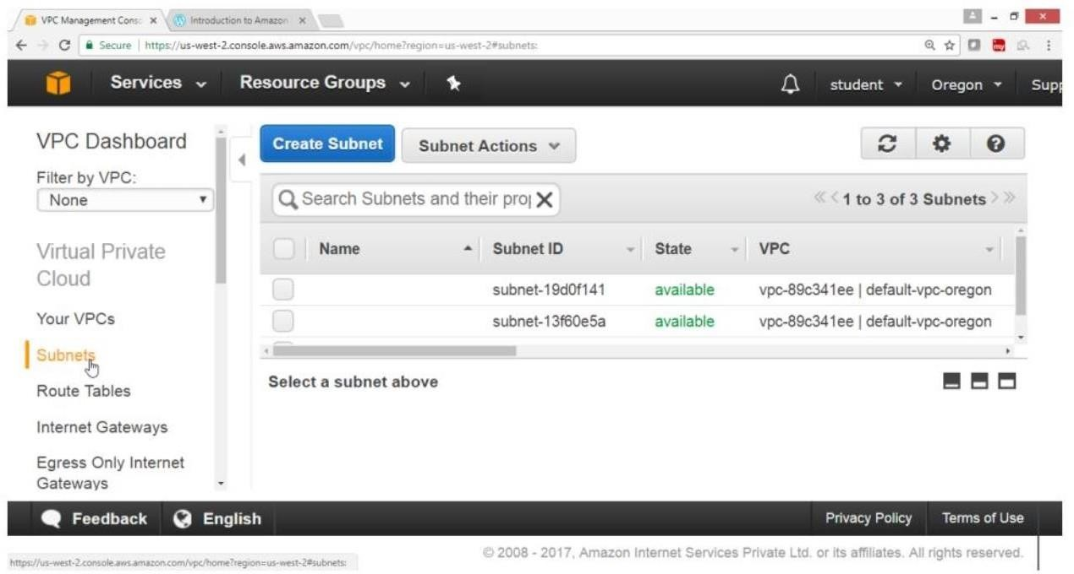

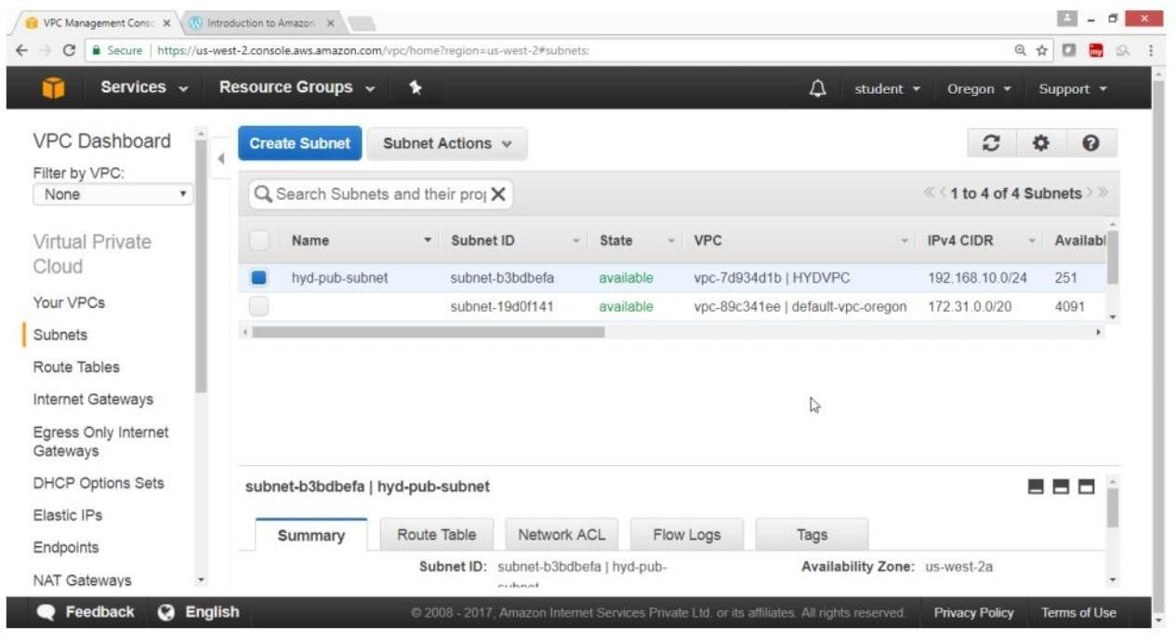On Create Subnet, page

For Name tag -> hyd-pub-subnet For VPC -> HYDVPC

For IPv4 CIDR block -> 192.168.10.0/24

Click on Yes Create button

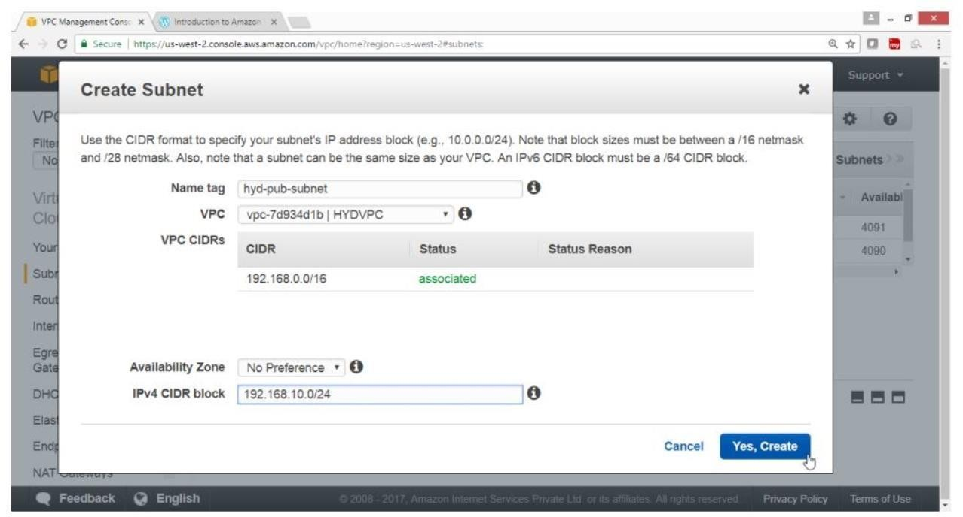

Verify

Hyd-pub-subnet got created

Click on Subnet

Click on Create subnet button

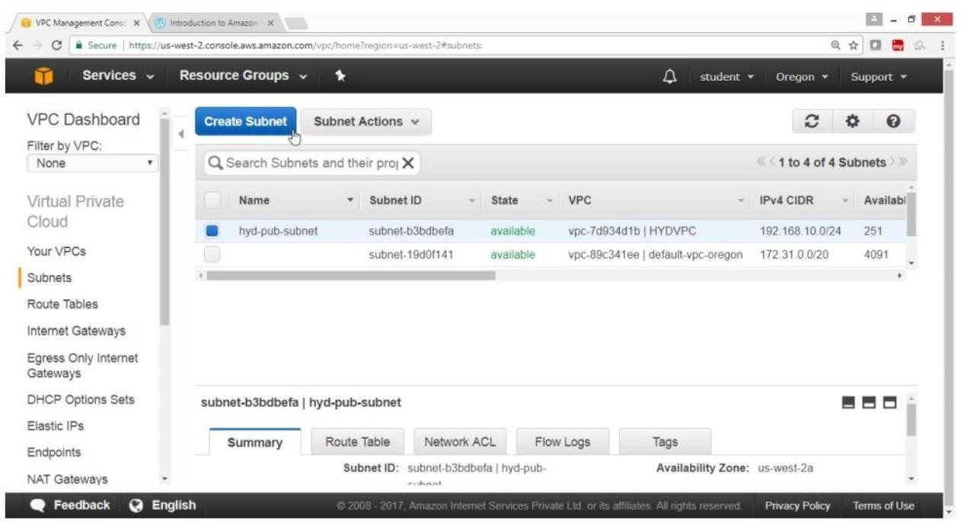

On create subnet page

For Name tag -> hyd-pvt-subnet For VPC -> HYDVPC

For IPv4 CIDR block -> 192.168.20.0/24

Click on Yes Create button

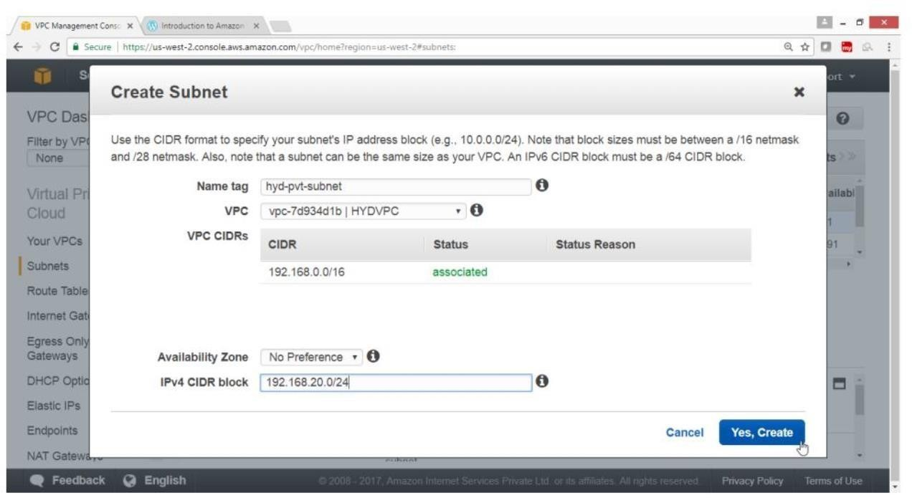

Verify

Hyd-pvr-subnet got created

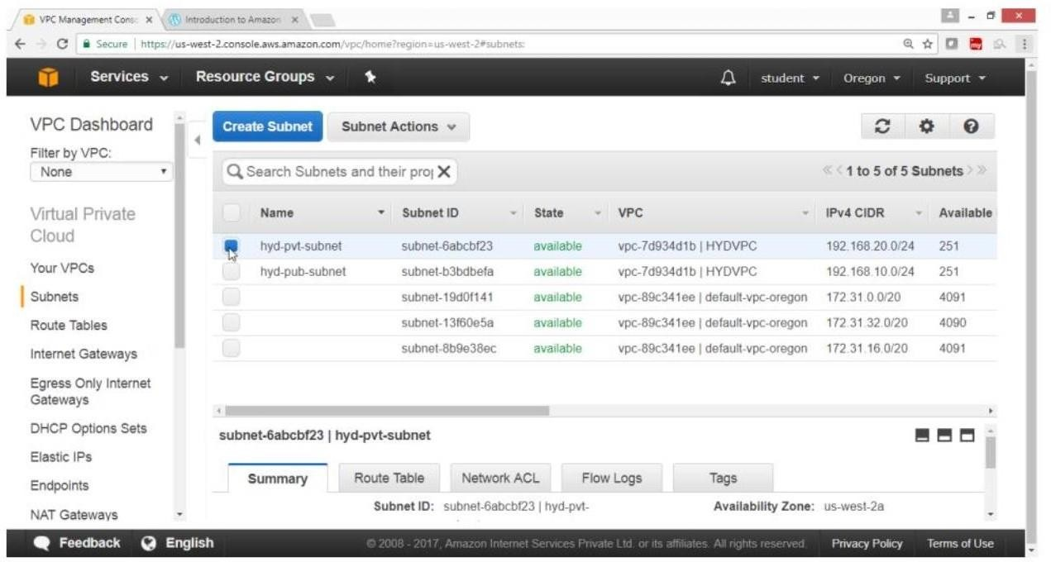

## AIM:

**7.4:** Create an Internet gateway and attach to your VPC

## PROCEDURE:

In VPC Dashboard panel Click on Internet Gateway

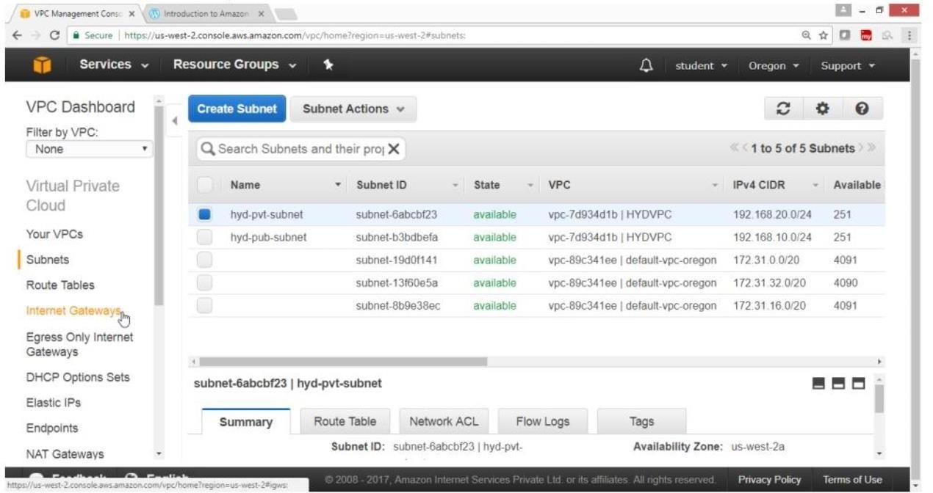

Click on Create Internet Gateway button

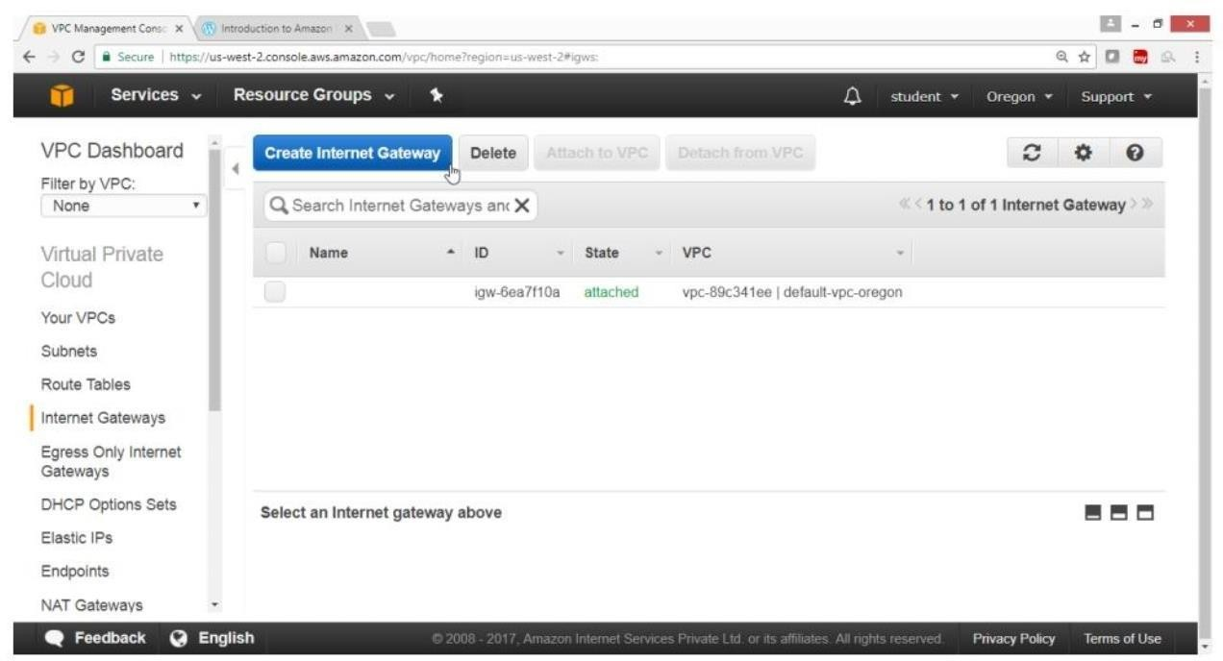

In Create Internet Gateway, box For Name tag -> HYDIGW Click on “Yes, create” button

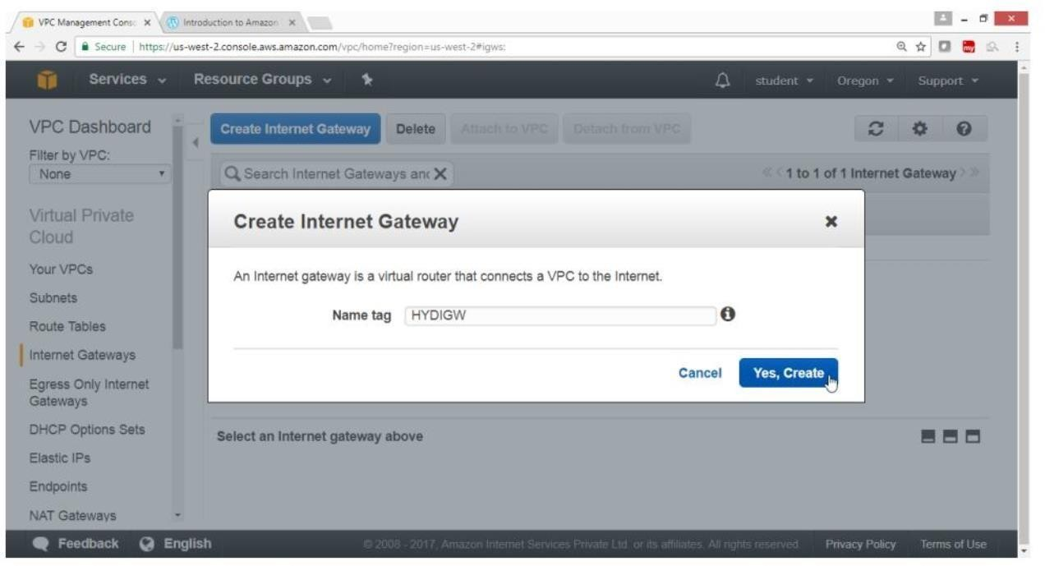

Verify

Internet gateway is created

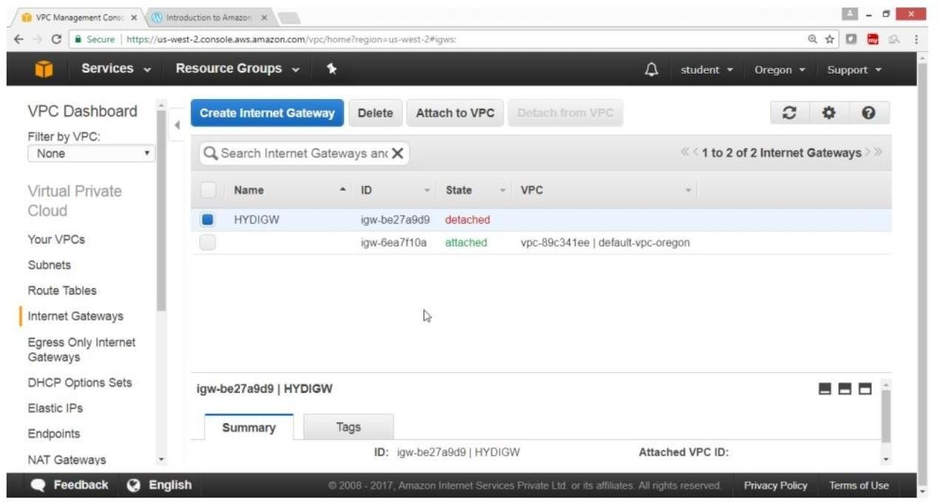

Select HYDIGW Click “Attach to VPC”

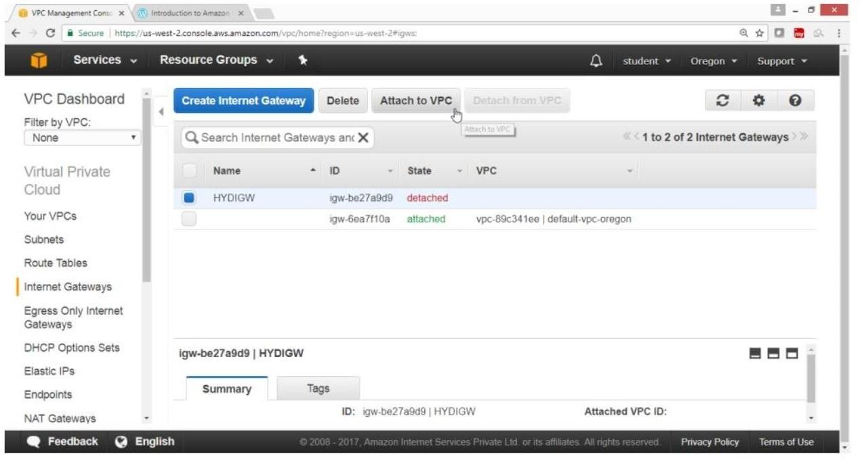

In “Attach to VPC” box For VPC -> HYDVPC Click on “Yes, Attach” button

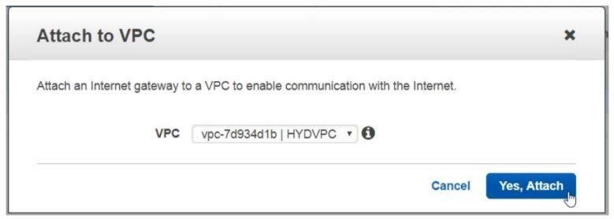

Verify

Internet gateway is connected to your VPC

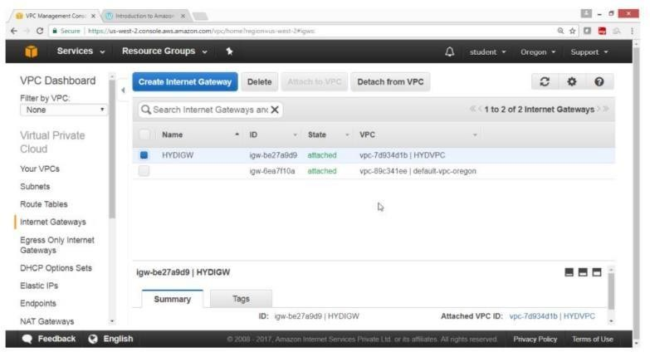

**AIM**:

**7.5.** Create Pubic Routing Table, associate subnet and add routing rules

**PROCEDURE:** On VPC Dashboard panel Click on Route Table

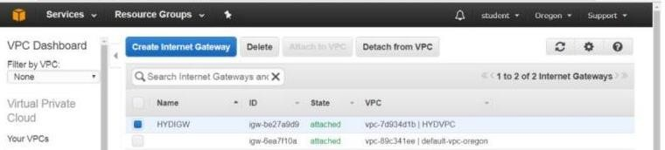

Click on “Create Route Table” button

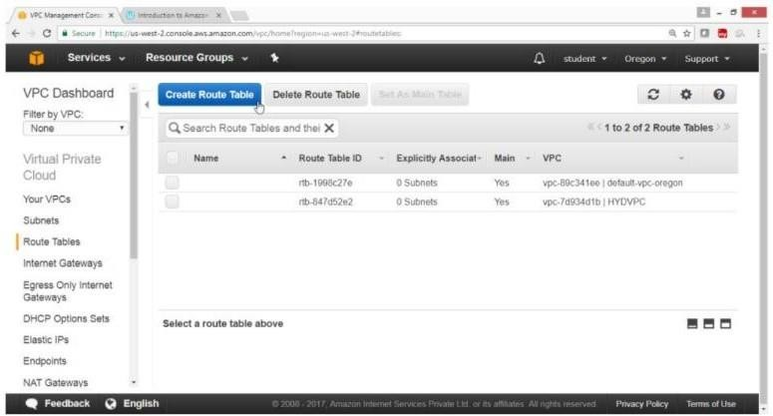

On “Create Route Table” box For Name tag -> hyd-pub-route For VPC -> HYDVPC Click on “Yes, Create” button

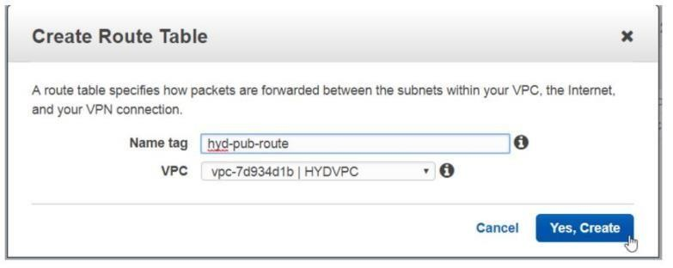

Verify

hyd-pub-route table is created

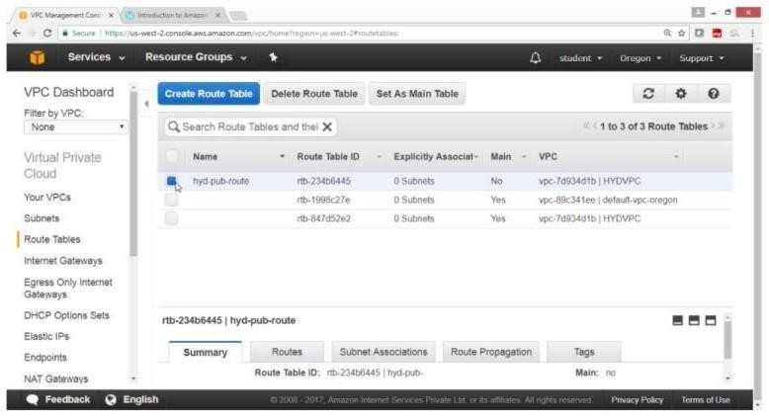

Click on “Subnet Association” button

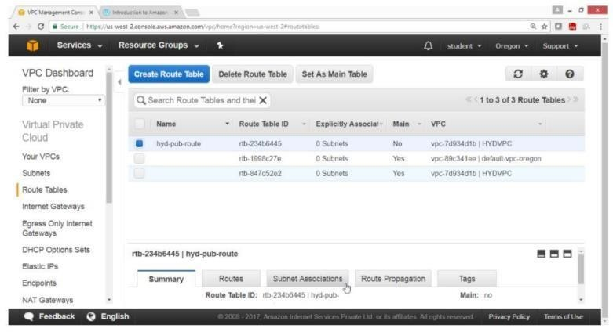

Click on Edit button

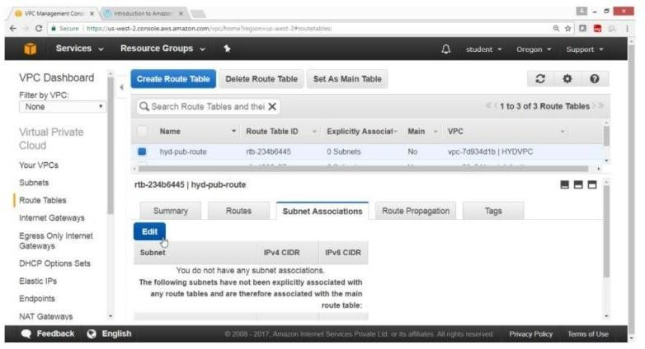

Select checkbox of hyd-pub-subnet -> 192.168.10.0/24

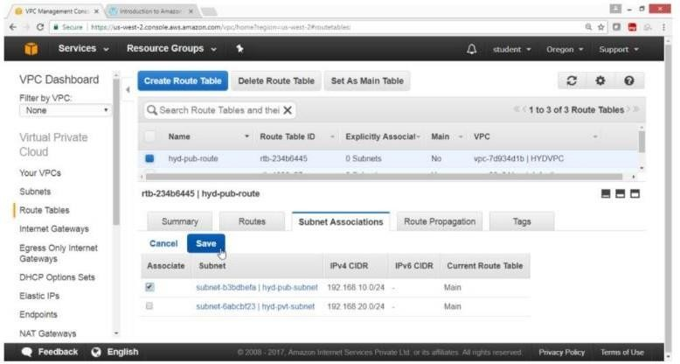

Verify

hyd-pub-subnet is associated with routing table

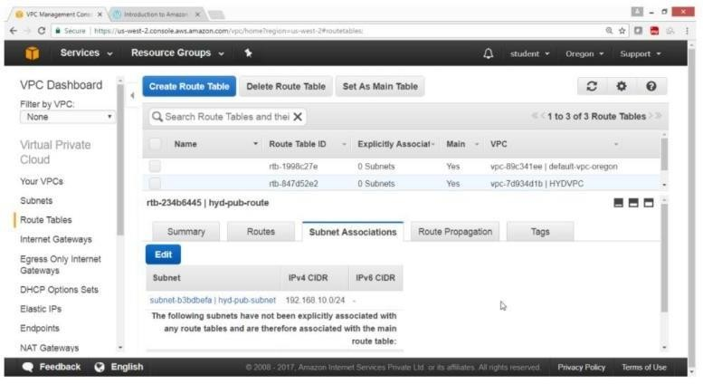

Click on Route button Click on Edit button

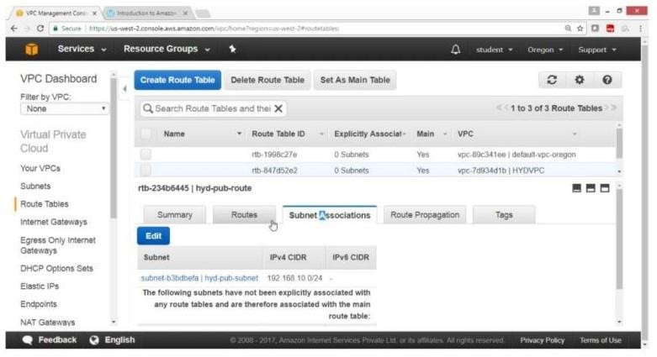

Click on ”Add another route” button

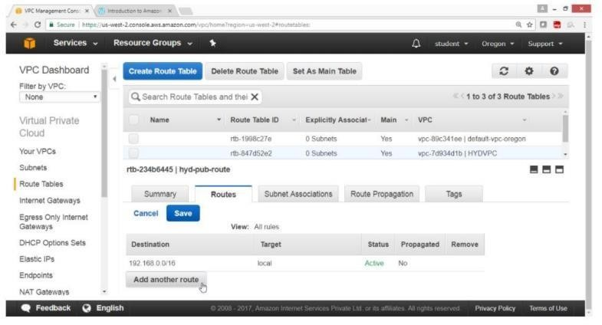

For Destination -> 0.0.0.0/0 For Target ->select HYDIGW

Click on Save button

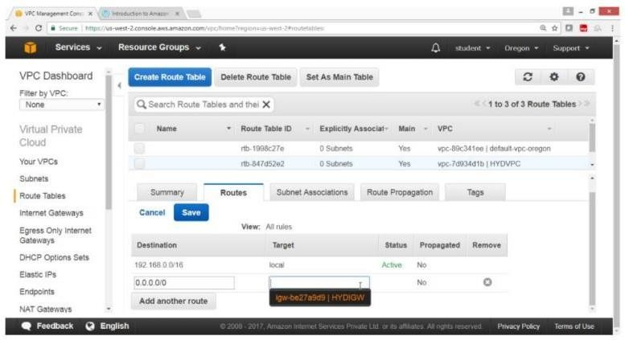

Verification

Public route is added through internet gateway

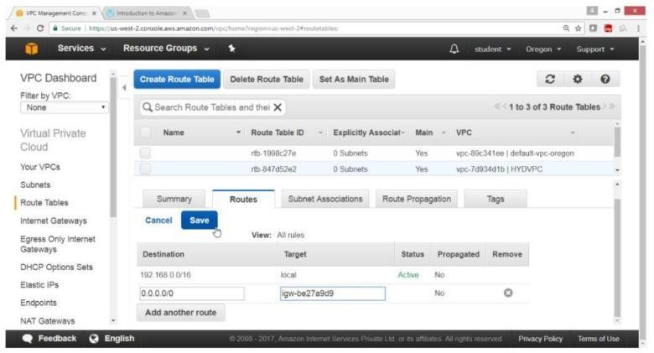

Verify

Status column show Active

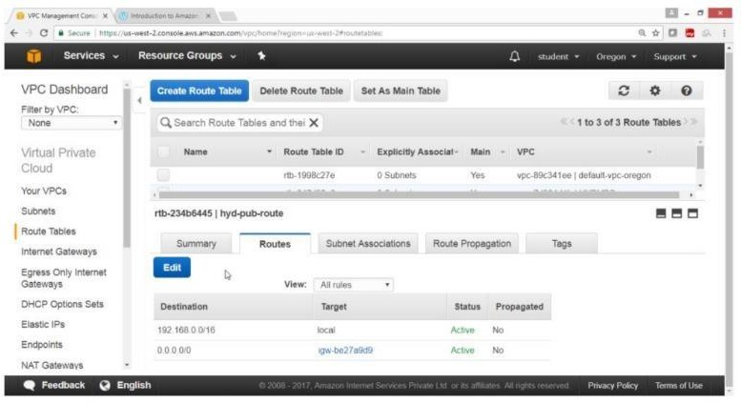

## AIM:

* 1. Create Private Routing Table, associate subnet and add routing rules

**PROCEDURE:** On VPC Dashboard panel Select Route table Click on “Create Route Table”

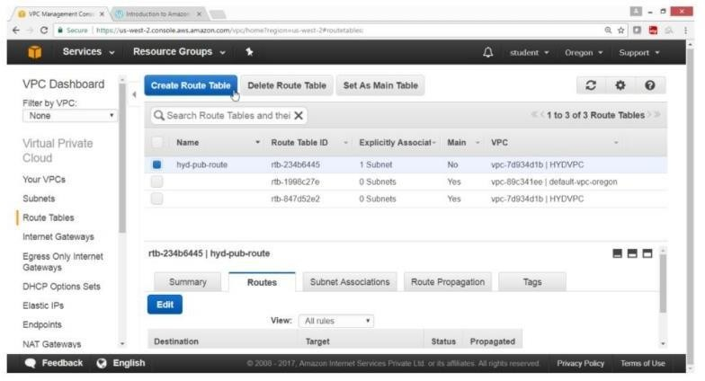

On “Create Route Table” box

For name tag -> hyd-pvt-route For VPC -> HYDVPC

Click on “Yes, Create button”

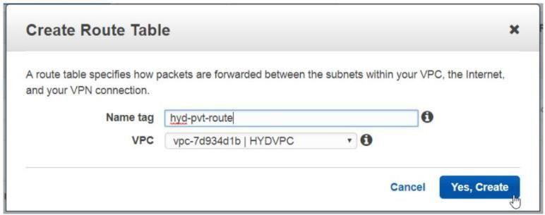

Verify

Hyd-pvt-route table is create

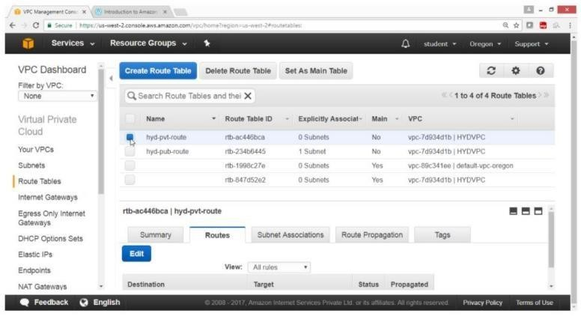

Click on Subnet Association button

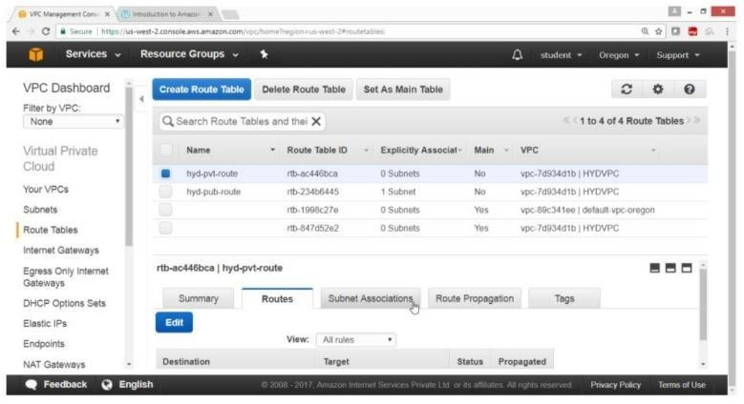

Click on Edit button

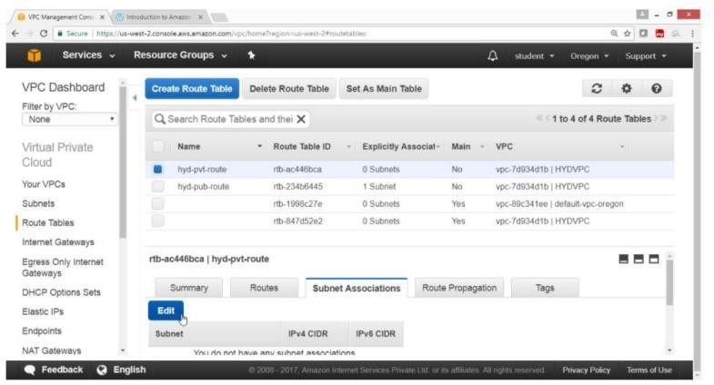

Select Checkbox hyd-pvt-subnet -> 192.168.20.0/24

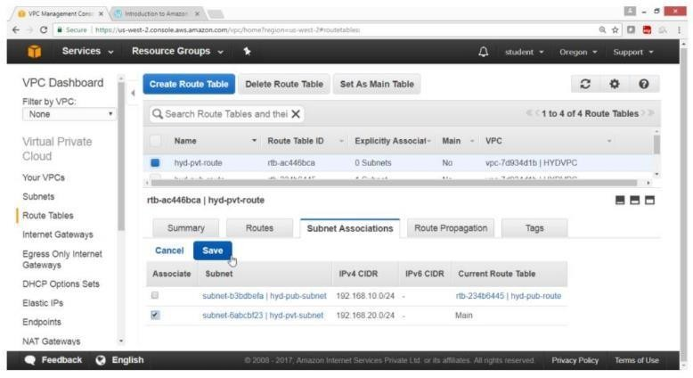

Click on Save button

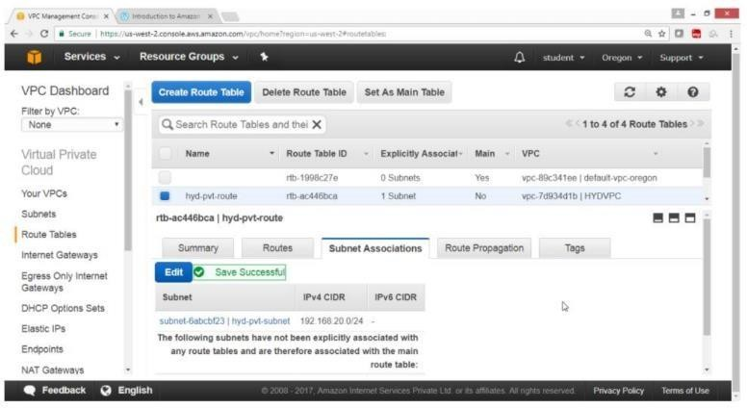

Verify

Hyd-pvt-subnet is associated with hyd-pvt-route table

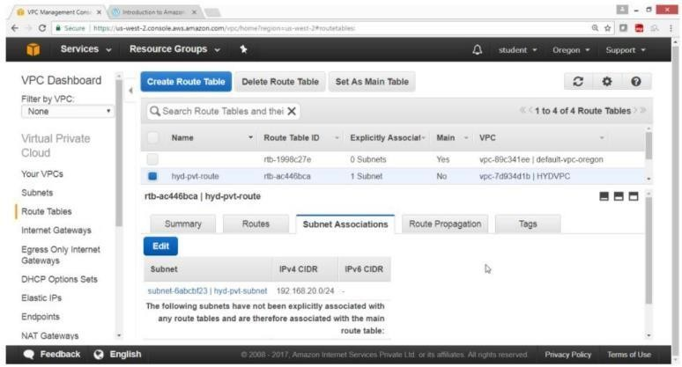

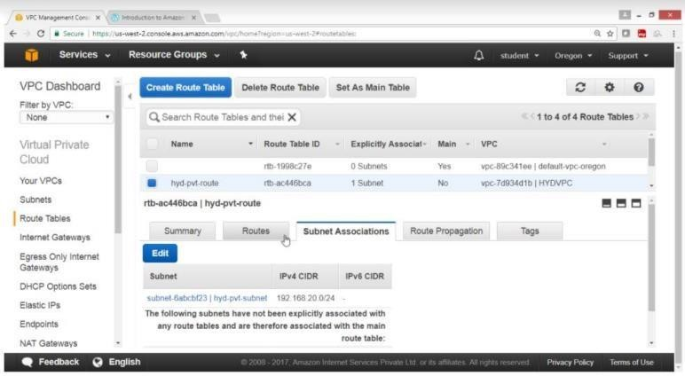

Click on Route button

Note: No need to add IGW in pvt route

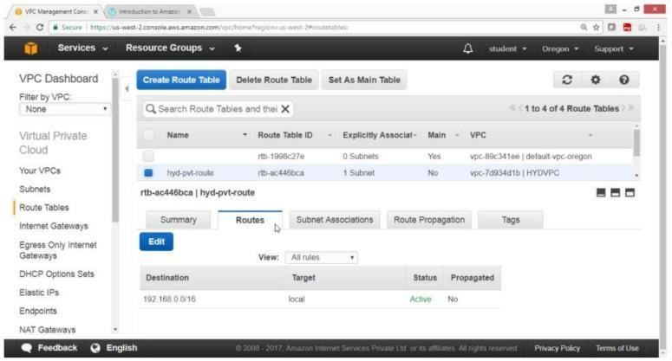

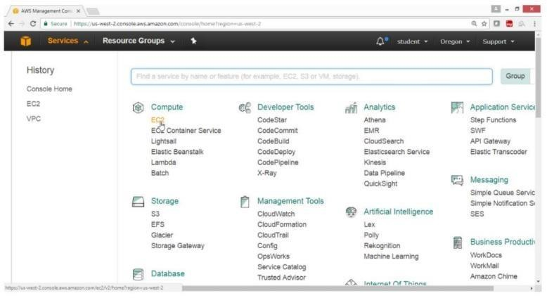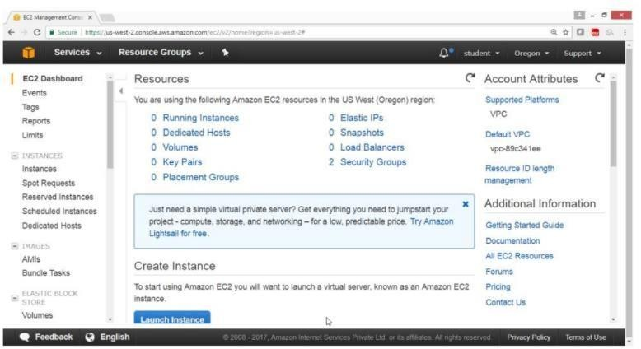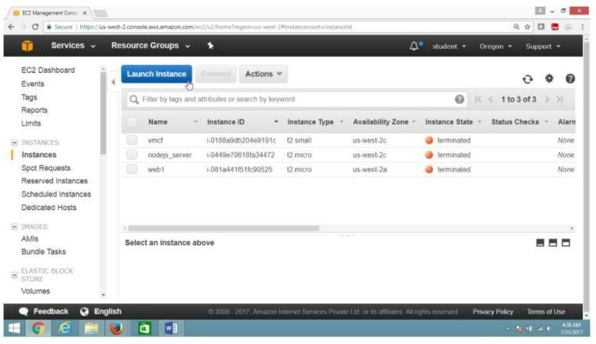

## AIM:

* 1. To launch Windows instance in Public subnet **PROCEDURE:** Open the AWS Console Click on Services Click on EC2 Service

On the EC2 Dashboard panel Click on Instance

Click on Launch Instance button

Select IAM “Microsoft windows server 2012 Base -ami-a1c1ddd8” Free tier eligible

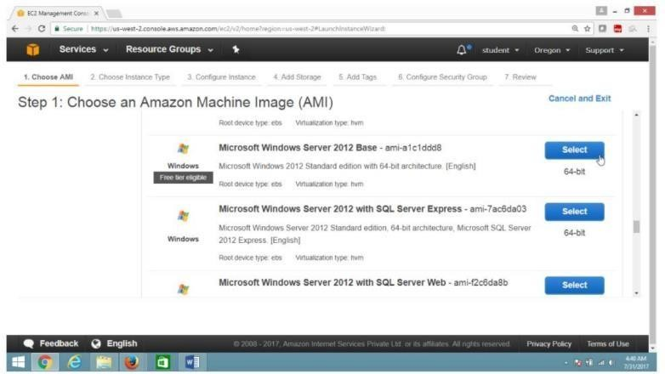

On the “Choose an Instance Type” page Select “General purpose t2.micro”

Click on “Next Configure Instance Details” button

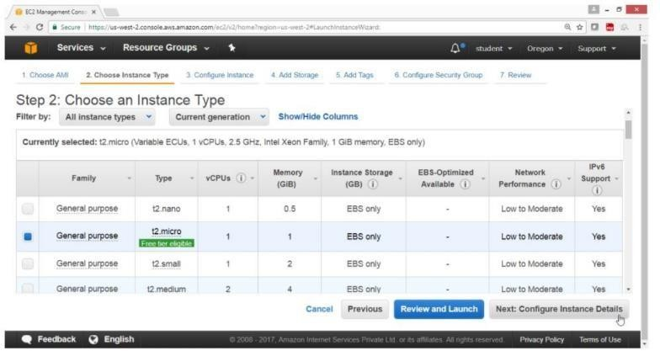

On the “Configure Instance Details” page For “Number of instances” -> 1

For “Network” -> HYDVPC

For “Subnet” -> hyd-pub-subnet

For Auto-assign Public IP -> Enable Click on “Next: Add Storage” button

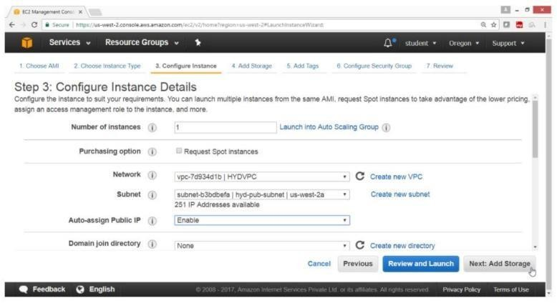

On the “Add storage” page Take default values Click on “Next: Add tags” button

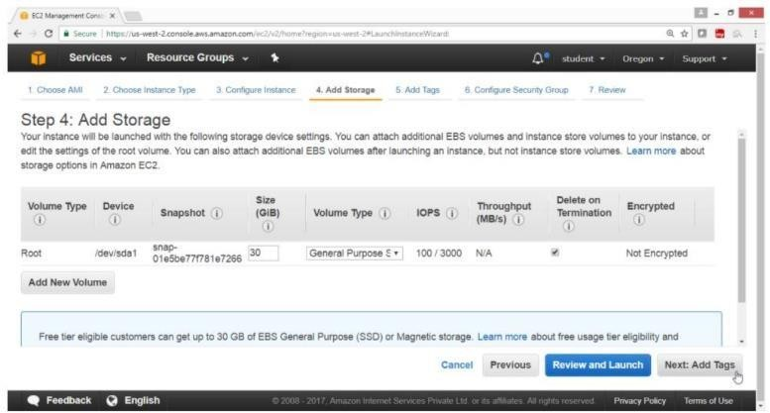

Click on “Add tag” button

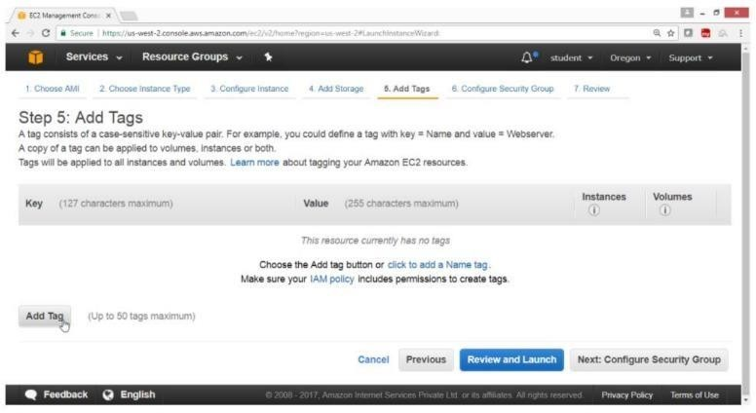

For “Key” -> Name

For Value -> Winpubvm

Click on “Next:Configure Security Group”

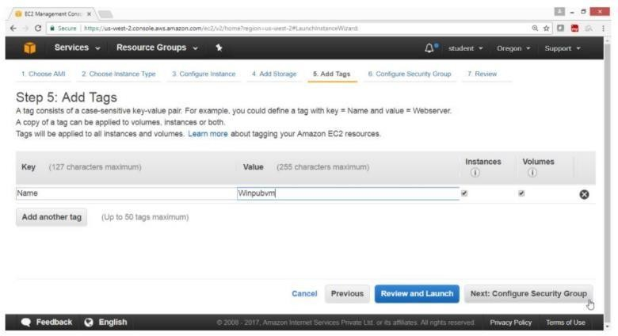

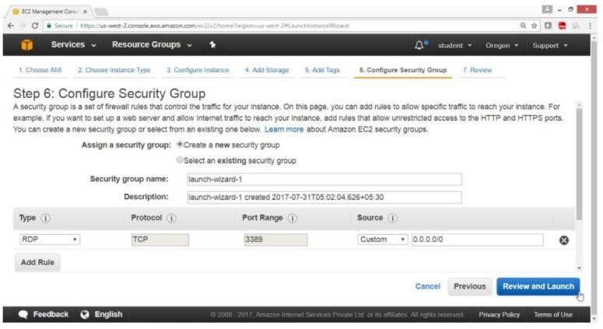

On the “Configure security group” page Take Default valuesClick on “Review and Launch” button

Click on “Launch button”

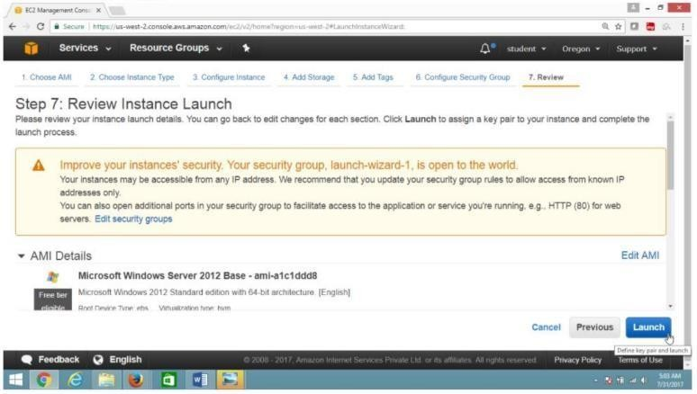

Select “Create a new key pair” For “Key Pair name” -> winkey

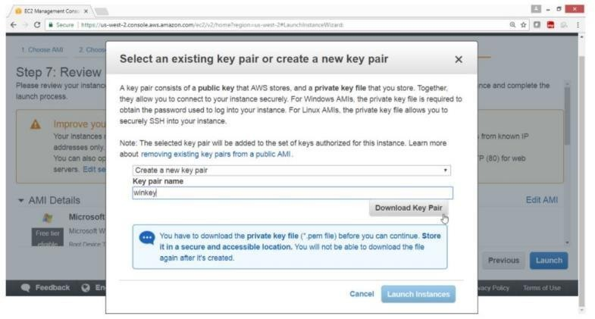

Click on “Download Key Pair” button

Click on “Launch instance button”

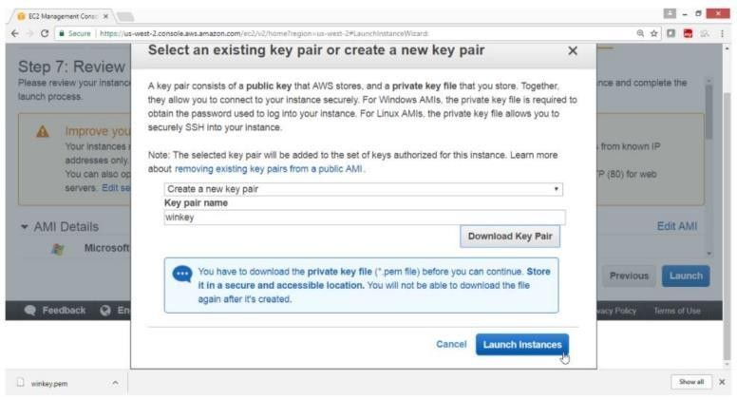

Check summary, Drag down Click on “View instance” button

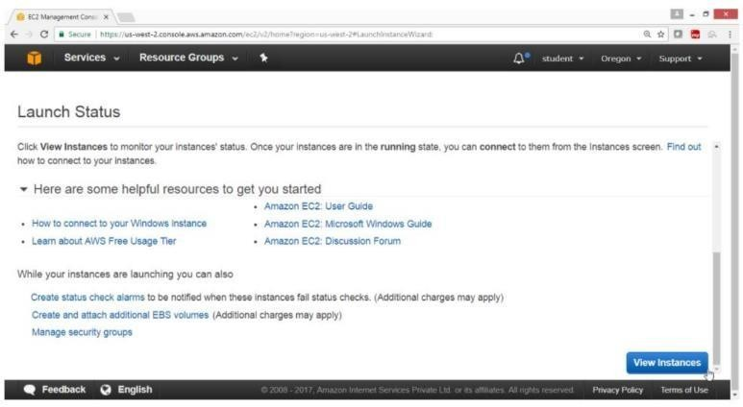

Verify the instance is Running

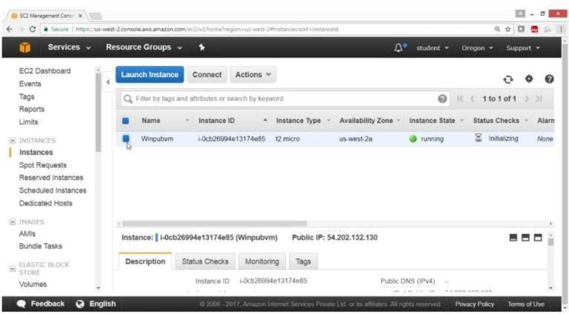

## AIM:

* 1. To launch Windows instance in private Subnet under your VPC

## PROCEDURE:

Open the AWS Console Click on Services

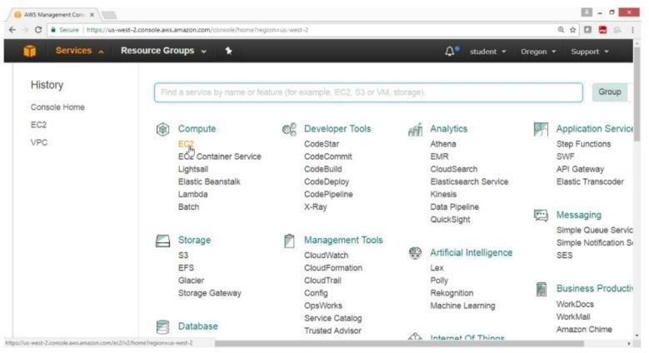

Click on EC2 ServiceOn the EC2 Dashboard Panel Click on instance

Click on “Launch instance” button

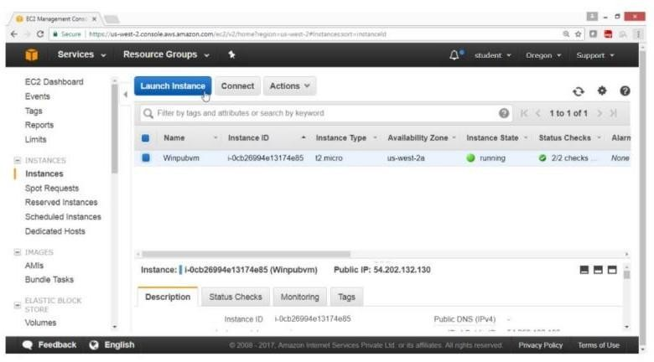

On the “Choose an Amazon Machine Image(AMI)” page

Select AMI “Microsoft Windows Server 2012 R2 Base - ami a1c1 dd8” Free tier eligible

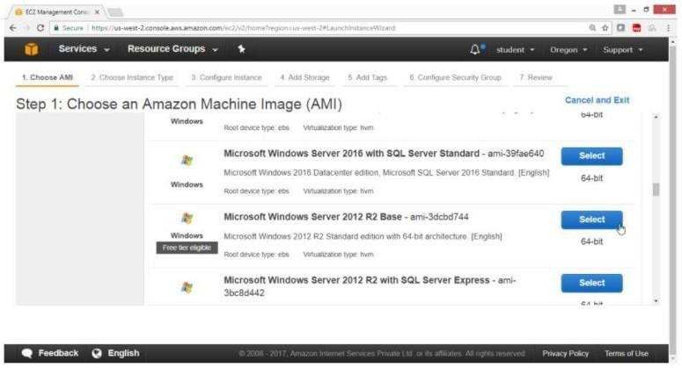

On the “Choose an Instance Type” page Select

“General purpose t2.micro”

Click on”Next Configure Instance Details” button

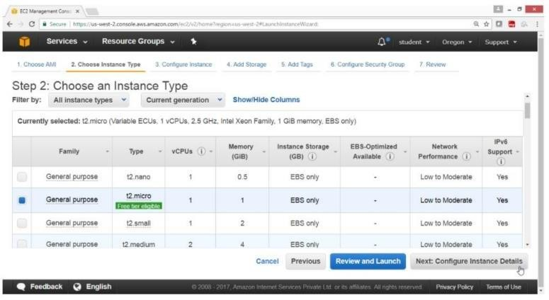

On the “Configuration Instance Details” page For “Number of instances” -> 1 For “Network” -> HYDVPC For

“Subnet” -> hyd-pvt-subnet

For “Auto-assign Public IP” -> Disabled Click on “Next: Add Storage” button

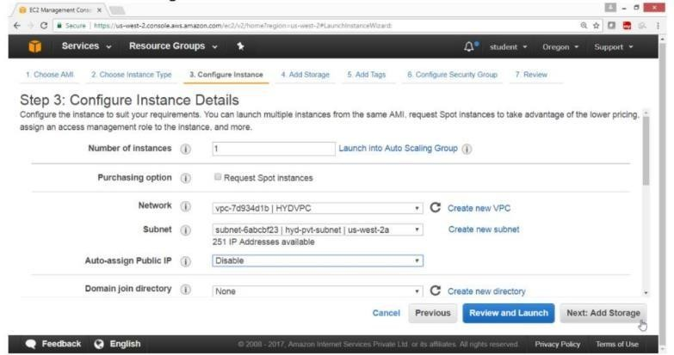

On the “Add Storage” page Take default values

Click on “Next: Add tags” button

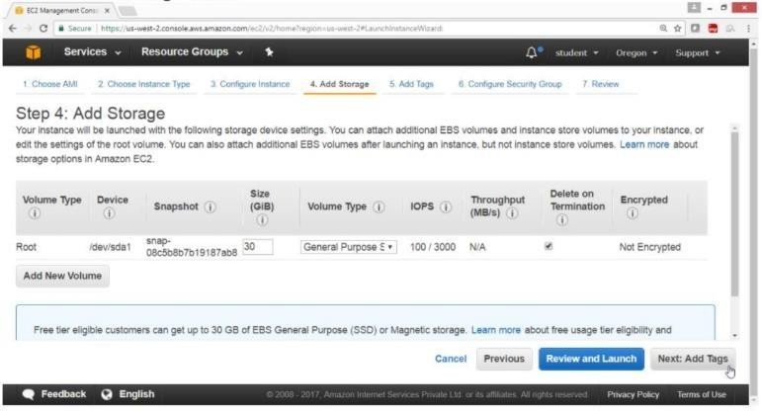

Click on “Add tag” button

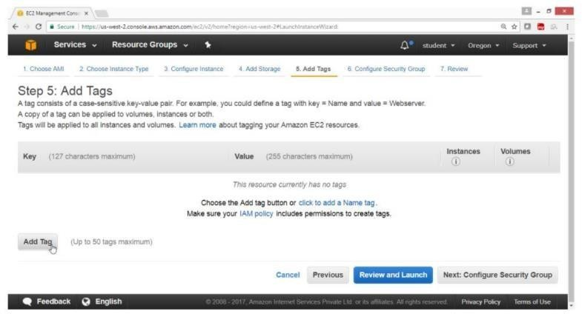

For “Key” -> Name

For Value -> Winpvtvm

Click on “Next: Configure Security Group” button

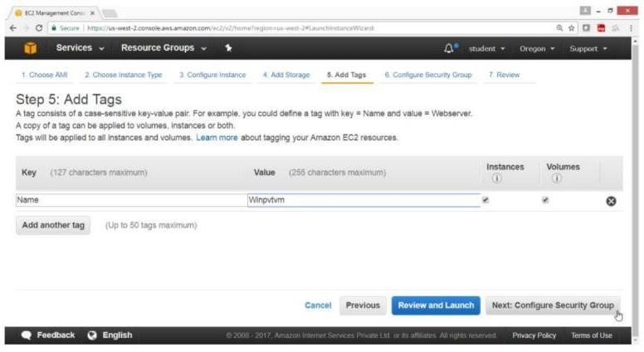

Take Default Values

Click on “Review and Launch” button

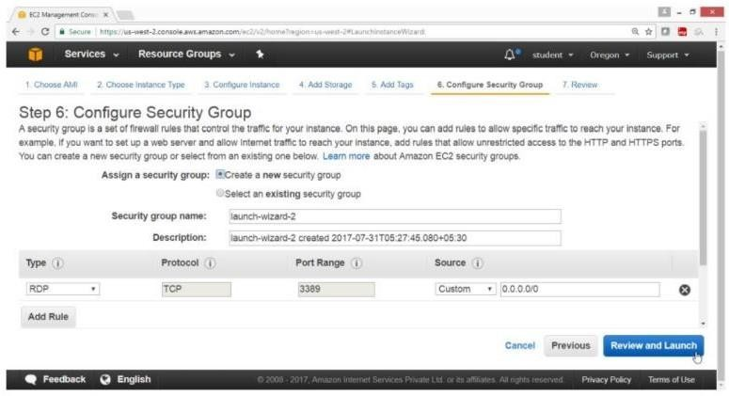

Drag down

Click on “Launch” button

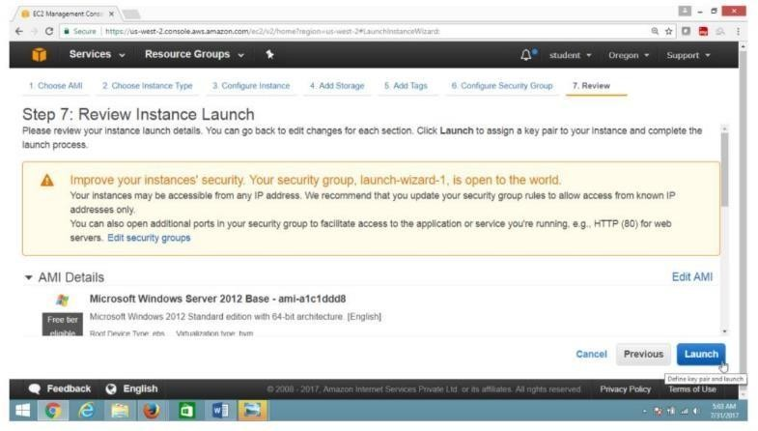

Select “Choose an existing key pair”

For “Key pair name” -> winkey Select I

acknowledge check box Click on “Launch Instance” button

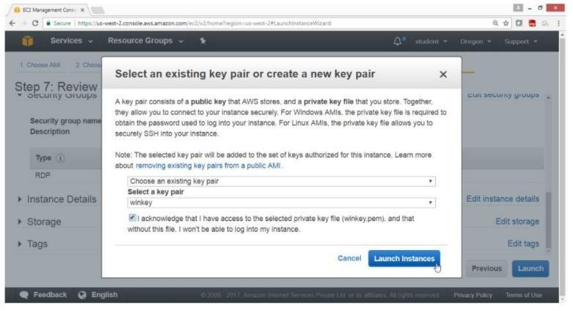

Check summary, Drag down Click on “View Instance” button

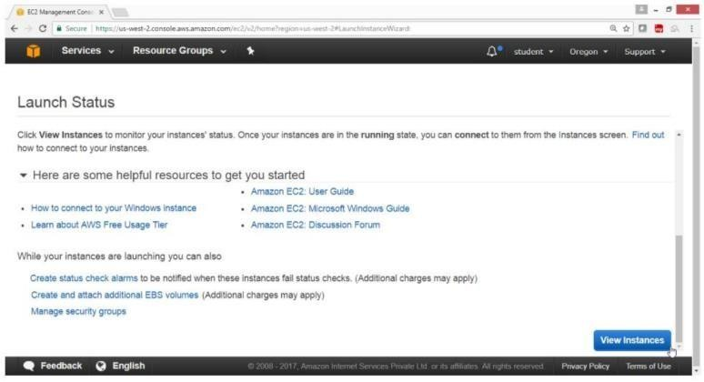

Verify that instance is Running

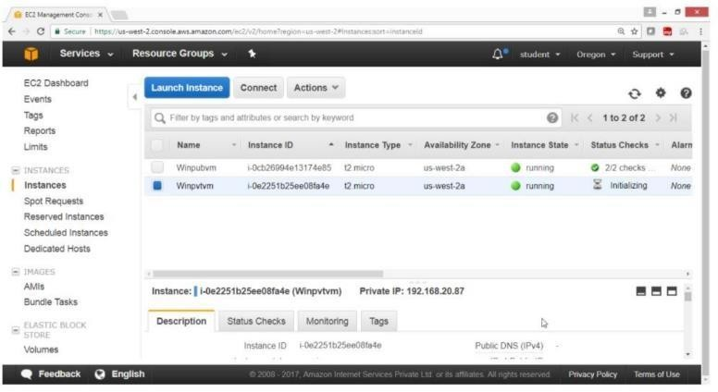

Verification

Output shows that both instances in public & private subnet are running.

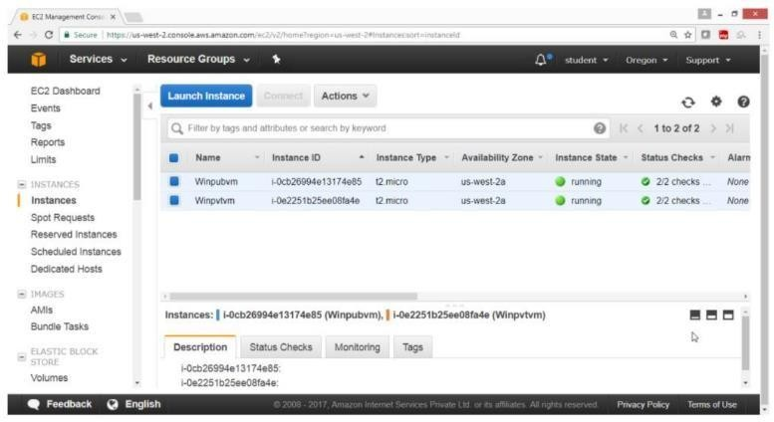

Now to connect an instance in private subnet first connect an instance in public network then from there connect to an instance in private subnet as shown in diagram

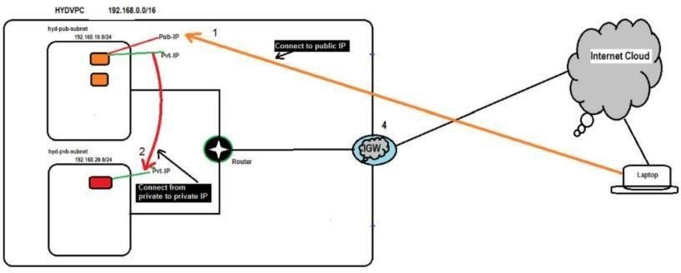

## AIM:

* 1. **:** To Connect to Public subnet instance

## PROCEDURE:

First locate the public IP of a public instance

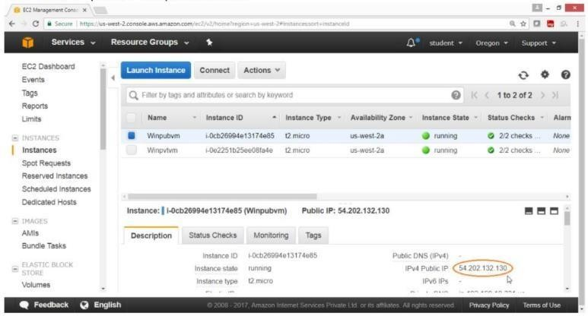

Click on “Connect” button

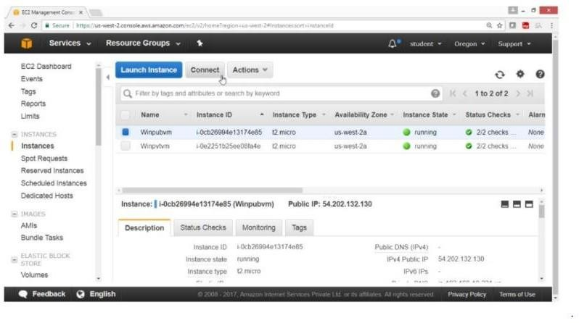

Click on “Download Remote Desktop file” Click on “Get Password”

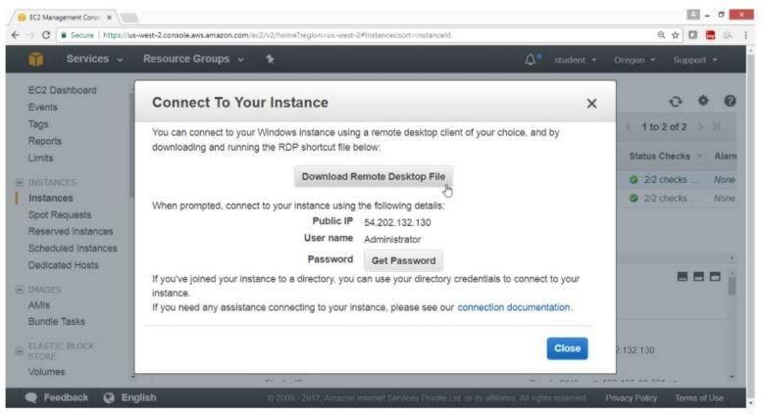

Provide the path of key file Click on Choose file button

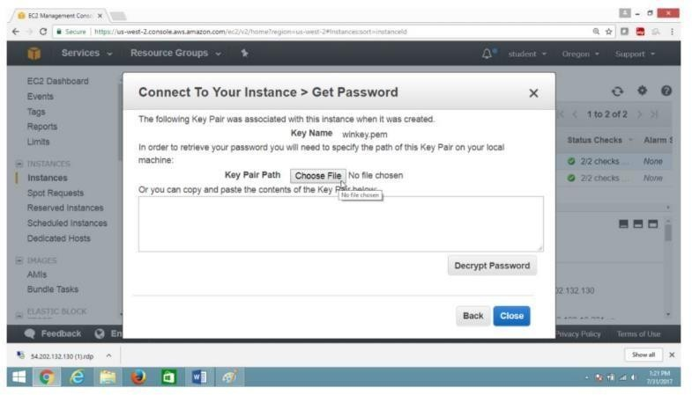

Select the key file Click on Open button

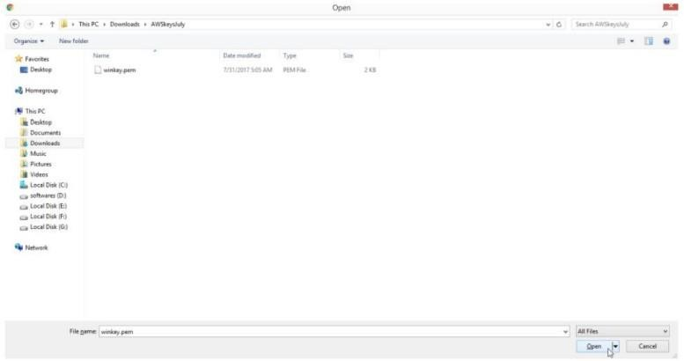

Now click on “Decrypt Password” button

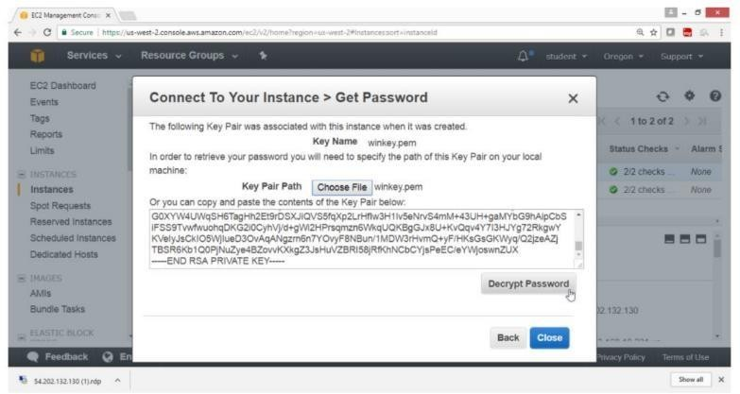

Verification

Password is generated copy in notepad Click on Close button

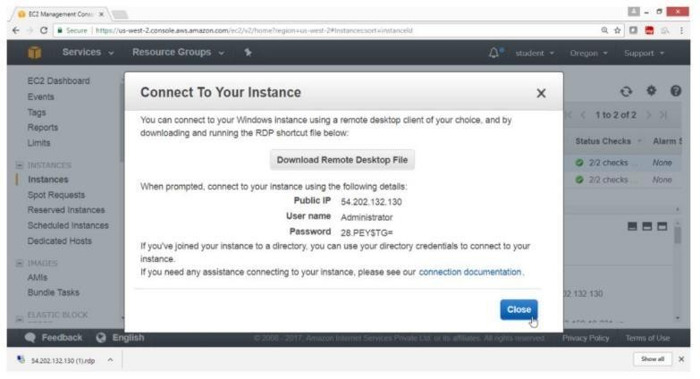

Double Click on RDP file

Provide Windows Username -> Administrator Password ->

“28.Y=$DEEP” , as shown above

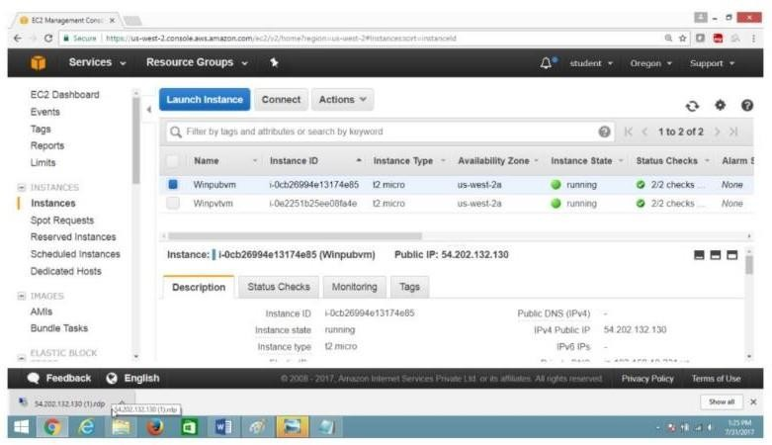

Click on “Connect” button

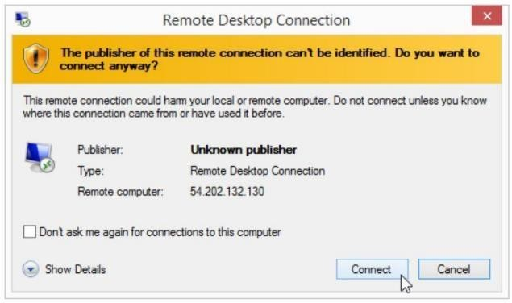

Paste the password Click on OK button

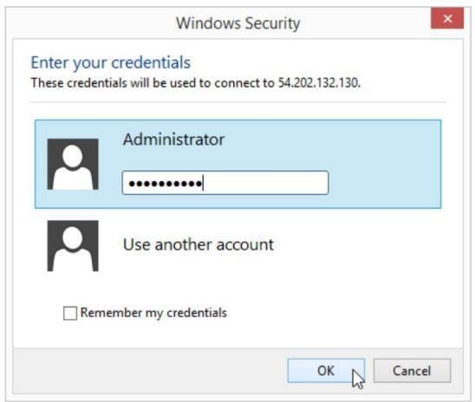

Click on Yes button

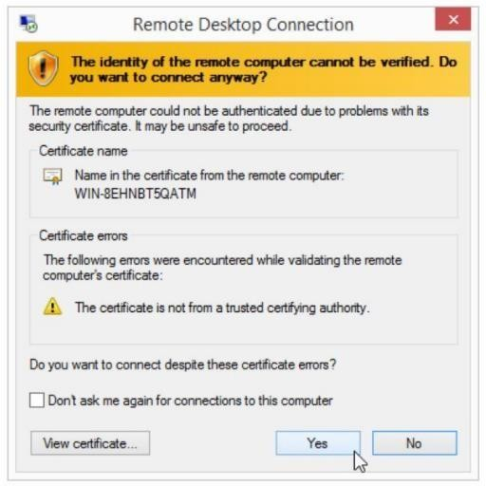

Verify

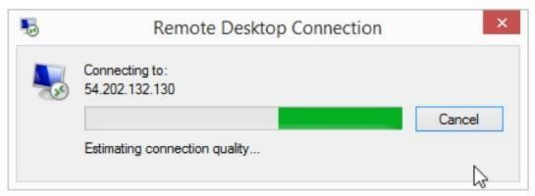

Verification

Now you are connected to Windows Public instance

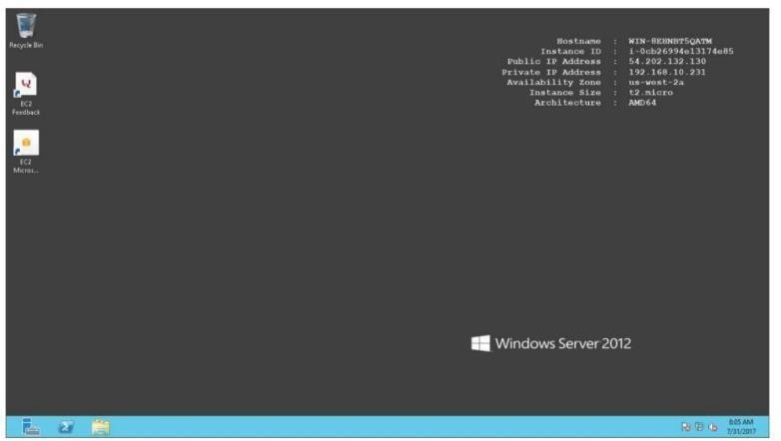

On Windows Desktop public and private both IP’s are displayed

Go to EC2 Dashboard Select private instance Get the private IP of the instance

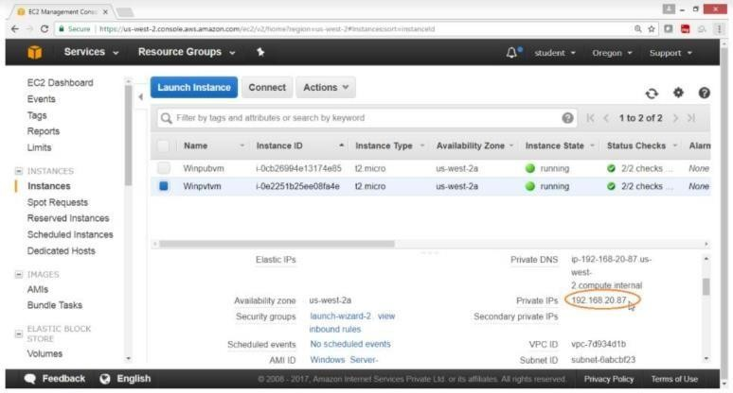

Click on Connect button

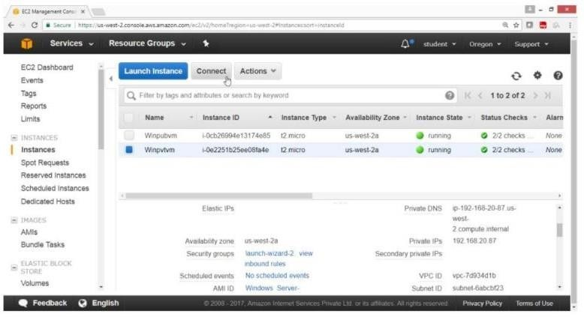

To get the password

Click on “Get Password” button

Click on “Decrypt Password”

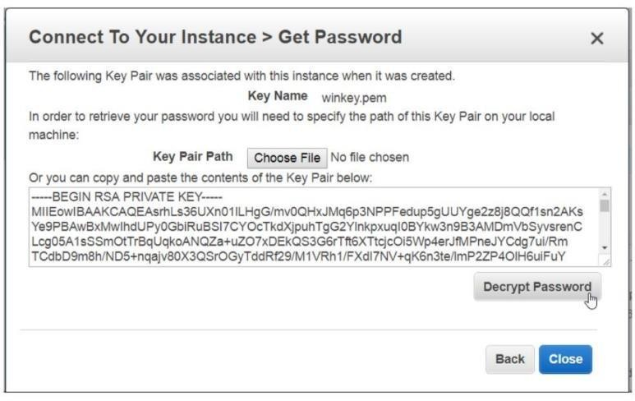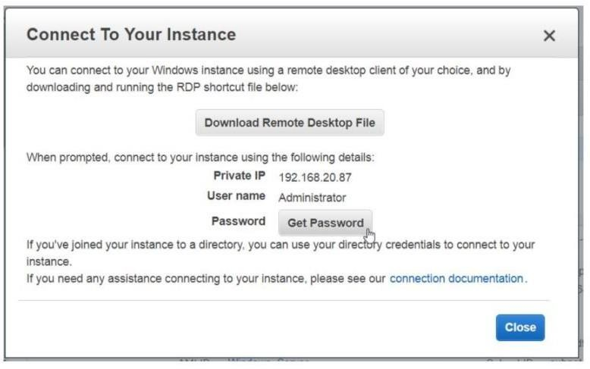

Verify

IP and password of private subnet instance is provided

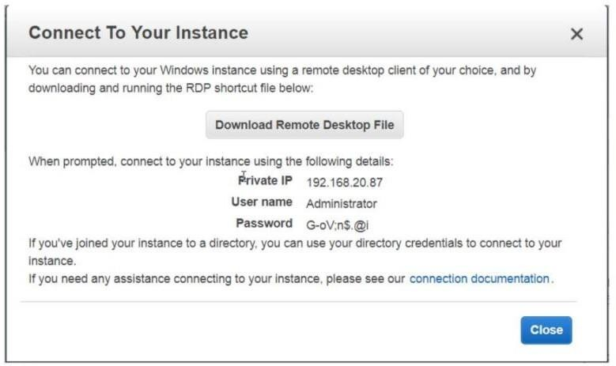

Now logging to public instance

Open Run and type mstsc to connect to window private instance

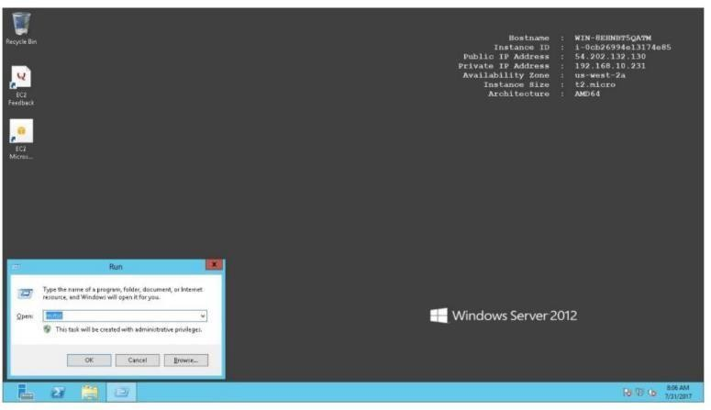

Provide private instance

Private IP -> 192.168.20.87

Username -> Administrator Password -> Go-,@17

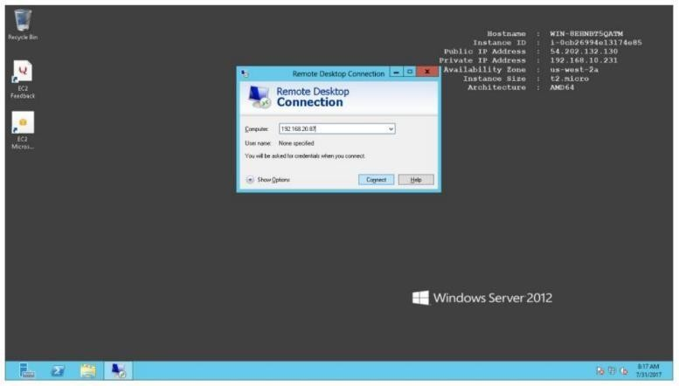

Now Provide Username & password

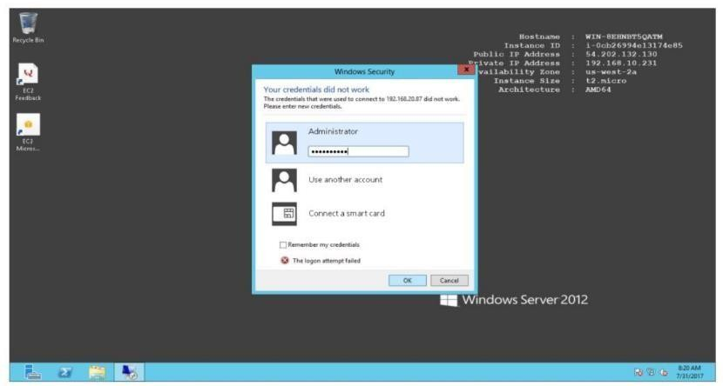

Verification

Check private IP at Right top corner

Now you are connected to windows private instance.

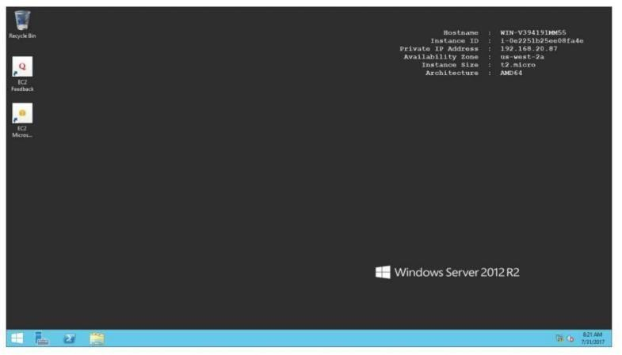

## AIM:

**7.10.** To Connect to a private subnet instance

## PROCEDURE:

Launch linux instance in public subnet -> hyd-pub-subnet Open the AWS console Click on Services

Click on Instances

Click on “Launch Instance” button

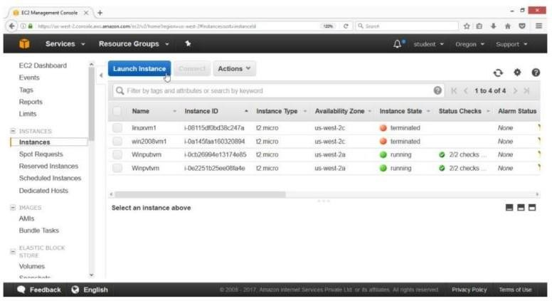

On the “Choose an Amazon Machine Image (AMI)” page

Select AMI “Amazon Linux AMI 2017.03.1 (HVM)”, SSD Volume Type -ami- 6df1e514 Click on select button

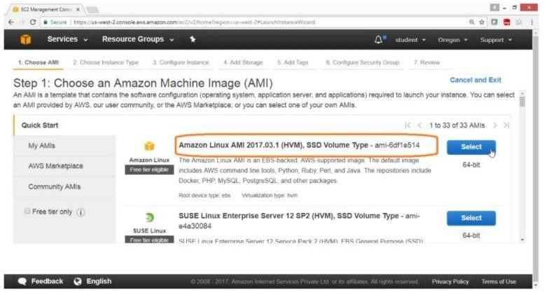

On the “Choose an instance Type” page Select “General purpose”

Type -> t2.micro

Click on “Next: Configure Instance Details”

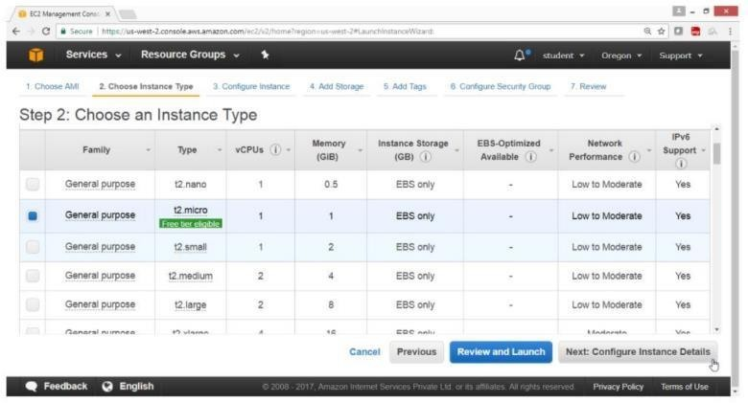

On the “Configuration Instance Details” page Number of instances -> 1 Network -

> HYDVPC

sUBNET -> HYD-PUB-SUBNET

Auto-assign Public IP -> Enable

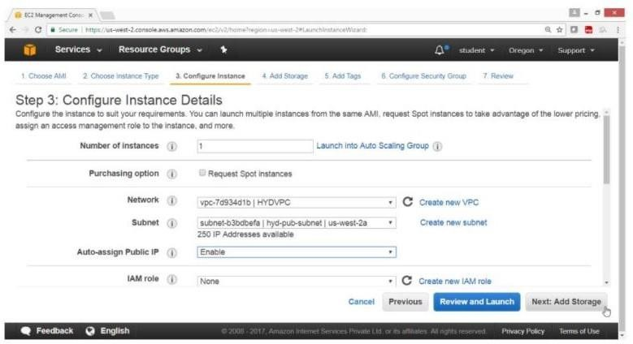

On the “Add storage” page Leave the values as default

Click on “Next: Add Tags” button

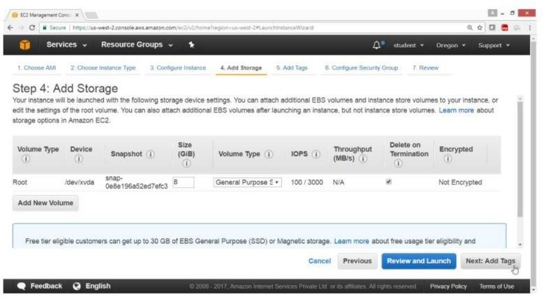

On the “Add Tags” page Key -> Name

Value -> Linux Pubvn

Click on “Next Configuration Security Group” button On the “Configuration Security Group” page

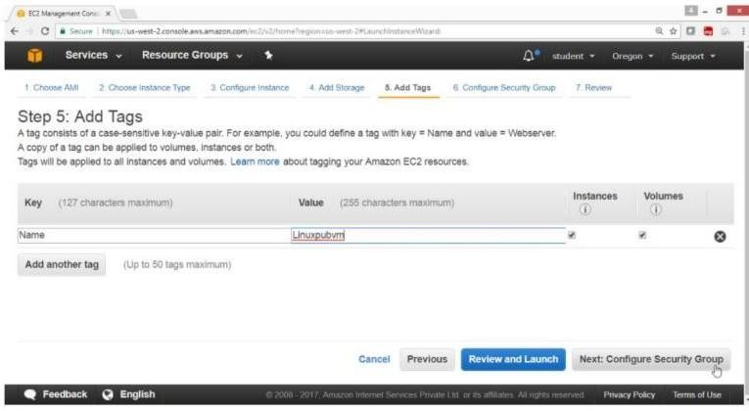

Assign a security group -> Create a new security group Leave remaining values as default

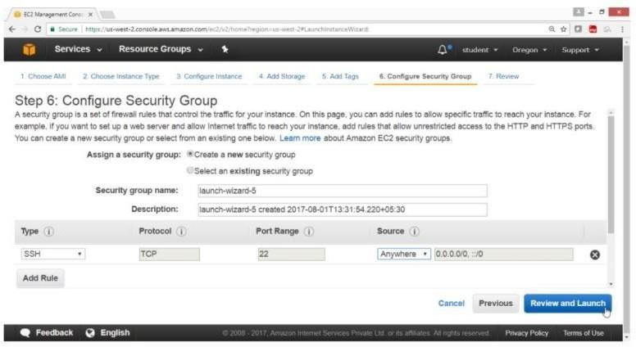

Click on Review and Launch button

On the “Review Instance Launch” page Click on Launch button

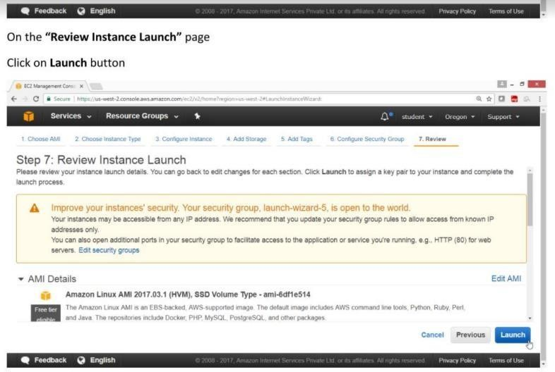

On the “Select an existing key pair or create a new key pair” page Select Create a new key pair

Key pair name -> linux vm key1 Click on “Launch Instance” button

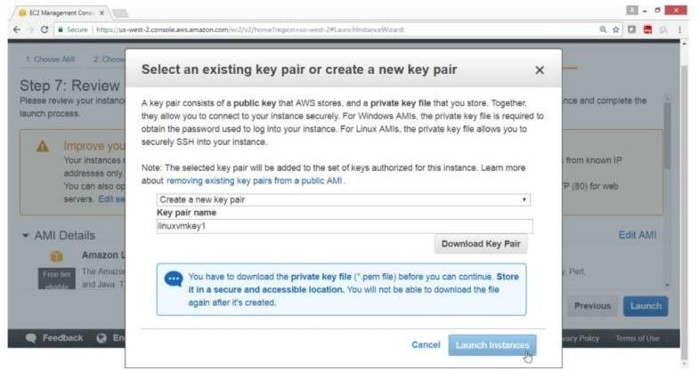

Click the summary

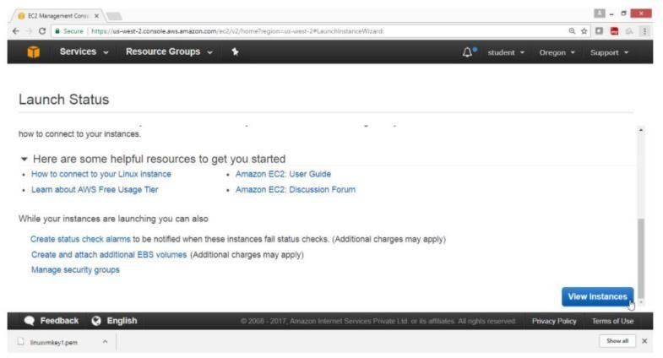

Click on View Instance button Verification

Linux instance in public subnet is launched

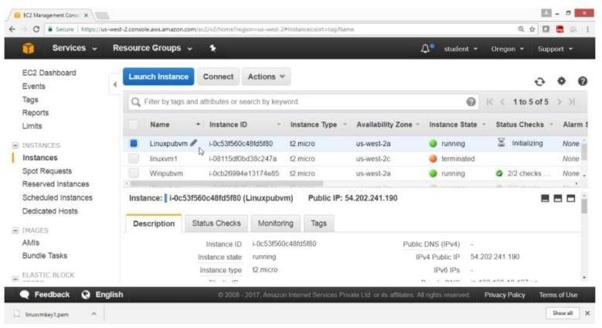

**AIM**:

* 1. **:** To connect Linux instance in private subnet

## PROCEDURE:

First copy the key to Linux instance in public subnet Now connect to linux instance in public

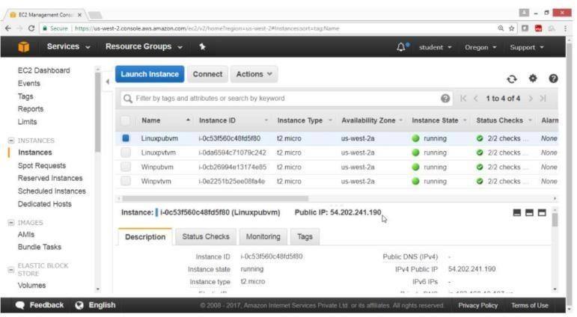

Then connect to linux instance in privateSelect public linux instance and get public ip

View the guide lines

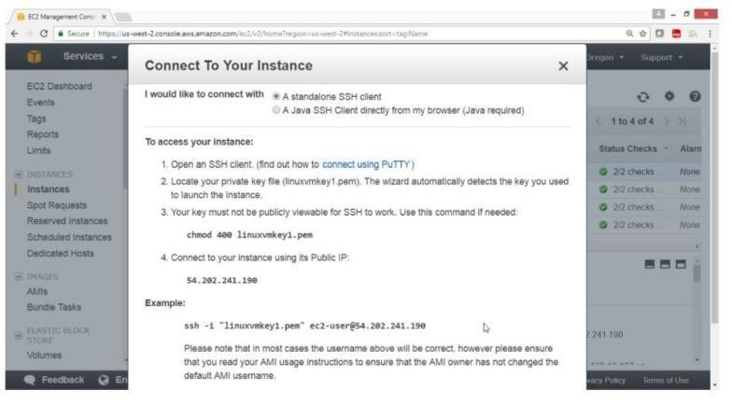

Now connect to public instance using ssh command

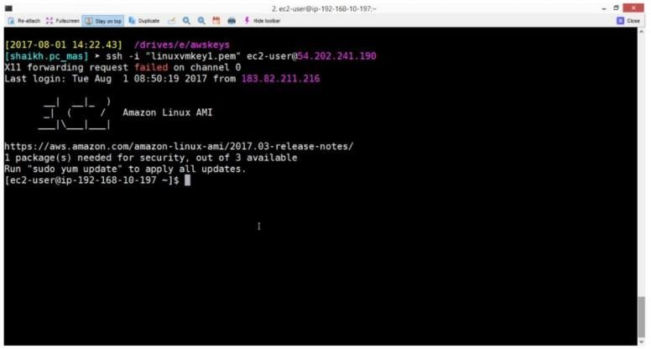

Select private instance and get private ip

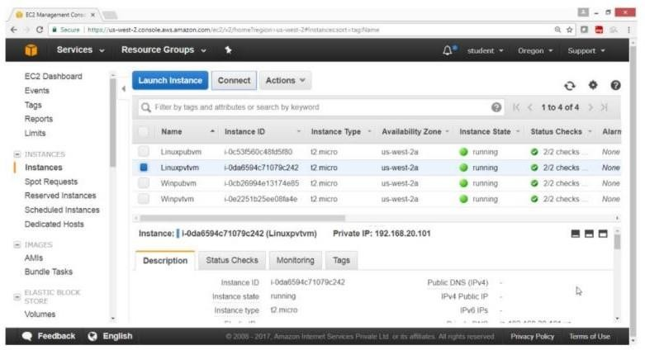

View the details of private instance

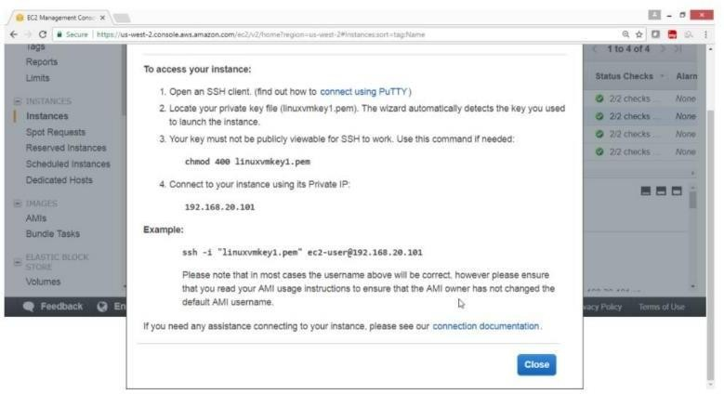

Verification

Run ssh command to login to private instance

Now you are connected to private instance in private subnet

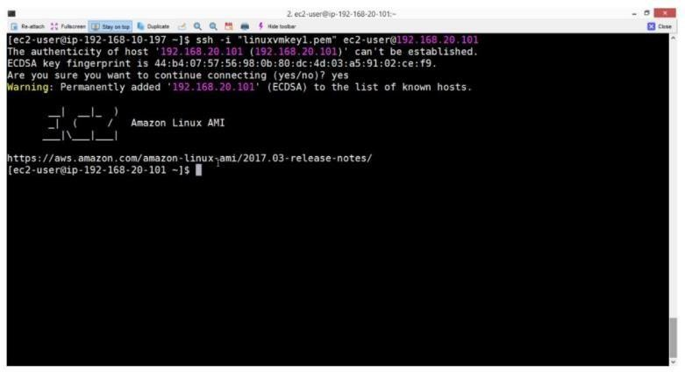

## AIM:

* 1. **:** To Connect Linux instance in public subnet

## PROCEDURE:

Launch linux instance in private subnet -> hyd-pvt-subnet Open the AWS console

Click on Services Click on Instances

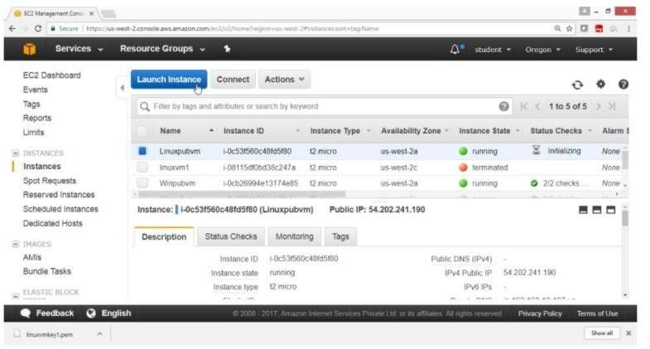Click on “Launch Instance” buttonOn the “Choose an Amazon Machine Image (AMI)” page Select AMI “Amazon Linux AMI 2017.03.1(HVM)”, SSD Volume Type -ami- 6df1e514

Click on Select button

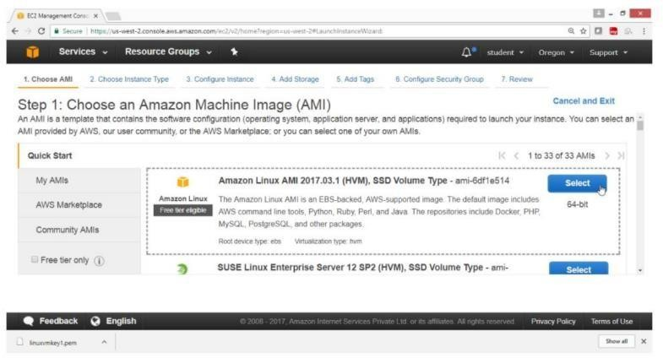

On the “Choose an instance Type” page Select “General purpose”

Type -> t2.microClick on “Next: Configure Security Group” button

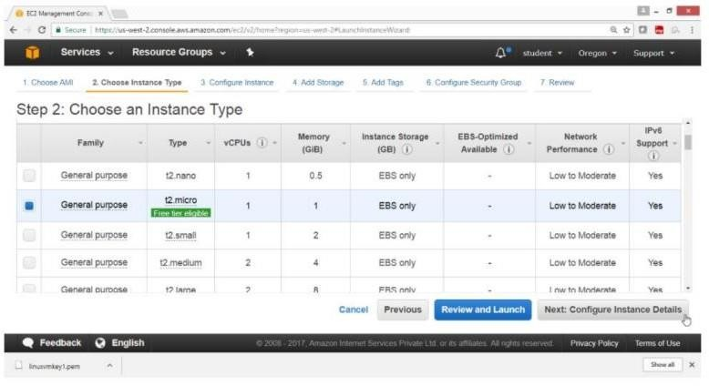

On the “Configuration Instance Details” page Number of instances -> 1

Network -> HYDVPC

Subnet -> hyd-pvt-subnet

Auto-assign Public IP -> Disable

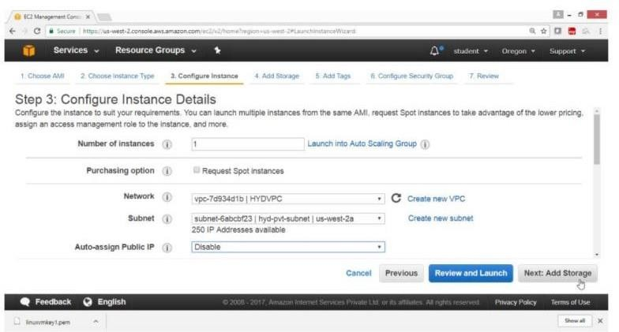

On the “Add Storage” page Leave the value as default

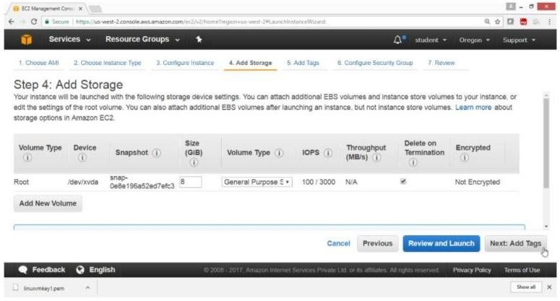

Click on “Next : Add Tags” button

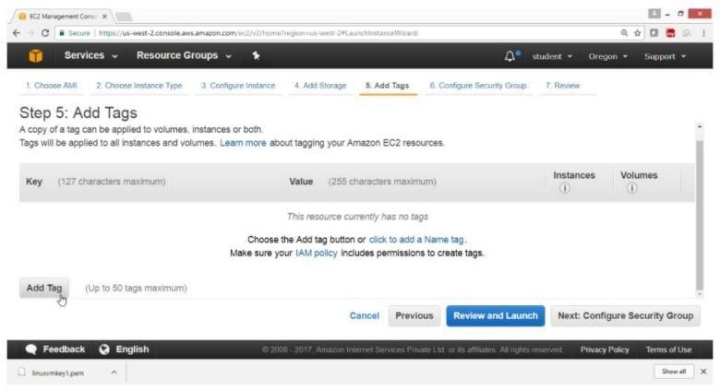

Click on Add Tag

On the “Add Tags” page Key -> Name

Value -> Linuxpvtvm

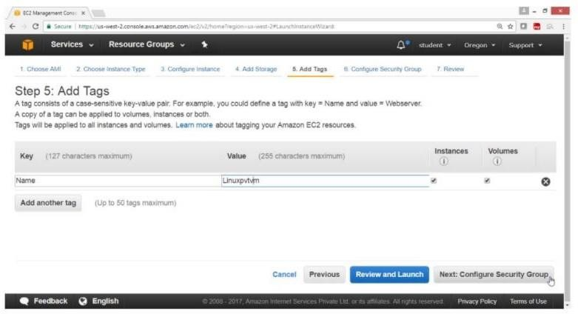

Click on “Next: Configure Security Group” button

On the “Configuration Security Group” page

Assign a security group -> Create a new security group Leave remaining values as default

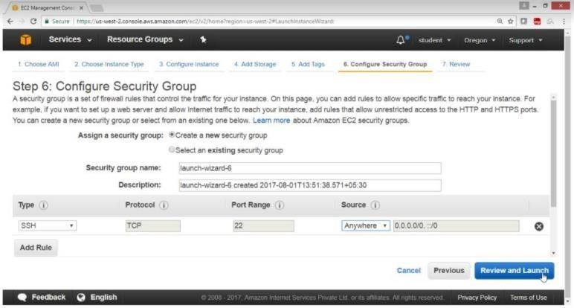

Click on “Review and Launch” button

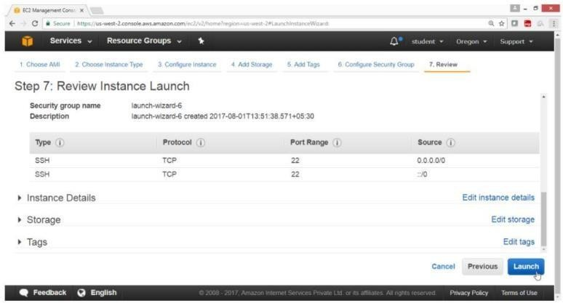

On the “Review Instance Launch” page Click on Launch button

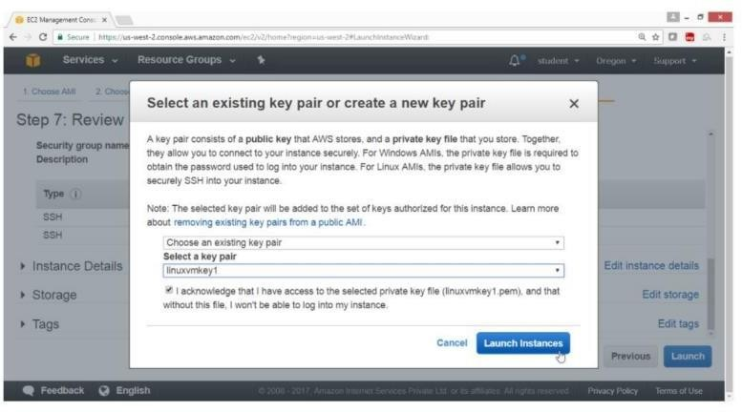

On the “Select an existing key pair or create a new key pair” box Select Create a new key pair

Key pair name -> linuxvmkey1 Click on “Launch Instance” button

Check the summary Click on View Instance button

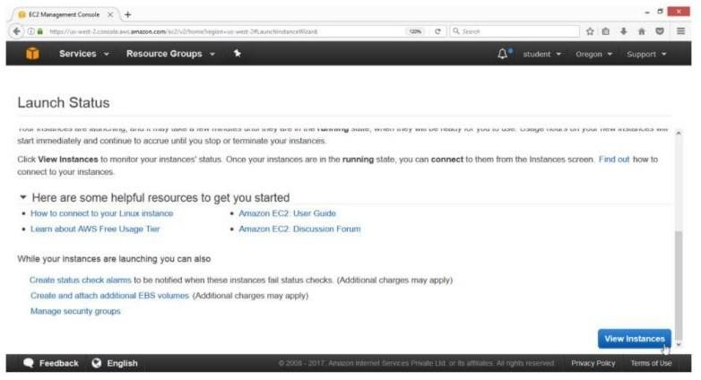

Verification

Linux instance in public subnet is launched

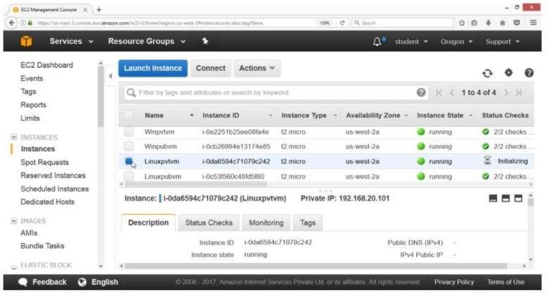

# VIVA VOCE QUESTIONS

**Virtualization:**

* + 1. List the reasons to opt for virtualization
    2. Name different types of virtualizations
    3. State how to you use a VMware tool?
    4. Purpose of Hypervisor and its types
    5. Difference between full virtualization & para virtualization?
    6. Uses of VMware workstation
    7. Different hypervisors available in Linux
    8. Difference between Xen & KVM?
    9. Type-1 and Type-2 hypervisor
    10. State how to verify Virtualization Technology (VT) is enabled in your server’s BIOS or not?
    11. Different types of server software’s VMware provide
    12. Explain memory and storage virtualization
    13. Specify the key components of VM infrastructure?

# Amazon Web Services:

* + 1. Purpose of Amazon EC2 Service.
    2. Features of The Amazon EC2 Service.
    3. Security Best Practices for Amazon EC2.
    4. Explain Storage for Amazon EC2 Instance.
    5. Explain Stopping, Starting, And Terminating an Amazon EC2 Instance.
    6. Basic Structures of The Amazon EC2 Service.
    7. Describe Storage for Amazon EC2 Occurrence.
    8. Can S3 Be Cast-off with EC2 Instances, In Case Of “yes” Please Specify How.
    9. List the regions and Availability Zones In Amazon EC2? Explain in Brief
    10. Explain How to Launch EC2 Instance in An Availability Zone
    11. Infer how to Persist Root Device Volume in Amazon EC2 Instance?
    12. Purpose of Security Group in Amazon EC2
    13. Features of Security Group in Amazon EC2
    14. State how to Create Security Group in Amazon EC2
    15. Outline how to Launch an Amazon EC2 Instance?
    16. Show the steps to Connect to Your Amazon EC2 Instance?
    17. State how to add a EBS Volume To Your Amazon EC2 Instance?
    18. Process to Clean Up Your Amazon EC2 Instance and Volume?
    19. Best Practices for Amazon EC2
    20. Amazon Machine Image (aim)?
    21. Name Amazon Machine Image and What Is the Relation Between Instance and Ami?
    22. Identify the Relation Between Instance and Ami?
    23. Explain how to Migrate an Instance to Another Availability Zone?
    24. Purpose is Key Pair?
    25. Process to Create Key Pair?
    26. State how to Create Your Own Amazon Machine Image (ami)?
    27. Steps to determine the Root Device Type of Your Ami?
    28. Size Limit for Amazon EC2 Instance Store-backed Amis And Amazon EBS- backed Amis?
    29. Pricing of Amazon EC2? Explain in Detail?
    30. State how to Update Ami Tools at Boot Time?
    31. Steps to Disable Password-based Logins for Root in Amazon EC2 Instance?
    32. Significance of Public Key Credentials and How to Install It?
    33. Stopping and Terminating an Instance different from Each Other? How
    34. Is It Possible To Change The Private IP Addresses Of An EC2 While It Is Running/stopped In A VP
    35. Can S3 Be Used with EC2 Instances, If Yes, How?
    36. If You Want to Launch Amazon Elastic Compute Cloud (EC2) Instances And Assign Each Instance A Predetermined Private Ip Address You Should?
    37. Explain What Happens When I Reboot an EC2 Instance?
    38. Issues While Connecting to An EC2 Instance